**8年级第26课时**

**《开启人生之旅——面对疫情的居家生活》参考答案**

**任务一：Watch the video and answer.**

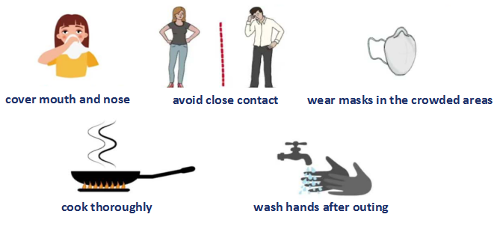

**任务二：Complete the sentences.**

Mike:

1. have stopped;hasn’t stopped
2. have been

Kevin:

1. I have started exercising at home.
2. I have used the workout apps to choose different classes to get my body moving. I feel refreshed!

Candy:

1. I have learnt to cook several dishes. I can cook well and I really enjoy cooking for my parents. These are the dishes I’ve made. Look delicious?

**任务三：Writing**

Dear Betty,

I’m glad to hear from you. Don't worry. I believe that everything will get well soon. I am fine these days.

Recently, I have stayed at home for several weeks, but I don’t feel bored because I have done a variety of activities. Firstly, I have been able to learn online. I am as busy with my study at home as I was at school. Secondly, I have learnt to cook several dishes. Here are some photos of the dishes I have cooked. They look delicious, don’t they?

Here is some advice about how to avoid the virus. You’d better not go to crowded places, which means staying at home is a smart choice. Furthermore, remember to wash your hands after coming home. Last but not least, have you ever thought that it is really important to stay positive during this special period?

We can take this holiday as a good chance of self-improving. Hope my experiences and advice can help you plan your own happy and fulfilling life.

Yours,

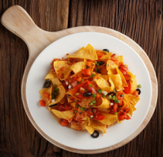Candy

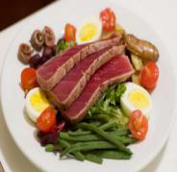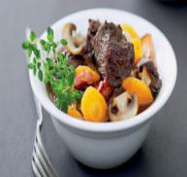

**任务四：研究性实践活动**

|  |
| --- |
| **Questionnaire** |
| **About Travel History** |
| 1.Have you been to Wuhan recently?                             A. Yes        B. No |
| 2.Have you been abroad recently?                                   A. Yes        B. No |
| **About  Life & Study** |
| 1. Have you donated money to the hospitals?                A. Yes        B. No |
| 2. How long have you stayed at home?  ____________________________________________________________ |
| 3. What have you done at home since the vacation was extended?  ____________________________________________________________  ____________________________________________________________ |
| **About Attitude & Feelings** |
| 1. What have you learnt from this unexpected public health incident? |

**Report**

I have recently conducted a survey on what students have done at home. I have collected 80 answer sheets till now. The result is as follows.

As for the travel history, nobody has been to Wuhan or abroad recently. Meanwhile, all the students have stayed at home for weeks. 10% of those have donated their pocket money to the hospitals in the hope of contributing their efforts to conquer the virus. All the students have taken the online lessons. That is to say, though the virus might have stopped us from going back to school, it hasn’t stopped us from learning. More than half of the students have started exercising at home. However, only a few students have helped parents do the housework, such as cooking. Therefore, I highly recommend that more exercising and housework should be taken part in.

All in all, I think we should take the holiday as a good chance of self-improving and balance our life and study.

**任务五: Exercise**

1. A 2. D 3. C 4. C 5.B

**拓展资源参考答案：Homestay holiday**

1. Due to the outbreak of novel coronavirus pneumonia.
2. It is transmitted through droplets coughed and sneezed by infected people.
3. They can travel as far as two meters.
4. By avoiding people and public spaces.
5. We’ve developed better hygienic habits and learnt to cherish the simple pleasures that we’ve been taking for granted-being able to take a walk, go to a restaurant or hang out with friends.