**8年级英语第24课时**

**《开启人生之旅—面对各种挑战的良好心态》学习指南**

**【学习目标】**

1. 学会描述应对挑战的经历；
2. 梳理不同人物的对待挑战的不同态度；
3. 形成面对梦想与挫折，积极争取的人生观和价值观。

**【学习任务单】**

**任务一：听**Lingling **与**Tony **的对话, 回答下列问题。**

1. What kind of competition is Lingling going to enter?

_____________________________________________________________

1. Has she ever won any prizes before?________________________________
2. Why does she still want to try?

______________________________________________________________

1. Will Tony enter the speaking competition?

A. Yes, he will. B. No, he won’t.

5. Why doesn’t he want to enter the speaking competition?

A．Because he has won many prizes in speaking competitions before.

B．Because he hasn’t won any prizes in speaking competitions before.

**Complete the mind map.**

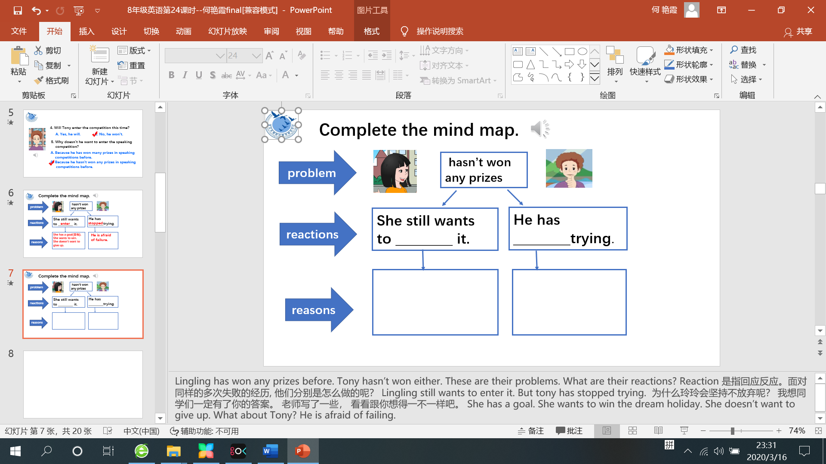

**Discussion:**

1. If you were Lingling, would you do the same?

__________________________________________________________________

1. Do you think Lingling will win the competition this time?

**___________________________________________________________________**

**任务二: 阅读关于Corner Stroud 的故事，了解他的人生经历。**

To get the tennis court(球场)，Conner Stroud has to push his wheelchair there.

The 15-year-old boy from North Carolina, US was born without legs. But when he picks up his racquet(球拍) and begins to hit a ball, you quickly see that the young man just wants to win.

Stroud began playing tennis at the age of 5 at the small tennis club which his parents owned. For years, he played against able-bodied players by putting rubber(橡胶) on the stumps(残余部分) of his legs. Though he was a foot (英尺)or two shorter than many of the players he played against, he won a number of matches. He became well-known enough that he got to meet Rafael Nadal, his favorite player, at the US open in 2013.

“The most important thing is that he’s happy,” Nadal told reporters about Stroud after that 15-minute meeting. “He’s playing tennis… That’s a great example of being happy even if your life doesn’t give you everything. “

Stroud started playing wheelchair tennis at 13 and now he is No.1 in the US.

Earlier this summer, he played for the US in the world’s biggest junior wheelchair team tennis event—the World Team Cup. He played six matches and won five of them as the US won the cup for the first since 2000.

“He is a polite boy, but he will rip (撕扯) your heart out trying to beat you,” Jason Harnett, a United States Tennis Association coach, said of Stroud. “You see that attitude in a lot of the best players, whether they are able-bodied or disabled (残疾的).”

Teenage players can often get disappointed and angry. They may throw their racquet or shout at themselves after they miss shots. However, Stroud never does that.

“I just try to stay positive,” Stroud said. “After every point, I try to say I’m going to win the next point, or the next game, or the next match if I lost the whole match. There’s always a chance to be positive. You can always win another time.”

**梳理Conner Stroud 的经历。**

|  |  |
| --- | --- |
| **Name** | Conner Stroud |
| **Age** | ___________ |
| **Job** | Tennis player |
| **Experiences** | He was born without ___________.  At the age of 5, he __________________________________  against________________players.  He won ________________________ and  became ________________.  He _______________________________________at 13.  Now, he is ________________in the US. |

**Discussion:** What made him become the best wheelchair tennis player in the US?

____________________________________________________________________________________________________________________________________________

**任务三: Read the fable (寓言) and put the missing sentences in.**

Once there were two seeds(种子). They often talked with each other. One day, the first seed said, “I want to grow! 1._________________” Later it grew. It had a chance to enjoy the sun and the rain.

The second seed said, “2. ________________ If I grow, I have to live in the soil(土壤). I might be eaten by little animals. How terrible! If I become a beautiful flower, a child will come and pick me. 3._____________________ It didn’t grow.

In Spring, a chick (小鸡)came. The chick ate the second seed and left. See? 4._________________________

|  |
| --- |
| 1. We should face our life bravely. 2. It’s much better for me to wait because it is safe. 3. I want to be big so that I can enjoy the sun and the rain. 4. I’m afraid of growing up. |

**Discussion:** Which seed do you want to be? Why?

____________________________________________________________________________________________________________________________________________

**任务四: 归纳总结Good attitude towards challenges**

|  |
| --- |
|  |

**任务五：写发言稿，分享你应对挑战的经历。**

目前，中学生普遍感到压力很大。为帮助同学学会正确应对压力，你们班将在下周召开以“如何应对挑战”为主题的班会。请你准备一个发言稿，跟大家分享一下你的经历。谈谈你面对过什么样的挑战？你是怎样应对的？从中有何收获？

1. What kind of challenge have you ever experienced?
2. How did you deal with it?
3. What have you learned from it?

**_______________________________________________________________________________________________________________________________________________________________________________________________________________________________________________________________________________________________________________________________________________**