**7年级英语第25课时**

**《如何做个有礼貌的旅行者》学习指南**

**【学习目标】**

1. 能够用英文礼貌地表达请求，并表述旅行中涉及交通、场所和就餐的词汇。
2. 能够从交通、场所和就餐三个方面制定旅行计划，并关注旅行中的礼貌用语。

**【学习任务单】**

**任务1：How to be polite at the station**

（1）Write down what vehicles you will take when you travel.

（2）Listen to a dialogue and fill in the blank.

* tell me the times of trains to London, ?
* does the 7:59 train get to London?
* come back at about 7 p. m.
* is a return ticket?

**任务2：How to be polite when you ask for directions**

（1）Write down where you will go when you travel.

（2）List the polite words you will use to ask for directions.

**任务3：How to be polite in the restaurant**

（1）Match the words of sweet food with the pictures.

trifle 乳脂松糕 carrot cake pudding scone 司康饼 apple pie

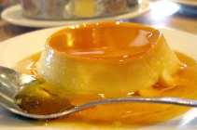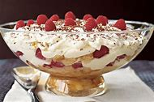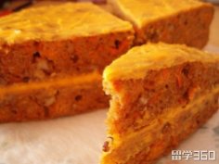

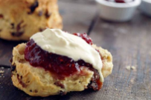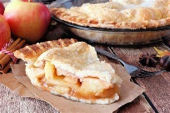

（2）List the polite words used in the restaurant.

**任务4：Please use the mind-map to make a travel plan. The travel plan includes how to travel, where to go and what to eat. Of course, you can add more information. Don’t forget to list the polite words for travel. Wish you a pleasant trip!**

**任务5：完形填空。从下面各题所给的A、B、C三个选项中，选择最佳选项。**

People in different countries have different ways of doing things. Something is 1 in one country, but it may be quite impolite in another. In Britain, you mustn’t lift your bowl to your .2 when you are having some liquid (液体) food. But it’s 3 in China. And in Japan you even needn`t worry about making 4 while you are having it. It shows that you`re enjoying it. But people in Britain think it is bad manners. If you are a visitor in Mongolia, what manners do they wish 5 to have? They wish you to have a loud “burp” (打嗝) after you finish eating. Burping shows that you 6 the food.

In Britain, you should try not to 7 your hands on the table when you’re having a meal. But in Arab (阿拉伯) countries you must be very 8 with your hands. You mustn’t eat with your left hand. Arabs consider (认为) it very 9 manners eating with left hands. So when you are in other countries, 10 carefully and follow them. As a saying goes, “Do as the Romans do.”

( ) 1. A. helpful B. useful C. polite

( ) 2. A. mouth B. nose C. ears

( ) 3. A. same B. different C. important

( ) 4. A. friends B. noise C. mistakes

( ) 5. A. them B. he C. you

( ) 6. A.win B. buy C. like

( ) 7. A. put B. take C. give

( ) 8. A. interested B. careful C. difficult

( ) 9. A. easy B. bad C. good

( ) 10. A. watch B. see C. read