7年级英语第24课时
《用英语讲中国节气》拓展资源
（一）List of the 24 Solar Terms 二十四节气英中对照
Solar Terms | Chinese
Start of Spring | lì chūn立春
Rain Water | yǔ shuǐ雨水
Awakening of Insects | jīng zhé惊蛰
Vernal Equinox /the Spring Equinox | chūn fēn春分
Pure Brightness /Clear and Bright | qīng míng 清明
Grain Rain | gǔ yǔ谷雨
Start of Summer | lì xià立夏
Small Full (Grain) | xiǎo mǎn小满
Grain in Ear | máng zhǒng 芒种
Summer Solstice | xià zhì夏至
Minor Heat | xiǎo shǔ小暑
Major Heat | dà shǔ大暑
Start of Autumn | lì qiū 立秋
Limit of Heat | chù shǔ 处暑
White Dew | bái lù 白露
Autumnal Equinox | qiū fēn 秋分
Cold Dew | hán lù 寒露
Frost Descent | shuāng jiàng 霜降
Start of Winter | lì dōng 立冬
Minor Snow | xiǎo xuě 小雪
Major Snow | dà xuě 大雪
Winter Solstice | dōng zhì 冬至

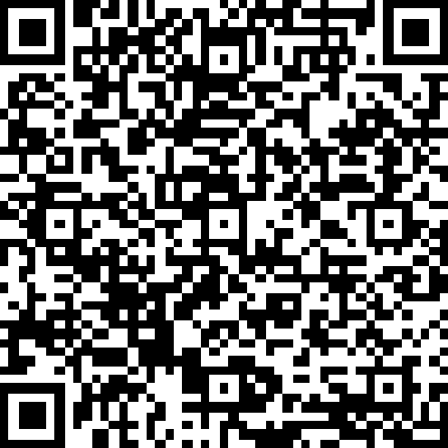
（二）扫描下面二维码，了解更多关于中国节气的英文介绍吧！

