**“人与自然” Reading Club 2 NATURE FILM ——学习任务单**

**【学习目标】**

1. **能够提炼文本中的信息和观点;**
2. **能够掌握介绍电影的基本方法和相关词汇;**
3. **能够批判性地思考自然和人和谐相处的关系和方法。**

**【学法指导】**

**阅读时，重点关注并学习：**

**1. 介绍一部电影方法，包括介绍的角度以及所用词汇。**

**2. 如何提取语篇中直接陈述的情感态度、价值观和社会文化现象。**

【任务一】快速阅读文章，体会语篇的出处和文体特点。

【任务二】快速阅读，理清文章脉络，学习介绍电影的角度。

【任务三】阅读并完成表格，提取电影介绍的细节信息。

【任务四】再次阅读课文，提取语篇中的观点态度。

【任务五】批判性思考：自然和人应如何和谐相处，并用语篇中的证据论证。

【任务六】学生讨论：应如何处理人类和野生动物之间的关系。

**Reading Club 2 NATURE FILM**

**1. Active and share**

Where can we see a discussion like in this text?

Have you ever seen the film *Wolf Totem*?

**2. Skim the text and find out what aspects of the film are talked about.**

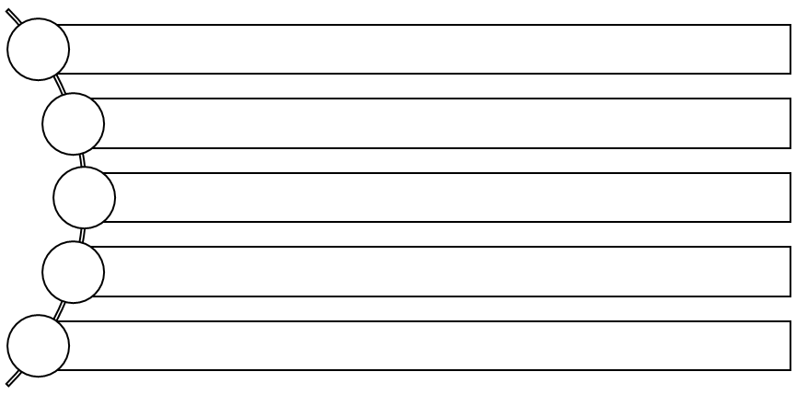

3. **General Understanding: Read and answer the questions**

1. Why do people enjoy the film Wolf Totem?
2. Why does TomTom admire the crew’s treatment of the wolves in the films? Underline the evidence.

4. **Critical thinking:**

**What do you think the writer Jiang Rong wants to say about people and wolves?**

Choose the following statements and use evidence from the text to support your choices.

A. People are more dangerous than wolves.

B. People should kill dangerous animals.

C. People should leave animals alone.

D. Wolves are not very dangerous.

**5. Discussion:**

How do you understand the relationship between humans and wildlife?

**Optional Task:**

1. Watch the film *Wolf Totem* after class and write a movie review about it.

2. Find more films about humans and nature and recommend them to your classmates next class.