话题：人与社会《艺术》Reading(2)课后作业

阅读下面文章，选择最佳选项。

**A**

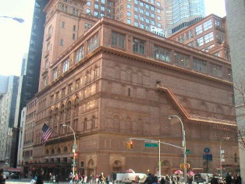One of the most famous buildings in the United States is Carnegie Hall, the home of classical and popular music concerts in New York. Carnegie Hall is known not just for its beauty and history, but also for its amazing sound. It has been said that the hall itself is an instrument. It takes the music and makes it larger than life.

Carnegie Hall is named after Andrew Carnegie, who paid for its construction. He was a rich man who also gave a lot of money to schools and public libraries. Construction on Carnegie Hall began in 1890 and the official opening night was on May 5, 1891. The hall was owned by the Carnegie family until 1924 when it was sold to Robert E. Simon. The building became very old and in 1960, the new owner made plans to destroy it and build an office block. Isaac Stern led a group of people who fought to save Carnegie Hall and finally, the city of New York bought it for $5 million. It was then fixed up between 1983 and 1995.

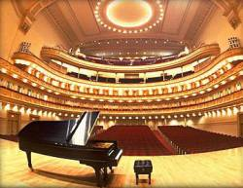In 1986, people realized that Carnegie Hall had never kept proper records of its history. Advertisements and stories in newspapers about how Carnegie Hall needed help to recover its history led people to send in old concert programs and information from all over the world. Over 12,000 concert programs were received and with these it was possible to make a proper record of Carnegie Hall’s concert history.

Carnegie Hall is actually made up of several different halls, but the Main Hall, now called the Isaac Stern Hall, is the most famous, and it can hold an audience of 2,804 in five levels of seating. Most of the greatest performers of classical music have performed in the Main Hall, and its reception (招待) areas are decorated with signed photographs of these musicians. Because the best and most famous musicians of all time have played at Carnegie Hall, it is the dream of most musicians who want to be great to play there. This has led to a very old joke which is now part of Carnegie Hall’s history. Question: “How do I get to Carnegie Hall?” Answer: “Practice, practice, practice.”

1. What happens inside Carnegie Hall?

A. Musical concerts. B. Historical events.

C. People dance. D. People become famous.

1. Who paid for Carnegie Hall to be built?

A. Isaac Stern. B. Robert E. Simon.

C. Andrew Carnegie. D. The city of New York.

1. Why do you think people wanted to save Carnegie Hall?

A. Because it made a lot of money.

B. Because it was interesting.

C. Because it was a part of New York’s history.

D. Because they didn’t like Robert E. Simon.

1. Why is the Carnegie Hall joke funny?

A. Because you expect the answer to be directions and not advice.

B. Because Carnegie Hall is a place where musicians practise a lot.

C. Because it is difficult to find your way to Carnegie Hall.

D. Because you don’t expect the answer to repeat the same word three times.