《语法填空》学习指南
【学习目标】
1. 通过试题了解语法填空的命题热点；
2. 掌握语法填空重要考点的解题策略，突破难点；
3. 在语篇中理解和使用所学语法知识及解题策略正确答题。
【学法指导】
一、熟知语法填空的考查特点：
语法填空有10个空，大概考查动词时态2-3个，考查非谓语2-3个，考查三大从句1-2个，考查介词1个，考查代词0-1个，考查名词0-1个，考查形容词0-1个，考查副词0-1个，考查冠词0-1个。
二、 主要考点设置：
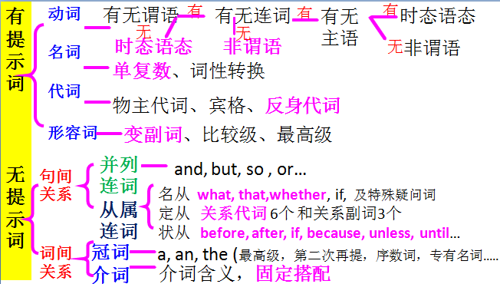

三、语法填空的解题技巧：
1. 阅读文章，把握主题语境和时态；
2. 阅读试题所在句子，判断考查类型；
3. 有提示词时，如果是动词，判断是谓语还是非谓，然后作答；如果是名词，可数名词可以考虑其复数形式、不可数名词考虑是否加ful变为形容词；如果是代词，考虑反身代词、形容词性物主代词等变化；如果是形容词，考虑比较级或最高级、考虑变为副词。
4.没有提示词时，考虑三大从句引导词、介词、连词、冠词等。
【学习任务】
一、纵观2019年期末各区语法填空考点与适应性训练试题对比：
 | 时态语态 | 非谓 | 从句 | 形容词 | 副词 | 名词 | 介词 | 代词 | 冠词
朝阳 | 3过，现被，现 | 2to do，doing | 2定，名 | 1 | 1 |  | 1 on/ over/ about
海淀 | 3过进，现在，现完 | 2doing，to do | 2状，定 | 1  natural |  | 1复数troubles | 1 with
东城 | 3过完，过被，现 | 2to do，done | 2定，名 | 1  cultural |  | 1复数animals | 1 behind/  after
西城 | 3现，现完，过被 | 2to do，doing | 1定 |  | 1-ly | 1复数ways | 1 for |  | 1 the
适用性训练 | 2 过，现被 | 2 doing，done | 1 定 | 1 successful | 1 easily | 1  Studies | 1  in | 1  my

二、 典型例题分析
北京市适应性训练语法填空
阅读下列短文，根据短文内容填空。在未给提示词的空白处仅填写 1 个适当 的单词，在给出提示词的空白处用括号内所给词的正确形式填空。
A
Mrs. Bailey was important in the educational journey that carried me through school and into my profession. Until I joined her class, I hadn’t believed in my ability as a writer. She 1 (persuade) me to join the poetry society and lit in me a fire for literature. She recognised 2 (I) potential and showed me that I could write with creativity and enthusiasm. Because of the confidence she inspired in me, I’ve carved out a 3 (success) profession as a journalist.

【答案与解析】
A篇是记叙文，主题语境是人与自我。介绍了作者在老师的鼓励下，加入了诗社，提高了文学素养，最后成功成为一名记者。
1. persuaded 考查时态。本篇主题时态是一般过去时，此处与下文and lit 是并列关系，所以也用一般过去时态。
2. my 考查代词。用形容词性物主代词，修饰名词potential，一起构成动词recognised的宾语。
3. successful 考查形容词。 修饰名词profession，用形容词形式。
B
Some university students carried out a campaign 4 they celebrated their whole day without cell phones. This move was to improve their relationships with their near and dear ones and to keep them away from the virtual (虚拟的) life. 5 (study) indicate that a majority of young people used their phones during lessons, over family meals or even at the cinema. The problem of phone addiction (成瘾) has been observed since a few years ago, with experts and psychologists 6 (try) to increase awareness about this problem.
B篇是说明文，主题语境是人与社会。介绍了大学生发起一项运动，庆祝不使用手机的日子，这样的运动改善了与亲朋好友的关系。
4. where 考查定语从句。从句中不缺少主语、宾语，先行词是a campaign，相当于虚拟的地点，所以用where，where在从句中作地点状语。
5. Studies 考查名词。此处用作主语，前面没有修饰词，谓语动词是indicate，所以用复数形式。【误解分析】有学生填写studying，虽然动名词可以作主语，但是，谓语是indicate。
6. trying 考查非谓语动词。 “with+复合宾语”结构，即“with+名词+非谓语动词”，在此结构中表示主动时用doing，表示被动时用done，表示将要做的事情用to do。【误解分析】可能会有考生写成tried、to try或者try。没有理解“with+复合宾语”结构。
C
The tiger shark 7 (consider) to be one of the most dangerous sharks in the world. Why are tiger sharks so dangerous? First, they like to live 8 waters where humans usually swim, so the chances of an encounter (遭遇) are much greater. Second, tiger sharks are so strong and aggressive that they can 9 (easy) hit a person. And third, tiger sharks have teeth perfectly 10 (design) for cutting their food, so it is certain that the damage will be disastrous.
C篇是议论文，主题语境是人与自然。虎鲸被认为是最危险的动物之一，从三个方面具体介绍了其危险之处，以便让人们了解如何防范。
7. is considered 考查语态。主语是shark，作谓语，构成被动关系，所以用被动语态。
8. in 考查介词。句意为“他们喜欢生活在人们经常游泳的水域”。【误解分析】介词对考生来说是个难点，此处只要理解句子的意思，根据生活常识可以解答。
9. easily 考查副词。 修饰动词用副词形式。
10. designed 考查非谓语动词。该句谓语是have，所以此处应该用非谓语动词，design与其所修时的名词teeth构成逻辑上的被动关系，所以用过去分词。

