**9年级英语第24课时 学习指南**

**【学习目标】**

在本节课结束时，我们能够：

1、运用完形填空的命题特点和做题步骤，独立完成完形填空。

2、掌握积累完形填空词汇的方法（包括词类活用、一词多义和固定搭配等）。

**任务1、和老师一起完成下面这篇完形填空**

**Steven's New Sled**

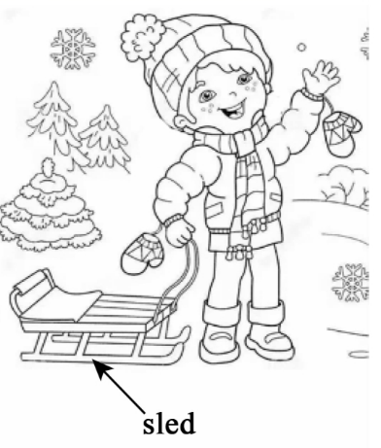 Steven woke on Christmas morning to find a new sled. “Oh, wow!” he shouted. This was the best Christmas 1 ! Steven was still excited as the rest of his family opened their gifts. Secretly, he hoped he could get outside quickly to try out his new sled.

Finally, Steven asked, “ Dad, is it okay if I try out my sled?" Dad 2 . Soon, Steven was sledding down Twin Hills in the neighbourhood park. He felt the wind against his face as he flew down.

Later that day, Steven carefully leaned（靠）the sled up against the outside of his house under his bedroom window.

The next day, Steven ran outside as soon as he could. “Oh, no! ”Steven shouted. His sled was missing! He ran as fast as he could to the park. There at Twin Hills he 3 it! Steven's neighbour, Kevin, was on Steven's new sled! "Kevin! That's my sled! You stole my new sled! ”But Kevin just laughed and headed up the hill for another run down.

Steven ran home, crying all the way. He found his dad in the garage and told him what had happened. Steven's dad said, "Calm down, Son. There may be another 4 for the missing of your sled.”

Steven couldn't believe his dad was 5 with Kevin. “But, Dad. Kevin's at Twin Hills using my sled right now! We need to go to get it! ”

Dad said 6 , "First of all, you need to make sure your sled is actually stolen. Look over there.” Steven was 7 at what he saw. His sled leaned against the wall of the garage next to his bicycle. Dad put his arm around Steven and said, "I put your sled away last night when I saw you had left it outside.” Steven 8 his head. He felt bad about the way he had spoken to his neighbour. "I should say sorry to Kevin, ” he said. Dad replied, “There's no time like the present.”

|  |  |  |  |
| --- | --- | --- | --- |
| 1. A. present | B. show | C. tree | D. music |
| 2. A. doubted | B. understood | C. complained | D. agreed |
| 3. A. left | B. found | C. rode | D. accepted |
| 4. A. sign | B. suggestion | C. reason | D. search |
| 5. A. siding | B. dealing | C. working | D. arguing |
| 6. A. honestly | B. patiently | C. confidently | D. cheerfully |
| 7. A. disappointed | B. frightened | C. excited | D. surprised |
| 8. A. hung | B. turned | C. shook | D. raised |

语言积累

**任务2、独立完成下面的完形填空**

**Santa Can Come before Christmas**

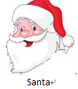It was last June. I entered a supermarket to pick some vegetables，when a young man asked me，“Can you tell me where the 1 counter（柜台） is? ”

“Well， the milk is in the lower right corner，” I replied.

Picking up my things，I finally came to the milk counter where I met the same man 2 almost 10 bottles of milk.

I asked，“Do you need a basket or a trolley？”

“Sure，thank you.” he answered.

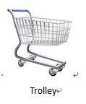I was 3 he was still picking more bottles and after a few minutes his trolley had 24 bottles of milk.

I laughed and asked, “Why so many bottles?”

He smiled and said, “These are for my street dogs. Today, I want to be a Santa for them.”

I said, “Well, it`s too early for you to be a Santa. It is still June and Christmas comes in December.”

He 4 at me and walked a few steps, as if he wanted to say something but he left the counter without saying anything.

5 , we met again at the bread counter.

“So these bread and cakes are also for the street dogs, Mr. Santa.”

He smiled and said, “Yes. These are also for the dogs and I love to be Mr. Santa in the month of June. Santa is a representation(象征) of surprises and love. Santa comes in December as we 6 him around Christmas. But in real life there is a Santa in each one of us that shines through our personality at some point of time, no matter which month it is. Maybe when you offered help to me by getting me a trolley, there was a hidden Santa in you. When we offer food to a poor man or a(n) _7_ to someone who is caught in the rain, we are being Santa there. So when you offer help to others or get help from others, just think that Santa has come all the way for you.”

He left and I was happy that I had met him. It was right to understand that Santa can come before Christmas. We just need to realize that he is around us by 8 happiness and unconditional love.

|  |  |  |  |
| --- | --- | --- | --- |
| 1. A. vegetable | B. milk | C. bread | D. fish |
| 2. A .putting | B. choosing | C. holding | D. bringing |
| 3 A. sad | B. excited | C. angry | D. surprised |
| 4. A .pointed | B. laughed | C. shouted | D. turned |
| 5. A. Luckily | B. Suddenly | C. Hopefully | D. Naturally |
| 6. A. call | B. show | C. expect | D. invite |
| 7. A. camera | B. umbrella | C. apple | D. box |
| 8. A. storing | B. facing | C. spreading | D. increasing |

语言积累