**9年级英语第23课时 学习指南**

**【学习目标】**

**在本节课结束的时候，我们能够：**

1.通过略读、精读，对比新旧时代的生活，完成“对比图示”；

2.将图形组织器的名字和图示匹配，感知图示的概念和优势；

3.通过阅读实践，应用“论证图示”，体验其对阅读的作用。

**【学习任务单】**

**任务1、阅读文章，回答问题。**

**Life now and then**

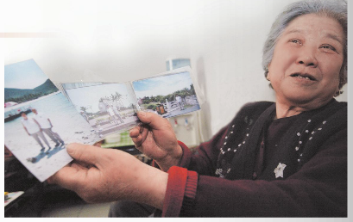Mrs. Li is over seventy years old. She has lived in Beijing all her life. I asked her about life today and in the past.

**What was your life like in the past?**

My family lived in a tiny house. There were no electric lights, only candles. My father was a postman, and he often worked twelve hours a day outside in the winter cold or in the summer heat. My mum was a farm girl before she met my father. She was a kind and loving mother. She didn’t go out to work. There were five children in my family, and looking after us was more than a full-time job.

I remember the family meals. The food was simple. We could only eat meat once or twice a year. I wasn’t sent to school because my family couldn’t afford it, and what’s more, because I was a girl.

**How has life changed?**

Families have got smaller than they were in the past. Today most people only have one child! The role of women has changed too. My daughter is really lucky. She has a good education, and she goes to work even after getting married. I’m happy to see she’s busy working every day, but sometimes I feel lonely because she can’t come to see me often.

Transport and travel are easier today. When I was young, I went everywhere on foot or sometimes by bike. Now you can take the bus everywhere, and there’s also the underground. And you young people can take a plane to anywhere in the world. The only thing I don’t like, though, is that there’s so much more traffic. It’s so difficult to cross the road.

Of course, we didn’t have television when I was a child. I really enjoy watching television today. There’re so many good programmes, like the Beijing Opera and old films. But some of the shows are too noisy for me.

Generally speaking, I think life is better today. We eat better and we live longer.

1. What aspects (方面) did Mrs. Li mention?

__________________________________________________________________________

1. Please read carefully and compare “life in the past” and “life today” from the following aspects.

|  |  |  |
| --- | --- | --- |
|  | Life in the past | Life today |
| family |  |  |
| work |  |  |
| education |  |  |
| transport |  |  |
| entertainment  (television) |  |  |

**任务2、匹配图形组织器的名字和图示。**

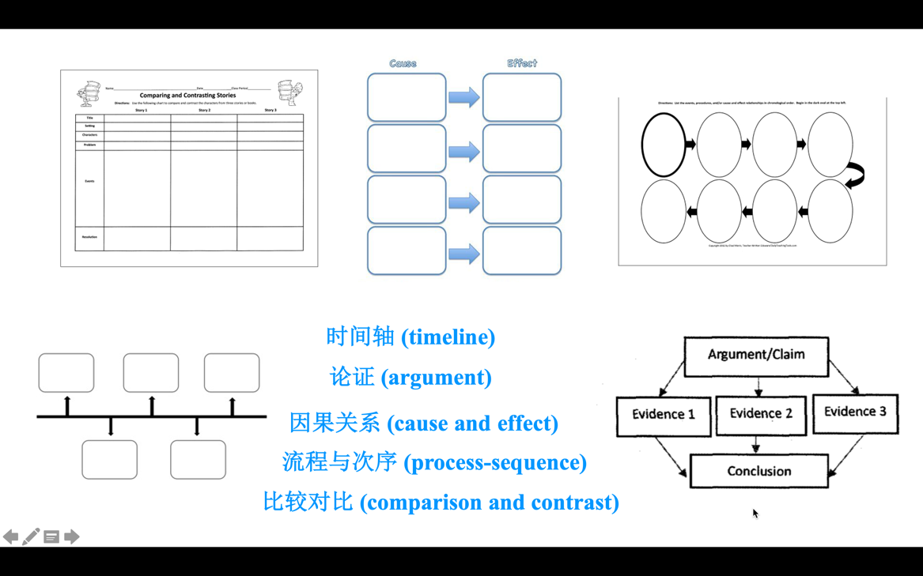

**任务3、阅读文章，完成“论证图示”和题目。**

**Should Children Be Allowed to Get Bored?**

Children need time to stand and stare. They should be allowed to get bored so that they can develop their ability to be creative.

      Children are expected by their parents to be reading a textbook all the time. However, research shows that it may **hamper** the development of their imagination, while boredom can give them opportunities to develop creativity.

Boredom is often linked with loneliness, but a writer named Meera Syal said boredom had helped her in developing her mind. She told researchers about her childhood.

       Having few things to do, Syal often talked with her neighbors. She also tried to do things like learning to bake cakes. “But importantly, I thought and wrote a lot, because I was bored,” Syal said. She kept a diary, filling her time with short stories and poems she made up.

Grayson Perry, an artist, grew up in a family with little money. He enjoyed himself by making up stories, drawing pictures for his stories and reading many books in the library.

        Bored but free, he spent hours looking out of the window, watching the changing clouds and seasons. Perry filled up his free time with what he liked. He became creative, because he could think freely.

Dr. Belton is an expert on the effects of emotions on learning. “Boredom could be an uncomfortable feeling,” she said. “But some young people cannot deal with that boredom creatively. So sometimes they may break a classroom window, or drive a car out for a mad race.”

        Usually, when children have nothing to do, they would turn on the TV, the computer, or the phone. Their time on these things has increased, yet they need to have time to think about their experiences through play or just watching the world around them.

It is this kind of thinking that can inspire the imagination. On the other hand, the TV or phone may cut short the thinking process. That can be harmful to the development of creativity.

 “For developing the ability to be creative,” Dr. Belton advised, “perhaps we need to stand and stare, and stay off-line from time to time.”

      （2016年北京中考英语阅读理解D篇）

53. What does the word “hamper” in Paragraph 2 probably mean? __________

A. Slow down.

B. Keep up with.

C. Go beyond.

D. Give rise to.

54. The writer talks about Syal and Perry to ____

1. Stress the great differences between them
2. Introduce a popular writer and a famous artist
3. Suggest good ways of going through boredom
4. Show effects of boredom on developing creativity

55. What can we learn from the passage?

1. Boredom provides children with space to think freely.
2. It’s much better for children to be busy than be bored.
3. Boredom helps children deal with difficulties properly.
4. It’s boring for children to think about their experiences.