**9年级英语第22课时 学习指南**

**[学习目标]**

在本课结束后，我们能够：

1.通过分析不同语境下动词的时态语态，理解与概括六种时态、两种语态的含义。

2.通过描述Betty在疫情前、现在、未来的活动与计划，学会正确运用动词的时态语态。

3.通过创作海报，灵活使用不同的时态语态描述自己疫情前、现在及未来的活动。

**[学习任务单]**

**任务1 根据语境，判断时态并口头翻译**

1. 贝蒂昨天用微信和姥姥聊天。_____________________________________
2. 昨天贝蒂正在看电视的时候，妈妈突然进屋了。__________________________
3. 贝蒂每天帮妈妈做家务。_____________________________________________
4. 贝蒂正在在线学习英语。_____________________________________________
5. 贝蒂已经看过电影《流浪地球》三次了。_______________________________
6. 贝蒂打算秋天和朋友们去野餐。_______________________________________
7. 当我长大了，我会做什么工作呢？_____________________________________
8. 火神山医院在十天内被建起来了。_____________________________________

**任务2 制作时间轴，反映不同时态的概念**

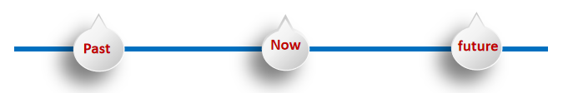

**任务3 实战练习**

1. Sam _______ with his friends every weekend.

A. skates B. is skating C. has skated D. was skating

2. Lucy is my friend. We______each other since she came to our school.

A. know B. knew C. have known D. will know

3. My mother _____ some washing when the telephone rang.

A. does B.did C. is doing D. was doing

4. David is a tennis player. He _____ to play tennis when he was six.

A. begins B.will begin C. began D. has began

5. The mobile phone _______ in 1973.

A. invents B. was invented C.invented D. is invented

6. Please don’t make so much noise. The baby ______ .

A. sleeps B.slept C. will sleep D. is sleeping

7. A new road _____ near my school next year.

A. builds B.will build C. is built D. will be built

8. The students are excited. They _____ on a school trip next Monday.

A. went B. go C. will go D.have gone