9年级英语第21课时 学习指南
【学习目标】
本节课结束时，我们能够：
1. 能通过听力实战练习①，捕捉听力材料中多条事实性具体信息，进行梳理判断，提升信息筛选的能力；
2. 能通过听力实战练习②，捕捉人物所做事情、事情发生时间等关键信息，进行加工整合，提升推理判断的能力；
3. 能通过听力实战练习③和④，梳理语段中句子、段落之间的关系，理解主旨要义和说话者的意图，提升归纳分析的能力。

【学习指南】
实战①---获取多个事实性具体信息
1. What can we learn from the conversation?
A. Mike offers to help with Annie’s lessons.
B. Annie refuses to study at home for so long.
C. The doctor is worried about Annie’s health.

实战小结①
常见提问形式：
____________________________________________________
____________________________________________________
____________________________________________________
____________________________________________________
解题策略：
____________________________________________________
____________________________________________________
____________________________________________________

实战②---推断推理
1. What is the relationship between the two speakers?
A. Classmates. B. Neighbours. C. Doctor and patient.

2. When will the festival finish?
A. On Sunday. B. On Saturday. C. On Friday.
3. What will the woman do?
A. Take the bus to the festival.
B. Go to the festival in the morning.
C. Stay at the festival until midnight.

实战小结②
常见推理内容：
____________________________________________________
____________________________________________________
____________________________________________________
解题策略：
____________________________________________________
____________________________________________________
____________________________________________________

实战③---主旨要义
1. What is the speaker mainly talking about?
A. Where to spend Father’s Day.
B. How to choose a good gift for Dad.
C. What to do with Dad on Father’s Day.

2. What does the boy mainly talk about?
A. What to do in his house.
B. How to get to his house.
C. When to get to his house.

实战④---目的意图
1. What is the purpose of the speaker?
A. To invite the students to join in school clubs.
B. To give some advice of choosing school programmes.
C. To introduce the school’s history and popular activities.

实战小结③+④

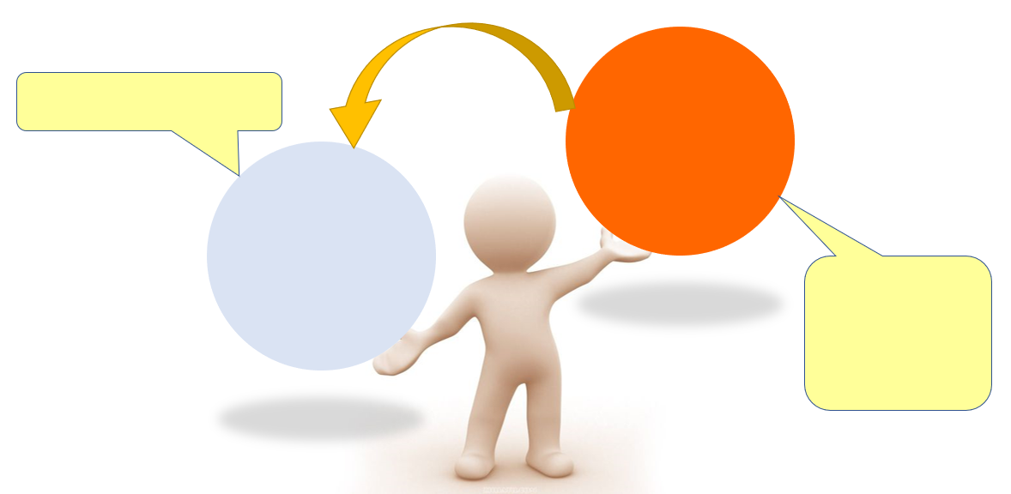

听力材料：
对话一：
M: Hello, this is Mike. Is that Annie speaking?
W: Yes. Hi, Mike.
M: I didn’t see you at school today. Miss Brown said you had a bad cold. Do you feel better now?
W: A little better. Thank you, Mike.
M: That’s all right. I hope you can come back soon.
W: I hope so, but the doctor said I had to stay at home for at least six days. It’s bad flu.
M: That’s too long! Is there anything I can do for you?
W: Well, now I’m worried about my lessons.
M: Oh, I see. You needn’t worry about them. I’ll help you with your lessons when you are well.
W: Thanks. But staying at home all day is really boring.
M: Yeah, but you need to have a good rest. I will bring you some books after school tomorrow.
W: Great! Thanks!
M: You’re welcome. See you tomorrow!
W: See you!

对话二：
W: Excuse me. It’s Judy. Would you mind turning down the music, please?
M: Sorry, pardon?
W: Could you please turn the music down? I can’t go to sleep!
M: Oh. Is that better?
W: A little better. It’s at midnight now.
M: Come on, Judy. It’s my birthday, you know, so I asked a few friends over.
W: But I have to get up early tomorrow.
M: All right. Sorry about that!

对话三：
W: I hear that there will be a festival in the park.
M: Yes. It’s a festival of food and art.
W: Really? That sounds unusual. When does the festival begin?
M: On Friday. Last year it finished on Saturday, but this year the festival will last for three days.
W: Great! Is it open all day?
M: The gates open at eleven in the morning, and they stay open until midnight.
W: I don’t think I’ll stay that long. I will go in the afternoon at about three o’clock and stay until
half past seven.
M: Well, don’t come by car. The city centre will be very busy. No. 5 Bus goes to the park every 15 minutes and you can take the bus there.
W: Good idea.

独白一：
Good day, and welcome to our programme! I’m Grace. Next Sunday is Father’s Day. We are going to talk about what we can do on that day. Well, here are some of the activities for dads and kids to do together.
Make a meal. You can make breakfast for Dad on that day, but it isn’t more fun to help the whole family cook together. Plan a meal with Dad, then try to do much of the food preparation and cooking.
Play games. It’s a good idea to play a game for Dad. For example, if he loves playing football, you can invite his friends and yours to have a game with him. That can make Dad feel younger on his special day.
Read a book. Pick a book and spend the afternoon sharing a story with each other and then take turns reading or act out the story for the rest of family.
Create a gift. Bring out your best ideas and work on them together! Remember, the most important gifts include a kiss and a thank-you card.
Hope you’ll have a happy day with your dad!

独白二：
Hello, Tom. I decided to send you a speaking letter this time! It’s much more fun than a normal letter or an e-mail.
From your last email, I’m happy to know that you’re coming to England next month and you have bought your plane ticket. Now I want to tell you how to get to my house. After you arrive at the airport, you can catch a train that takes you to my town, Billingshurst. I wrote to you before about Billingshurst. It’s not very big, but it’s a very beautiful town and it has a lot of history. I can take you to some very historic places when you come.
Anyway, my house is very near Billingshurst Station. You come out of the station and walk on Station Road. It’s a big road with large, old trees on both sides of the road. Continue down Station Road for about two hundred metres. There is a big school on your left—that is my school! After you pass the school, take the first road called Silver Lane on the right. And then take the first right in Silver Lane into a small road called Birch Drive. Walk down Birch Drive for about one hundred metres, and you will see our house on the left. It’s the first house after Maple Road.
In my next letter, I will tell you about some things to do during your trip. I look forward to seeing you next month. Goodbye and I’ll speak to you soon.

独白三：
Hello, everyone. Welcome to Alpha High School for the exchange programme. Here you can take part in some school activities. Now, I’d like to share you something about the most popular clubs in our school.
Let’s begin with our reading club. It started in 2010, and it has about 90 members now. Every Thursday afternoon, the members stay together to share their ideas on books. If you are crazy about books, the reading club is right there waiting for you!
If you are a music lover, come to our music club. This club has a total of 85 members who usually meet on Saturday. Sometimes they go to the concerts together and sometimes they put on performances themselves.
For those who enjoy outdoor sports, the bicycle club can be a good choice. Bicycle races are usually organised on Wednesday and last about two hours. Together with 50 cyclists, you can not only see the beautiful nature, but also make yourself stronger.
The last club I would like to introduce today is the environment protection club. The club was set up in 2008 and the aim of the club is to make our life greener. In the club, you can plant trees on the farm and get to know how to recycle the things around you, such as paper, water bottles, beer cans and so on.
Of course, there are also many other clubs in our school. So, everybody. Join the club and we’ll have much fun and spend a meaningful time together.

