8年级英语第23课时
《开启EQ之旅—第三站：致敬英雄会表达》学习指南
【学习目标】
1.能够识别并表达自己在疫情中的多种情绪情感。
2.能读懂有关疫情的简短新闻报道，并从中获取有关人物行为的信息。
3.能用恰当的形容词描写疫情中某个人物给你留下的印象，并表达自己的感受。
【学习任务单】

任务一：课前预习。居家自学一月有余，请你写一写你的感受。
- At first, when I knew we didn’t have to go to school, I felt ________________

______________________________________________________________.
- Now, when I stay at home alone every day, I feel _______________________

_______________________________________________________________.
- When I think of the future, I feel _____________________________________

________________________________________________________________.

任务二: 阅读关于Medical workers的新闻图片和报道，回答问题。
 | What do they do in the photos? | What are they like? | How do you feel?

Medical workers
任务三:阅读关于Community workers的新闻图片和报道，在符合题意的选项后的方框内打钩。
1. What do they do in the photos?
deliver food to residents at home
dance for residents to cheer them up
check the passes to enter the community

2. What are they like?
hard-working
dutiful
well-organized
humorous

3. How do you feel?

thankful
grateful
sad
touched
moved
worried

4. 请你根据本课积累的词汇和自己的词汇储备，介绍一位战斗在抗疫前线的社区工作者吧！
___________________________________________________________________
___________________________________________________________________
___________________________________________________________________
任务四: 阅读关于Citizens的新闻图片和报道，将下列单词或词组归类。

- stay at home
- cooperative
- confident
- touched
- hopeful
- careful
- proud
- thankful
- grateful
- understand the lockdown
- responsible
- moved
- know what they need to do

 | What do they do in the photos? | What are they like? | How do you feel?
Citizens
请你根据本课积累的词汇和自己的词汇储备，介绍一位为抗疫做贡献的普通市民吧！
___________________________________________________________________
___________________________________________________________________
___________________________________________________________________
以上新闻资源来自www.chinadaily.com.cn
任务五: 归纳总结。
1. 如何把他人的行为和你的感受相连接？请列举几个例句/句型。
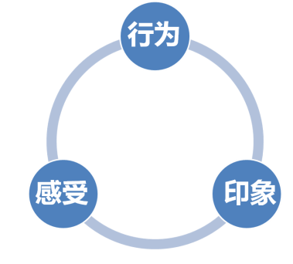
_________________________________________
_________________________________________

_________________________________________
_________________________________________
2. 如何描述对某人的印象？请列举几个例句/句型。
_________________________________________
_________________________________________
_________________________________________
_________________________________________
任务六: Exercise.
一、根据中英文提示完成句子。
1. 我很感激能有像他这样优秀的工作人员。
I _______________________ we have such a good worker like him.
- 当看到医生们忙着帮助病人时，我们十分感动。
_______________________ when we see the doctors busy helping the patients.
- 他工作如此努力，以至于我们社区的每个人都很感谢他。
He _______________________ everyone in our community is thankful.
二、Writing.
抗疫英雄在哪里？在医院、在病房、在各行各业、在你我身边。请你以Heroes around us为题，选取一位你身边的人，介绍他/她对这次抗击新冠疫情所做的点滴贡献，以及给你留下的印象和感受。（60词以上，开头已给出，不计入词数。参考例词见课上内容）。

Heroes around us
There are all kinds of heroes around us during the war against coronavirus.I’d like to introduce one of them.
______________________________________________________________________ ______________________________________________________________________
______________________________________________________________________
____________________________________________________________________________________________________________________________________________
______________________________________________________________________
______________________________________________________________________

