8年级英语第21课时
《开启EQ之旅—第一站：事物感受巧表达》学习指南
【学习目标】
1. 能够熟练说出本节课的感官动词；
2. 能够使用感官动词描述事物；
3. 能够使用感官动词恰当得体地表达感受。

【学习任务单】
任务一:（请你预习）课前朗读下列短文，并把它译成汉语;课后背诵、默写短文。
I’m cooking lots of different things. The pizza is done. Have a try, please. It smells delicious and looks lovely, but my brother thinks the cheese on it tastes a bit sour. He has a sweet tooth. The chocolate cookies taste sweet and feel soft, so they are his favorite. The apple pie and the strawberry jam sound nice for him, too.

任务二:How do we use sense verbs to express our feelings?
Listen and answer.
1. What does the boy think of his dad’s singing at night?
——————————————————————
2. What does the girl think of the apple pie?
——————————————————————

任务三:How do we express our feelings in a polite way?
Listen: What does Mike think of Kelly’s food? Please complete the chart.

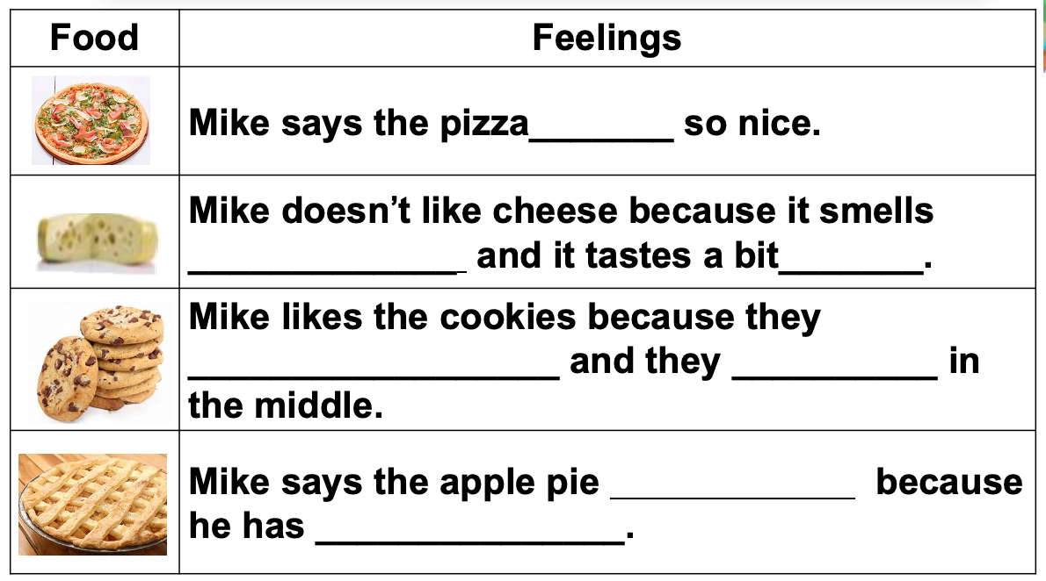

任务四:Summary.
sense verbs 感官动词
常用词及搭配
含义
用法
用途
事物感受巧表达

任务五:Writing.
This weekend, there is going to be a Cooking Contest in your family. Every family member will make a dish. You will be the judge and grade the dishes for different levels.
Now it’s your turn to announce the result. When you describe the dish, please give your reasons by using the sense verbs and the polite way.
_________________________________________________________________________________
_________________________________________________________________________________
_________________________________________________________________________________
_________________________________________________________________________________
任务六: Exercise.
一、单项选择
从下面各题所给的A、B、C、D四个选项中，选出可以填入空白处的最佳选项。
( )1. —Do you like the shirt?
—Yes, it______ soft.
A. feel B. felt C. is feeling D. feels
( )2. —Have you ever heard the song “Memory”?
—Yes, it ______ really fantastic.
A. looks B. look C. sounds D. sound
( )3. —What’s mum cooking in the kitchen?
—Fish, I guess. How nice it ______!
A. looks B. sounds C. tastes D. smells
( )4. —Would you like to try the hot pot, Mike?
—__________. It is too spicy for me.
A. No. B. OK, thanks.
C. You’re welcome. D. Thanks, but I’m afraid I don’t like it.

二、熟练朗读短文，与老师和同学分享吧！
It’s my birthday today. Mom is cooking lots of different things. The apple pie and cookies taste sweet and feel soft. My friends are singing Happy Birthday to me. It sounds beautiful. Tom gives me a model plane. It looks so cool! Lily gives me some flowers. They smell really nice. Look, what is it in Mary’s box? Ha, a big chocolate cake. It tastes really good. I love chocolate cakes because I have a sweet tooth. I feel quite happy today!

