**7年级英语第22课时**

**《英语文化背景下缤纷的颜色》拓展资源**

1. **Colors in the world.**

**你想了解更多有关颜色的英文表达吗？请扫描二维码进行学习吧！**

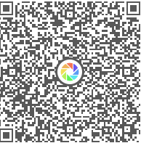

1. **“Color”专题阅读。**

**Showing your colors**

Have you ever tried to hide your emotions (情感) from someone during a conversation? It’s not always easy, as the colors on your face may tell the truth.

Scientists from the Ohio State University have found that people are able to tell other people’s emotions according to changes in the color of their faces, the Guardian reported.

Scientists studied pictures of people’s facial expressions (表情). They found that every facial expression has a unique color pattern (模式). For example, happiness makes our faces red around the cheeks (脸颊) and temples (太阳穴) and a little blue around the chin (下巴). Disgust (厌恶) creates a blue-yellow color around the lips, but also a red-green color around the nose and forehead.

“We believe these color patterns are due to (因为) small changes in blood flow triggered (触发) by the central nervous system (神经系统),” lead researcher Aleix Martinez told the Guardian.

But this raises a question: Is it the color alone, or also facial expressions, that help people tell other people’s emotions?

To figure this out, scientists added color patterns to pictures of faces that showed no facial expressions. They asked volunteers to tell what emotions the faces were showing. Volunteers were able to accurately (准确地) tell the emotion 75 percent of the time.

This may explain why there are some Chinese sayings that connect emotions to the color of one’s face. For example, when two people are heatedly arguing over something, we say they are red in the face (面红耳赤). When a person is very angry, we’d say he or she is blue in the face (脸色发青).

1. **“Color”绘本故事。**

**你想了解“color monster”的喜怒哀乐吗？请扫描二维码，观看绘本故事的视频吧！**

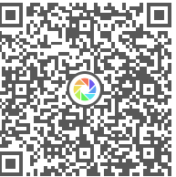**The color monster**