**7年级英语第21课时**

**《在语境下使用词汇—如何玩转购物》学习指南**

**【学习目标】**

1. 能够正确使用英文表述生活日用品以及购物地点。
2. 初步学会合理制定预算，具有正确的消费观，能够制作一张逻辑清晰的英文购物清单，并能够就自己的选择说明理由。

**【学习任务单】**

**任务1：List the things you want to buy in groups for the May Day holiday in English.**

|  |  |  |  |  |  |  |  |  |
| --- | --- | --- | --- | --- | --- | --- | --- | --- |
| **groups** | **vegetables** | **fruits** | **meat** | **snacks** | **drinks** |  | **clothing** |  |
|  |  |  |  |  |  |  |  |  |
|  |  |  |  |  |  |  |  |  |
|  |  |  |  |  |  |  |  |  |
|  |  |  |  |  |  |  |  |  |
|  |  |  |  |  |  |  |  |  |
|  |  |  |  |  |  |  |  |  |
|  |  |  |  |  |  |  |  |  |
|  |  |  |  |  |  |  |  |  |
|  |  |  |  |  |  |  |  |  |

**任务2：Share what presents you want to choose for your family members and why.**

**任务3：Find out where you can shop for them by making a match.**

fresh bread

*The Adventures of Tom Sawyer*

fancy shoes

meat grinder

a CD

mangoesdepartment store

bookshop

shoe shop

electrical store

market

supermarket

baker’s / bakery

record shop

**任务4：Now, you have 100RMB, can you make a shopping list for the coming May Day Holiday? And then write a short passage to tell us your shopping plans.**

**The following questions are for reference:**

* **What are you going to shop for?**
* **Where are you going to buy them?**
* **Why are you going to buy them?**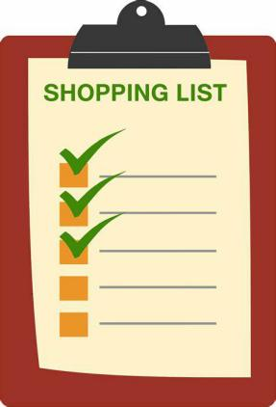

**任务5：阅读理解。从下面各题所给的A、B、C三个选项中，选择最佳选项。**

There are many ways of shopping today. The students in our class like different ways of shopping. Let's see how they shop in their daily life.

Ten students like going out and shopping with their parents or friends. They think it's interesting. They can see the things and try the clothes on. But they can shop only on weekends. On weekdays, they are busy at school.

Five students like shopping when they are watching TV. TV shopping is also a way of shopping. They think they can buy some special and cheap things. When they shop on TV, they don't need to go out but can see the products as well. But the only problem is that some of the products on TV aren't so good!

Twenty-two students are only interested (感兴趣的) in online shopping. They think the way can help them save time because it's easy and quick. Also, there is always a **discount** on the Internet. So they can save money. And they can find almost anything on the Internet. But the only problem is that you must be careful when you pay over the Internet. It isn't always safe.

1.Why do some students in the class like TV shopping?

A. Because the products on TV are good.

B. Because it helps them to buy something special.

C. Because it is safe and interesting.

2.Which way of shopping is the most popular (最受欢迎的) in the class?

A.TV shopping. B. Shopping in stores. C. Online shopping.

3.How many students are there in the writer's class?

A. Thirty-five. B. Thirty-six. C. Thirty-seven.

4.What does the underlined word "**discount**" mean in Chinese?

A. 广告 B. 折扣 C. 免费

5.What can we know from the passage?

A. When you shop on the Internet, you should be careful.

B. All the products on TV are special and good.

C. No students like going shopping with their parents in the class.