第3课时 话题：人与社会《艺术》课后作业

选择题

1. How is the passage organized? ( )

A. B. C. D.

2. Which is the characteristic of the paintings in Middle Ages? ( )

1. The painters painted outdoors.
2. The painters painted ordinary people.
3. The paintings showed respect and love for God.

D. The paintings showed certain qualities of the object.

3. Which of the following style first used the perspective? ( )

1. The Middle Ages B. The Renaissance C. Impressionism D. Modern Art

4. Match the painters with the four famous pictures.

[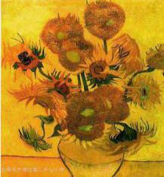](http://ddb.ezx.lwedu.sh.cn/bbs/UploadFile/2006-3/200633115541464868.jpg)[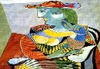](http://www.mkao.cn/Gallery/bijiasuo/200603/3171.asp)[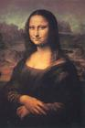](http://image.baidu.com/i?ct=503316480%26z=0%26tn=baiduimagedetail%26word=%C3%C9%C4%C8%C0%F6%C9%AF%26in=4%26cl=2%26cm=1%26sc=0%26lm=-1%26pn=3%26rn=1)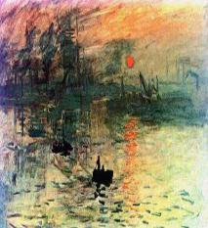

( ) ( ) ( ) ( )

A.Leonardo da Vinci（达芬奇）B.Monet（莫奈）C.Picasso（毕加索）D.Vincent Van Gogh（凡高）

5. Match th paintings with the styles.

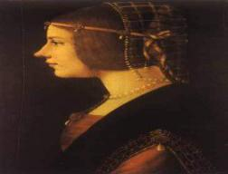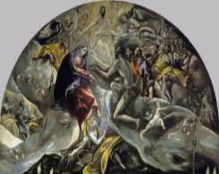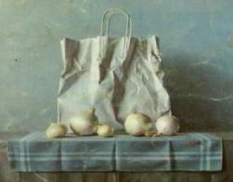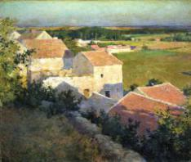

( ) ( ) ( ) ( )

1. The Middle Ages B. The Renaissance C. Impressionism D. Modern Art
2. Who invented the technique of drawing things in perspective? ( )
3. Giotto di Bondone B. Matisse C. Michelangelo D. Masaccio
4. Which style of paintings was considered as ridiculous at first? ( )
5. The Middle Ages B. The Renaissance C. Impressionism D. Modern Art
6. When were oil paints developed? ( )
7. From 5th to 15th century AD B. From 15th to 16th century

C. From late 19th to early 20th century D. From 20th century to today

9. From which period did people begin to adopt a more humanistic attitude to life and paint in a more realistic way? ( )

A. The Middle Ages B. The Renaissance C. Impressionism D. Modern Art

10. What did people think of the Impressionist painters at first?

A. Careless B. Abstract C. Realistic D. Creative

判断正误

Are these statements true (T) or false (F)? Give a reason if the answer is false.

1. Western art has changed very little over the last seventeen centuries. ( )
2. Paintings in the Middle Ages did not use perspective. ( )
3. Impressionists painted landscapes. ( )
4. You cannot recognize any object in abstract modern art. ( )
5. In the Renaissance most artists painted indoors. ( )
6. Abstract art is still an art style today. ( )