**9年级英语第19课时 课时作业**

1. **请使用英汉双解词典总结下列多义词的多个词性、英文和中文释义，并写下例句。**

**rule**

**mark**

1. **请完成下列完形片段（根据完形填空前后有联系并且连词较多的特点圈出连词，找出选项的依据并用箭头标出来）。**

Section 1

It was getting dark. Paul looked out of the window and sighed(叹气). Dad said he would come home by 5:30, but it was almost 7:00. Even if Dad came back, it wouldn’t be much fun playing 1 in the dark. Paul walked into his room and threw his baseball into the corner. He tried to do some homework, but couldn’t.

（ ）1. A. baseball B. cards C. chess D. toys

Section 2

The next day at school, Paul didn’t hand in his homework and 2 a test. Mrs. Green, his teacher, asked him to stay after school. “Paul, you didn’t do your homework. You didn’t pass the test and only got a D. This isn’t like you. What’s wrong?”

（ ）2. A. made B. missed C. failed D. chose

Section 3

He smiled and said, “These are for my street dogs. Today, I want to be a Santa ­­­­­­for them.”

I said, “Well, it’s too ­­­­­­ 3 for you to be a Santa. It is still June and Christmas comes in December.”

（ ）3. A. easy B. early C. helpful D. important

Section 4

When we offer food to a poor man or a(n) ­­­­­­ 4 to someone who is caught in the rain, we are being Santa there. So when you offer help to others or get help from others, just think that Santa has come all the way for you.”

（ ）4. A. camera B. umbrella C. apple D. box

**三、完成一篇完形填空。**

**The Smile of an Old Man**

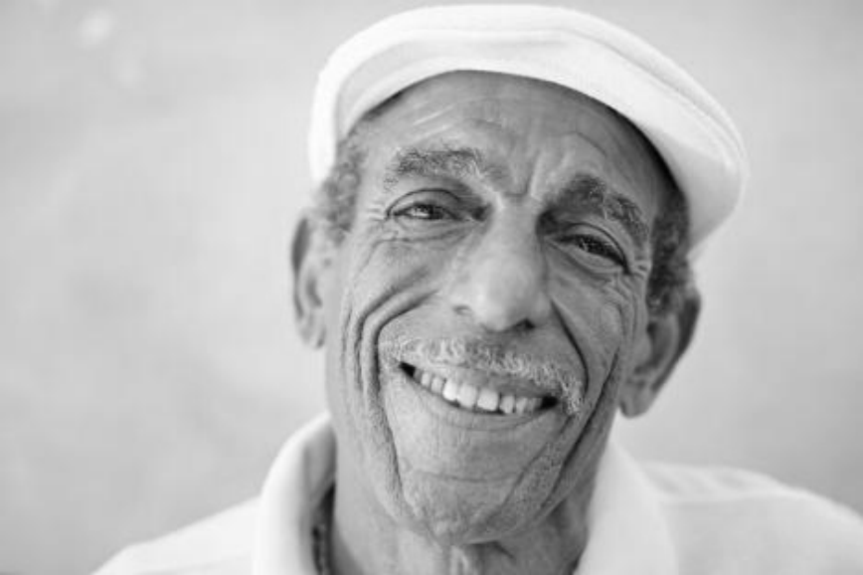I took the bus to work for many years. No one knew each other: the passengers all sat there sleepily in the morning. The bus was cheerless and silent.

One of the passengers was a small old man with grey hair who took the bus to the center for senior citizens(老年人) every morning. Nobody ever paid much __1__ to him.

One July morning he said good morning to the driver and __2__. The driver nodded guardedly (带着戒心地). The rest of us were silent. The next day, the old man boarded with a big smile again and said in a loud voice: “And a very good morning to you all! ” Some of us looked up, __3__， and murmured(小声嘀咕) “Good morning” in reply. The following weeks, our friend was dressed in a nice old suit and tie. His thin hair had been carefully combed. He said good morning to us every day and we gradually began to nod and talk to each other.

One morning he even had a bunch of flowers in his hand. The driver turned around __4__ and asked: “Have you got yourself a girlfriend, Charlie? ” We never got to know if that was his __5__， but he nodded his head shyly and said yes. The other passengers clapped(拍手叫好) at him.

Every morning after that Charlie always __6__ flowers. Some passengers also brought flowers for him. The bus became a happy place.

Then, one morning, as autumn was closing in, Charlie wasn’t__7__ at the stop. When he wasn’t there the next day and the day after that, we started wondering if he was sick or—hopefully—on holiday somewhere. When we came nearer to the center for senior citizens, one of the passengers asked the driver to wait. We all held our breaths when he went to the door.

The old gentleman was fine, but one of his close friends had died over the weekend. The next Monday Charlie was at the stop as __8__. His hair had turned greyer. We were silent as he walked onto the bus. No one mentioned his friend, but we each handed him a bunch of flowers. We wanted to be there for this man who brought us together that summer.

1. A. importance B. courage C. confidence D. attention

2. A. regretted B. smiled C. answered D. complained

3. A. surprised B. scared C. bored D. confused

4. A. suddenly B. immediately C. finally D. smilingly

5. A. card B. name C. number D. address

6. A. painted B. grew C. brought D. picked

7. A. talking B. waiting C. looking D. checking

8. A. usual B. strange　 C. brave　 D. true

**词汇积累：**

一词多义：

其它词汇：

优美句子：