**9年级英语第19课时 学习指南**

**【学习目标】**

本节课结束时，我们能够：

1. 理解并说出完形填空的文章特点，选项特点和挖空特点。
2. 说出完形填空的有效做题步骤。
3. 根据完形填空的特点和有效的做题步骤，完成2018年中考完形填空。

**【学习任务单】**

**任务1、总结完形填空的命题特点**

1. 文章特点 （在文章上写出相应的完形填空文章特点，7点）

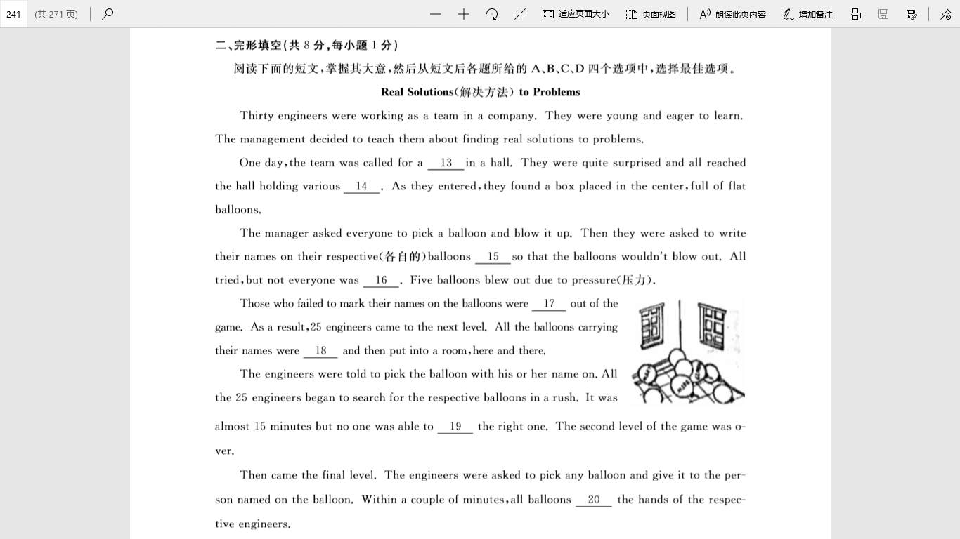

（二）挖空特点

（三）选项特点

**任务2、 请按正确的顺序为下列完形填空的做题步骤排序**

A．看插图，了解生词含义或文章场景。

B．看文章标题，预测文章内容。

C. 通读全文，精读首句，了解大意。

D. 精读文章，圈出连词，选出容易题答案，标出根据。

E. 复读全文，检查逻辑。

F. 看选项，标出词性，确定多义词的含义。

G. 精读没做出答案部分，反复推敲，选出答案。

完形填空的正确做题顺序是：____________________________________________

**任务3、实战练习： 2018年中考完形填空**

**Real Solutions（解决方法） to Problems**

Thirty engineers were working as a team in a company. They were young and eager to learn. The management decided to teach them about finding real solutions to problems.

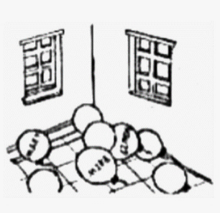One day, the team was called for a 1 in a hall. They were quite surprised and all reached the hall holding various 2 . As they entered, they found a box placed in the center, full of flat balloons.

The manager asked everyone to pick a balloon and blow it up. Then they were asked to write their names on their respective(各自的) balloons 3 so that the balloons wouldn’t blow out. All tried, but not everyone was 4 . Five balloons blew out due to pressure (压力).

Those who failed to mark their names on the balloons were 5 out of the game. As a result, 25 engineers came to the next level. All the balloons carrying their names were 6 and then put into a room, here and there.

The engineers were told to pick the balloon with his or her name on. All the 25 engineers began to search for the respective balloons in a rush. It was almost 15 minutes but no one was able to 7 the right one. The second level of the game was over.

Then came the final level. The engineers were asked to pick any balloon and give it to the person named on the balloon. Within a couple of minutes, all balloons 8 the hands of the respective engineers.

The manager announced this was the real solution to the problem. Many times in our life, sharing and helping others give us real solutions to problems.

|  |  |  |  |  |
| --- | --- | --- | --- | --- |
| （ ）1. | A. game | B. show | C. concert | D. party |
| （ ）2. | A. purposes | B. suggestions | C. thoughts | D. plans |
| （ ）3. | A. quietly | B. carefully | C. secretly | D. clearly |
| （ ）4. | A. honest | B. ready | C. patient | D. successful |
| （ ）5. | A. checked | B. helped | C. ruled | D. cheated |
| （ ）6. | A. collected | B. weighed | C. tied | D. cleaned |
| （ ）7. | A. mark | B. hide | C. number | D. find |
| （ ）8. | A. freed | B. reached | C. lifted | D. hit |

**语言积累：**

一词多义：

其它词汇：

优美句子：