**9年级英语第18课时 拓展任务**

**阅读2019年中考阅读D篇，选择正确的答案。**

**How Much Can We Afford to Forget?**

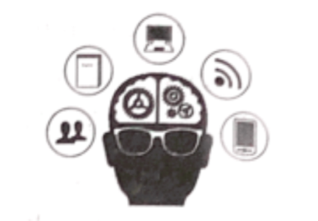 In 2018, *Science* magazine asked some young scientists what schools should teach students. Most said students should spend less time memorizing facts and have more space for creative activities. As the Internet grows more powerful, students can access knowledge easily. Why should they be required to carry so much of it around in their heads?

Civilizations (文明) develop through forgetting life skills that were once necessary. In the Agricultural (农业的) Age, a farmer could afford to forget hunting skills. When societies industrialized, the knowledge of farming could be safe to forget. Nowadays, smart machines give us access to most human knowledge. It seems that we no longer need to remember most things. Does it matter?

Researchers have recognized several problems that may happen. For one, human beings have biases (偏见), and smart machines are likely to increase our biases. Many people believe smart machines are necessarily correct and objective, but machines are trained through a repeated testing and scoring process. In the process, human beings still decide on the correct answers.

Another problem relates to the ease of accessing information. When there were no computers, efforts were required to get knowledge from other people, or go to the library. We know what knowledge lies in other brains or books, and what lies in our heads. But today, the Internet gives us the information we need quickly. This can lead to the mistaken belief-the knowledge we found was part of what we knew all along.

In a new civilization rich in machine intelligence, we have easy access to smart memory networks where information is stored. But dependence on a network suggests possibilities of being harmed easily. The **collapse** of any of the networks of relations our well-being (健康) depends upon, such as food and energy, would produce terrible results. Without food we get hungry; without energy we feel cold. And it is through widespread loss of memory that civilizations are at risk of falling into a dark age.

We forget old ways to free up time and space for new skills. As long as the older forms of knowledge are stored somewhere in our networks, and can be found when we need them, perhaps they're not really forgotten. Still, as time goes on, we gradually but unquestionably become strangers to future people.

1. Why are smart machines likely to increase our biases?

A. Because they go off course in testing and scoring.

B. Because we control the training process on them.

C. Because we offer them too much information.

D. Because they overuse the provided answers.

2. The ease of accessing information from the Internet_________.

A. frees us from making efforts to learn new skills

B. prevents civilizations from being lost at a high speed

C misleads us into thinking we already knew the knowledge

D. separates the facts we have from those in the smart machines

3. The word **“collapse”** in Paragraph 5 probably means “__________”.

A. a sudden failure B the basic rule

C a disappointing start D. the gradual development

4. What is the writer’s main purpose in writing this passage?

A. To question about the standards of information storage.

B. To discuss our problems of communication with machines.

C. To stress the importance of improving our memorizing ability.

D. To remind us of the risk of depending on machines to remember.