**9年级英语第17课时 拓展任务**

1. ****参照例子，完成下列词汇的派生词思维导图****

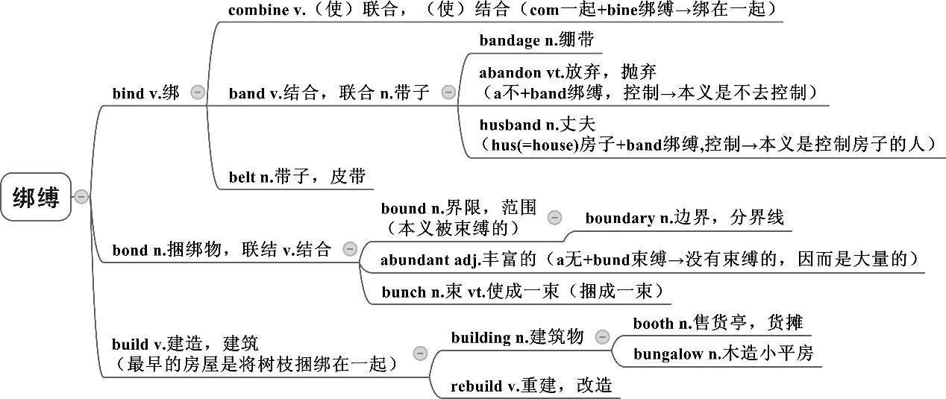

**care**

**active**

**direct**

**fair**

**satisfy**

1. ****建立个人词汇本，积累在阅读中遇到的合成词，派生词和词汇的转化用法****

|  |  |
| --- | --- |
|  | **举例** |
| **合成词** | **second-hand, paperback, dishwasher ……** |
| **派生词** | **solve-solution** |
| **转化词** | **She shows great interest in painting. (n.) 兴趣**  **sth. doesn’t interest me. (v.) 使…感兴趣** |

1. ****公众号“语言学人”****

**语言学人有一个专栏讲解英语词汇历代史及印欧词根，想深入了解英语词汇及其文化内涵的同学不妨前去阅读**

**【举例】：**

****ghos-ti-：陌生人、客人、主人、或是“彼此有客套对待的双方”，表示相互关系的双方。****

1. guest n. 客人

2. host n. 主人, hostile adj. 敌对的

3. hospice, hospitable, hospital, hospitality, host, hostage, hostel, hostler

****文化注释：****

**印欧语词ghos-ti-的基础含义是“有相互客套关系的双方”，在实用中的术语中常指彼此互为陌生人，既指客人、亦指主人(这两个人guest和host源自同一印欧词根)。词根ghos-ti-因此成为“主-客host-guest”关系，一种在印欧社会中十分重要，相互交换关系的核心表达。**

**彼此款待的重要性也体现在各类印欧语人名中，比如如尼文Runic (古代日耳曼语言) Hlewa-gastiz，意为“having famous guests有重要客人”，以及Lepontic Gaulish (山南高卢族语) Uvamo-kotsis, “having supreme guests有至高的客人”：名字中包含的元素通常反应了文化中的重要方面。同时，陌生人是潜在的客人友人，也可能是潜在的敌人；我们也因之注意到，英文词guest在拉丁文中的同源词，即*hostis*，意为“enemy敌人”**

1. ****【Tedtalk】: Go ahead, make up new words!****

[**https://www.ted.com/talks/erin_mckean_go_ahead_make_up_new_words/transcript#t-397514**](https://www.ted.com/talks/erin_mckean_go_ahead_make_up_new_words/transcript#t-397514)

Erin McKean是一位词典编纂者，她的工作是尽可能把所有词汇加入到词典中，但是她却认为一个词汇是否能进入词典取决于你—每一个词汇使用者。那么去听一听她对词汇的见解吧。或者阅读下文（演讲视频文本），找出Erin女士讲了哪些构词法的知识并举了哪些关于构词有意思的词汇例子。

I'm a lexicographer. I make dictionaries. And my job as a lexicographer is to try to put all the words possible into the dictionary. My job is not to decide what a word is; that is your job.

Everybody who speaks English decides together what's a word and what's not a word. Every language is just a group of people who agree to understand each other. Now, sometimes when people are trying to decide whether a word is good or bad, they don't really have a good reason. So they say something like, "Because grammar!" I don't actually really care about grammar too much--don't tell anybody.

But the word "grammar," actually, there are two kinds of grammar. There's the kind of grammar that lives inside your brain, and if you’re a native speaker of a language or a good speaker of a language, it's the unconscious rules that you follow when you speak that language. And this is what you learn when you learn a language as a child. And here's an example: This is a wug, right? It's a wug. Now there is another one. There are two of these. There are two... Audience: Wugs. Erin McKean: Exactly! You know how to make the plural of wug. That rule lives in your brain. You never had to be taught this rule, you just understand it. This is an experiment that was invented by a professor at [ Boston University] named Jean Berko Gleason back in 1958. So we’ve been talking about this for a long time.

Now, these kinds of natural rules that exist in your brain, they’re not like traffic laws, they’re more like laws of nature. And nobody has to remind you to obey a law of nature, right? When you leave the house in the morning, your mom doesn't say, "Hey, honey, I think it's going to be cold, take a hoodie, don't forget to obey the law of gravity." Nobody says this. Now, there are other rules that are more about manners than they are about nature. So you can think of a word as like a hat. Once you know how hats work, nobody has to tell you, "Don't wear hats on your feet. "What they have to tell you is, "Can you wear hats inside? Who gets to wear a hat? What are the kinds of hats you get to wear?" Those are more of the second kind of grammar, which linguists often call usage, as opposed to grammar.

Now, sometimes people use this kind of rules-based grammar to discourage people from making up words. And I think that is, well, stupid. So, for example, people are always telling you, "Be creative, make new music, do art, invent things, science and technology. "But when it comes to words, they’re like, "Don't! No. Creativity stops right here, whippersnappers. Give it a rest." But that makes no sense to me. Words are great. We should have more of them. I want you to make as many new words as possible. And I'm going to tell you six ways that you can use to make new words in English.

The first way is the simplest way. Basically, steal them from other languages. ["Go rob other people"] Linguists call this borrowing, but we never give the words back, so I'm just going to be honest and call it stealing. We usually take words for things that we like, like delicious food. We took "kumquat" from Chinese, we took "caramel" from French. We also take words for cool things like "ninja, "right? We took that from Japanese, which is kind of a cool trick because ninjas are hard to steal from.

So another way that you can make words in English is by squishing two other English words together. This is called compounding. Words in English are like Lego: If you use enough force, you can put any two of them together. We do this all the time in English: Words like "heartbroken," "bookworm," "sandcastle" all are compounds. So go ahead and make words like "duckface," just don't make duckface.

Another way that you can make words in English is kind of like compounding, but instead you use so much force when you squish the words together that some parts fall off. So these are blend words, like "brunch" is a blend of "breakfast" and "lunch." "Motel "is a blend of "motor" and "hotel." Who here knew that "motel" was a blend word? Yeah, that word is so old in English that lots of people don't know that there are parts missing. "Edutainment" is a blend of "education" and "entertainment." And of course,"electrocutel" is a blend of "electric" and "execute."

You can also make words by changing how they operate. This is called functional shift. You take a word that acts as one part of speech, and you change it into another part of speech. Okay, who here knew that "friend" hasn't always been a verb? "Friend" used to be noun and then we verbed it. Almost any word in English can be verbed. You can also take adjectives and make them into nouns. "Commercial" used to be an adjective and now it's a noun. And of course, you can "green" things.

Another way to make words in English is back-formation. You can take a word and you can kind of squish it down a little bit. So for example, in English we had the word "editor" before we had the word "edit." "Edit" was formed from "editor." Sometimes these back-formations sound a little silly: Bulldozers bulldoze, butlers butle and burglers burgle.

Another way to make words in English is to take the first letters of something and squish them together. So National Aeronautics and Space Administration becomes NASA. And of course you can do this with anything, OMG!

So it doesn't matter how silly the words are. They can be really good words of English. "Absquatulate" is a perfectly good word of English. "Mugwump" is a perfectly good word of English. So the words don't have to sound normal, they can sound really silly.

Why should you make words? You should make words because every word is a chance to express your idea and get your meaning across. And new words grab people's attention. They get people to focus on what you’re saying and that gives you a better chance to get your meaning across. A lot of people on this stage today have said, "In the future, you can do this, you can help with this, you can help us explore, you can help us invent. "You can make a new word right now. English has no age limit. Go ahead, start making words today, send them to me, and I will put them in my online dictionary, Wordnik. Thank you so much.