8年级英语第19课时

《我是大侦探—解结构之谜揭秘文章主旨》拓展资源

**一、正值植树节来临之际，是不是看到绿色感觉神清气爽？绿色生活，环保还省钱？快来读读这篇文章，看看一年下来能省多少钱吧！**

We all know that environmental protection is very important. But the problem is: what can we do every day to help protect the Earth?

Green technologies can make your home more energy efficient, and save money.

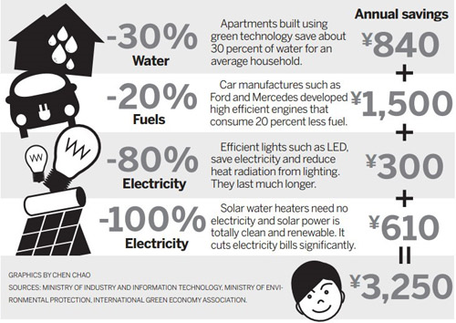

1. **绿色生活的小妙招也能唱着学，来唱一唱、学一学吧！**

**Sing the song: GOING GREEN**

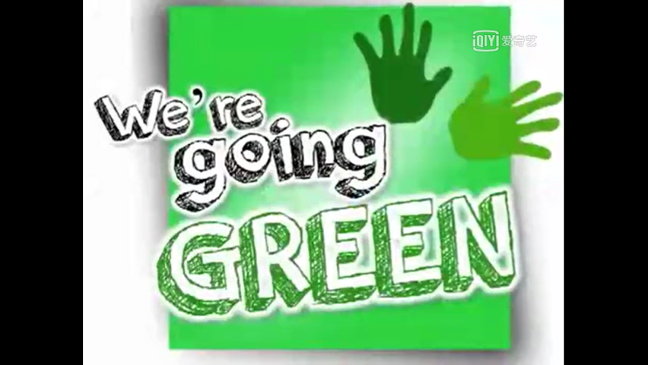MV: https://www.iqiyi.com/w_19s53l4hnl.html

We’re going GREEN.

You can go GREEN at your home or school.

Reduce, Reuse, Recycle.

REDUCE.

Be careful how long you take a shower.

You don’t need to stand there for 70 hours!

Turn off the water when you’re brushing your teeth,

and only use the necessary energy.

Turn off the lights when they’re not in use.

Think how much electricity you produce!

Take quick drinks.

Walk to school.

Reducing energy is really cool!

Pull out plugs when you’re not using them.

Turn off the computer every now and then.

Throw away litter.

Pick up trash.

And you’ll save the Earth in a flash!

We’re going GREEN.

We’re going GREEN.

We’re gonna take care of the Earth.

We’re going GREEN.

You can go GREEN at your home or school.

Reduce, Reuse, Recycle.

REUSE.

Reuse stuff when you’re out and about.

If you can use it again, don’t throw it out!

Reuse bottles.

Reuse bags.

Reuse containers.

Reuse rags.

Donate toys so someone else can use them!

Donate clothes.

Don’t just lose them!

We’re going GREEN.

We’re going GREEN.

We’re gonna take care of the Earth.

We’re going GREEN.

You can go GREEN at your home or school.

Reduce, Reuse, Recycle.

RECYCLE

Just throwing away is not enough.

Recycle somethings to make new stuff,

like paper, cans and plastic,

glass and cardboard,

game CDs and DVDs,

light bulbs, cartridges, and batteries,

laptops, cell phones and newspapers,

lots of metals you can choose.

...