8年级英语第17课时

《我是大侦探—破译英语阅读推理的密码》拓展资源

**大话神探**

**What is a detective?**

Detectives do not only live in fiction. Detective work is a real job. A detective is an expert at *figuring* out the facts behind a crime or mystery. They can work for the police. They can also be hired by a person or company. In this case, they are called a *private investigator (*私家侦探). Detectives need to find *clues* (线索), information, and *evidence* (证据). To do so, they will search public and private databases (数据库)，investigate people and look into evidence.

**Thinking and Speaking**

*What do you think of the detective work? A. funny B. exciting C. dangerous D.great*

**Read on Kungfu judge**

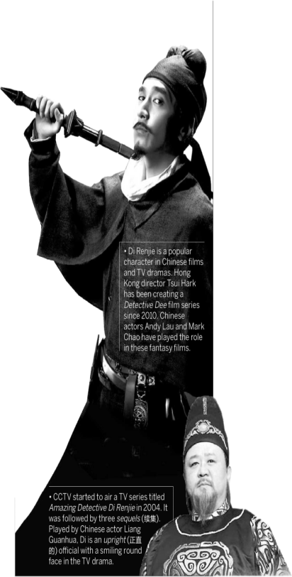Di Renjie was a top Tang Dynasty official. He was famous for his courage and wisdom (智慧). Dutchman Robert van Gulik brought Di to the West by turning him into the legendary (传奇的) Judge Dee.

You may know about Sherlock Holmes, the famous fictional British detective. But in China, Di Renjie’s popularity can compete with Holmes.

Unlike Holmes, Di is not a fictional character. Di Renjie (630-700) was a real person in history. He served twice as prime minister (宰相) in the Tang Dynasty (618-907) under Empress Wu Zetian. When he was the secretary general of the supreme court (大理寺)，he once judged (裁决) 17,000 cases in a year without complaint.

Maybe that’s why people liked to describe Di as a righteous(正义的) official, as well as a smart detective. He has long been popular in novels and on screen.

In the 18th century, a crime novel called Dee Goong An (《狄公案》）was published. Nowadays, there is a popular TV series called Amazing Detective Di Renjie (《神探狄仁杰》), as well as a series of Detective Dee films.

He even became internationally famous. Dutch diplomat (外交官)Robert van Gulik (高罗佩)(1910-1967) began to write a series of detective novels based on him in the 1950s.

In Gulik’s stories, Di Renjie is called Judge Dee. He is a fit man with a well-trimmed (修剪整齐的) beard. He is also a kung fu master.

Judge Dee often travels alone in clever disguises (乔装). Sometimes he makes mistakes and takes a while to solve a case. He believes in the power of deductive reasoning (推理). He doesn’t torture (拷问) criminals to get confession (招供). Instead, he tricks them into confessing themselves.

**Word Bank**

compete v. 竞争

complaint n. 抱怨，投诉

instead adv. 代替，而不是

**Reading Check**

What can you learn from the passage?

1. Dee never makes mistakes.
2. Dee often travels with his workers.
3. Dee is good at Kung fu.
4. Dee solves cases by torturing criminals.