8年级英语第17课时
《我是大侦探—破译英语阅读推理的密码》学习指南
【学习目标】
- 能根据推理判断题目的常见表达，识别推断问题的不同类型；
- 能运用微课中的推断方法解决英语阅读中常见的推理判断问题；
3. 能在解决推理判断问题的过程中提高词句理解能力、语篇分析能力和逻辑思维能力。

【学法指导】
1.在观看视频前先完成预习任务，即阅读自主完成任务一中的推理判断题。
2.认真观看微课，并认真记录要点。
3.认真完成评价试题和拓展材料，用红色笔做好疑难标记。

【学习任务单】
任务一：请阅读文章，选择最佳选项。
(A)
Shopping Festivals bring madness
Every app on my phone wanted me to know 11/11 was coming last week. I asked a coworker if it was a special holiday. She laughed and said it is a shopping holiday. “It’s just like Black Friday,” she explained. I hoped she was wrong.
Black Friday is the day after Thanksgiving in the United States. Starting around 4 am, thousands of people crowd outside of stores and malls. When the doors open, they rush to the shelves .What are they doing?
On Black Friday, stores offer deep discounts (优惠)，but they have a limited (有限的) number of items. As a result, it’s “normal” for people to fight each other for cheap TVs and laptops — even toilet paper! In less than 24 hours, many people they become mindless consumers.
Preparing for 11/11, I opened Taobao to find a discount on winter clothes. Two hours later, I found myself a mindless consumer too. Although I didn’t fight in the crowded stores, I got lost among all kinds of goods and kept buying things I didn’t really need. Maybe my coworker was right — in some ways, 11/11 is like Black Friday.
( ) 1. What does the writer think about 11/11?
A. He likes to shop online on 11/11.
B. 11/11 is exactly the same as Black Friday.
C. There are no deep discounts during 11/ 11.
D. People might buy some useless things.
(B)
Have you ever helped younger children with their reading, writing or maths? Do you think it helpful for yourself? According to a study in the US, students tutoring(辅导) wins easily over online lessons.
Now the idea is popular in Britain. Throughout this term, a group of 14-year-old teenagers at a school spend an hour a week helping children at a nearby primary school with their reading. All the teenage tutors have some lessons, which help them to catch up with their classmates at school. Although their intelligence is around average (平均), they have fallen behind on reading, writing and maths.
Jean Bond, from Warwick University, says that the main benefit (益处) of tutoring is that it helps build up the teenage tutors’ self-esteem (自尊). “The younger children come rushing up every time and welcome them. It makes the teenage tutors feel important. However, in normal school lessons, they often feel unable to deal with their school work. They are struggling at school themselves, so when the younger ones can’t learn, they know exactly why.”
The teenage tutors’ own reading has improved as a result of reading stories aloud to the younger children. Their view of education is changed. They have become more sympathetic (共鸣的) to their own teachers’ difficulties because they are frustrated (沮丧的) themselves when the younger children behave in a silly way.
The younger children get special attention from their patient tutors and they speak warmly of them. “He doesn’t shout like our teachers,”says eight-year-old Jenny. Yet, her tutor Jack sees himself as a strict teacher.
In the seven weeks of the experiment the teenage tutors have improved their reading and have felt more confident than before. The younger children have made great progress in reading skills by the end of the experiment.
( ) 2. The writer’s main purpose in writing this passage is to tell _______.
A. self-esteem is the key to one’s success
B. children should get special attention
C. the purpose of education is changed
D. teaching is a good way to learn

(C)
Mysterious Monster
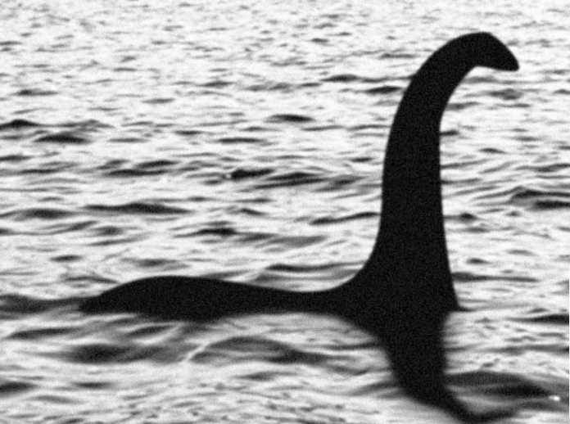
The Loch Ness monster (尼斯湖水怪) in Scotland has been a mystery (谜) for a very long time. There are people who have claimed (声称) to have seen it, but nobody has proved that it really exists. However, scientists from New Zealand recently found that this Scottish monster “might” be real, according to The Mirror.
The scientists traveled around the lake and took water samples (样本) from three different depths. Then, they collected DNA from the skin, scales (鳞片)，feathers, fur and waste of various animals. After testing the DNA, the scientists found that one of the theories (理论) about the monster might be correct.
Currently there are four main theories about the Loch Ness monster. One is that it is a long-necked plesiosaur (蛇颈龙) that continued to live after other dinosaurs died out. Another theory is that the “monster” is just a fish with a huge body.
Some people believe that the monster is an elephant, as the monster’s neck looks like the trunk (象鼻) of an elephant in some photos. Still others think there is no monster at all. The gas bubbles that can be seen on the lake’s surface might be caused by earthquakes beneath the lake. But scientists will not say which of these theories might be correct until later this year.
In fact, Loch Ness is not the only lake where people claim to have seen monsters. Some people have said that they saw a monster in Heavenly Lake on Changbai Mountain in Jilin province. It was also reported that a monster in Yunnan’s Dian Lake scared tourists away. But later, people found that the “monster” was a turtle from North America. Somebody put it into the lake. Without any natural enemies, it grew so large that it looked like a giant monster.
( )3. What can we infer from the passage?
A. The scientists will tell people their research results this year.
B. The four theories describe the monster as being four different animals.
C. Scientists don’t agree with any of the four theories.
D. Monsters in lakes are just common sea animals.

任务二：请观看微课《我是大侦探—破译英语阅读推理的密码》，完成以下内容：
- 请把阅读题目表述问题和推理判断的类型相匹配。
- 作者观点态度推断 (1) What can we infer from the passage?

- 写作目的推断 (2) What does the writer think of rock music?

- 隐含意义推断 (3) What is the writer’s purpose in writing ...?

- 写出下面词或词组的中文意思。
英文 | 中文 | 英文 | 中文
madness |  | in some ways
mindless |  | be like
useless |  | get lost
purpose |  | special attention
infer |  | not... until

- Passage A 中从哪里可以看出作者对11/11网上购物的态度是喜欢还是不喜欢？文章中作者写到了11/11与Black Friday有哪些异同？
__________________________________________________________________________________________________________________________________________
__________________________________________________________________________________________________________________________________________

- 在Passage B并没有“Teaching is a good way to learn.”这句话，为什么这个选项是正确的？你能找到哪些线索？
____________________________________________________________________________________________________________________________________________________________________________________________________________________________________________________________________________________

- 在Passage C中为什么选项A. The scientists will tell people their research results this year. 是正确的？请写出推理过程。
_______________________________________________________________________________________________________________________________________________________________________________________________________________6. 读读下面的侦探小故事，试试你的推理能力吧。
Finding an old man’s murderer (谋杀者)
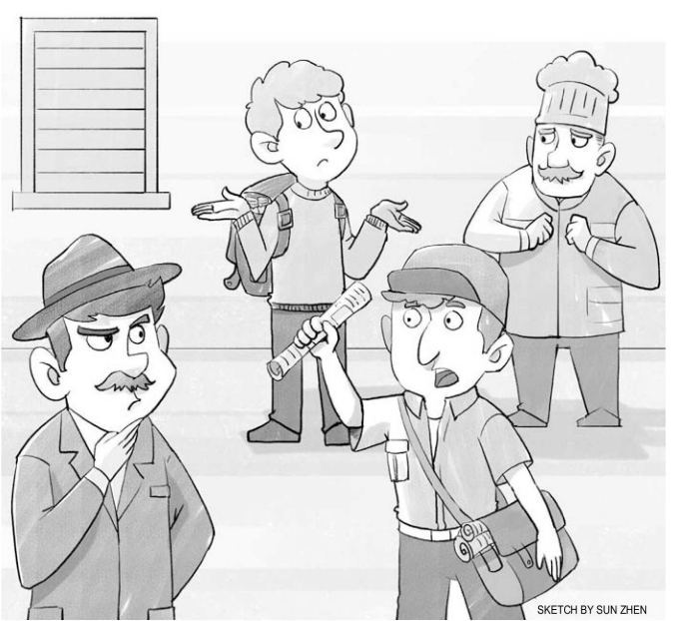
There was an old man who lived in a house by himself. Because of his old age, he wasn’t able to get around very well. Therefore, he had almost everything delivered (送货) to his home, including his newspaper, his milk, and his bread.
On Friday, while delivering the old man’s milk, the milkman knocked on the front door of the man’s house. But to his surprise, no one answered. This was the third day in a row (连续) that the man hadn’t come to his door. The milkman immediately thought there was something strange about the situation. He looked through the keyhole in the front door and was shocked to see the old man lying on the ground, apparently (明显地) dead.
The milkman called the police to the scene. They found that the man had been shot to death. After investigating the scene further, the police found no evidence (证据) other than a copy of Tuesday’s newspaper on the doorstep. They then gathered the three people who had most recently seen the old man: the milkman, the old man’s baker, and a newspaper deliveryman. They questioned the men to see if any of them had killed the old man.
While being questioned, all three men denied (否认) having killed him. It seemed unlikely that all three of them were innocent (无辜的). But the police had already figured out who the killer might be. They arrested (逮捕) the newspaper deliveryman. How did they figure out that he might be the murderer?
Question: Why did the police think the newspaper deliveryman might be the
murderer?
_______________________________________________________________________________________________________________________________________________________________________________________________________________

