8年级英语第16课时
《我是大侦探—寻找英语阅读的蛛丝马迹》学习指南
【学习目标】
- 能通过分析题干中的关键词，定位原文的关键句子或关键段落；
- 能通过对关键词、词组、句子的分析，正确理解原文中事实性、细节性信息；
- 能在正确理解原文原句的基础上，逐一比对细节题中的各个选项，分析异同，做出筛选。

【学法指导】
1. 准备好学习指南，红、黑色笔，马克笔。
2. 在收听讲解之前按下暂停键，先自己独立认真完成题目。
3. 注意学习过程中的圈、点、勾、划等做题痕迹。

【侦探学校之学习篇】
一、阅读理解：阅读下列短文，根据短文内容，从短文后各题所给的A、B、C、D四个选项中，选择最佳选项。
A
Taking care of Togo

Djatougbé Akouvi Aziaka is a girl from Togo, a country in West Africa. Working as a reporter, she has seven years of experience writing about problems such as environmental protection (环保) and gender equality (性别平等).
At the same time, she is also the president of a youth association (协会) called Welfare Togo. She has her own company as well, a media company called Eco Conscience TV.
Both her association and her company are working on sustainable development challenges (可持续发展挑战). Welfare Togo, for example, is recognized (经过验证的) by many UN organizations (组织). Its work covers areas such as climate (气候) change and human rights.
The association is now working with the UN and Togo’s government (政府) to fight desertification (荒漠化). Togo has very little forest coverage (森林覆盖). Because of the use of wood for fuel (燃料) and the practice of slash and burn (刀耕火种) agriculture (农业), the country’s forest coverage has dropped.
One of Welfare Togo’s most recent projects is the Signature Tree Project. It encourages students to leave their mark (痕迹) by planting trees. It also promotes the use of energy-saving stoves (节能炉) in villages in order to reduce the use of wood for fuel.
The association now has 4,090 young volunteers. “As the leader of these young people from different backgrounds, I have learned the importance of having good leadership (领袖) skills,” Aziaka said.
What’s more, Aziaka’s media house is helping more people pay attention to environmental problems. People in Togo don’t know much about how to protect the environment in their everyday lives. To educate them, the company makes documentaries on sustainable development problems.

Breaking the silence
Set up in 2009 by female university students, Welfare Togo is a youth NGO (Non-Governmental Organizations非政府组织). While working on protecting the environment, it has another focus protecting the rights of women and young girls.
For example, one of its projects is called Break the Silence. It encourages women and girls to speak out about the abuse (虐待) they face in their schools, homes and workplaces.
“One of my greatest achievements (成就) is the school project,” Aziaka said. “I have seen a decrease (下降) in cases of discrimination (歧视) towards girl students.”
1. What do we know about Djatougbé Akouvi Aziaka?
A. She is now 35 years old.
B. She has studied journalism (新闻业) for seven years.
C. She is from Africa.
D. She likes writing books.
2. Welfare Togo works with the Togo government to _____.
A. make better use of wood B. find clean energy to use as fuel
C. develop agriculture in Togo D. protect land from desertification
3. The Welfare Togo NGO _____.
A. has 4,090 young members
B. was started by people with BA degrees (学士学位)
C. has lots of money
D. was started by university students

【侦探学校之总结篇】
回顾笔记，正确选项和原文的关系是怎样的？

1. A country in West Africa
≈ Africa

2. protect ... from...
≈ fight

3. set up by female university students
≈ was started by university students

回顾笔记，选项设计有哪些特点？
正确选项
1.________________________________
2.________________________________
3. _______________________________
干扰项
1._________________________________
2._________________________________
3._________________________________

【侦探学校之练习篇】
二、阅读理解 ：阅读下列短文，根据短文内容，从短文后各题所给的A、B、C、D四个选项中，选择最佳选项。
B
Cleaning up the Ocean
Boyan Slat has been dreaming of cleaning up the world’s oceans ever since he was a teenager.
In 2010, the 16-year-old Dutch boy went on a diving (潜水) vacation in Greece and was surprised. “I saw more plastic (塑料) bags than fish in the water,” he said.
He became more aware of (意识到) ocean pollution. In 2013, Slat decided to give up higher education and set up The Ocean Cleanup, an NGO based in (在……设总部) the Netherlands that aims (以……为目标) to clean up ocean garbage. Now the 25-year-old has designed and set up the world’s first ocean cleanup system with his team.
Every year, over 8 million tons of plastics end up in our oceans, and it can take up to 500 years to break down. In 2018, the World Economic Forum predicted that the weight of ocean plastics will match that of all the fish in our oceans by 2050.
Sea animals easily get trapped (困住) in plastic. They can even die if they eat it. Smaller plastic pieces can also enter the food chain (食物链) and end up in our bodies.
Slat’s plan was to create an environmentally-friendly, large-scale (大规模的) system to remove (移除) plastic debris (残骸) from the ocean.
After seven years of tests, hundreds of models and many failures (失败), on Oct 2, 2019, a device (设备) called System 001/B came out. It successfully caught and collected a large amount of plastic debris floating (漂浮) in the ocean.
Slat and his team are working to improve System 001/B. Their dream is to remove 90 percent of all ocean plastic by 2040. “In a few years we will have a full-scale fleet (舰队) out there,” he said in public.
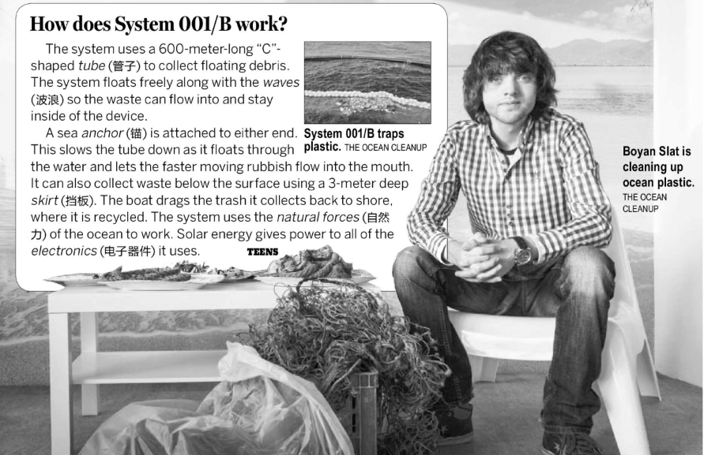
- What did Boyan Slat find while diving in Greece?
A. There is too much plastic in the ocean.
B. Ocean pollution is more serious in Greece.
C. It’s difficult to stop ocean pollution.
D. Sea animals die from plastic pollution.
5. What do we know about System 001/B?
A. It will come out by 2040.
B. It was difficult to create this system.
C. It will clean all of the garbage in the ocean.
D. It only catches small pieces of plastic debris.

