7年级英语第19课时
《will do知多少》拓展资源
一、阅读。请你阅读文章，并根据文章内容绘制一幅关于未来的图画。
What will the future bring us?
What will life be like in 50 years? A group of experts (专家) from the UK have painted us a picture – a report on life in the future. By 2069, according to the report, the digital revolution (电子革命) will have greatly changed the world. It will be like what the Industrial Revolution (工业革命) did 250 years ago.
What impossible (不可能的) things will become possible? Let’s take a look.
Space hotels
Don’t know where to go during the holiday? Outer space (外太空) might be a good place. People will have fun in space hotels. These hotels will be built near the moon or the planets (星球) of our solar system (太阳系).
Underwater highways (水下高速公路)
They will be built under the sea. People will travel in pods (吊舱) through underwater tubes (管道). It will take less than an hour to travel between the UK and mainland Europe (欧洲大陆).
Self-cleaning homes
Future homes might clean themselves while you’re at school or work, or while you sleep. It could be as easy as pressing a button (按下按键).
Insect-burgers(昆虫汉堡)
Insects will become our main food. They are rich in protein (蛋白质). People can make them into burgers and biscuits (饼干). People can breed more insects in their kitchens.
Quidditch-style sports(“魁地奇”式运动)
Our favorite sports teams might compete (竞赛) while flying on hoverboards (悬浮滑板). It would be just like the game of Quidditch in the Harry Potter books.
Underground skyscrapers(地下摩天大楼)
You could call them “earthscrapers”. They are underground buildings. During an earthquake (地震), these buildings would not fall over like normal skyscrapers.
Flying taxis and buses
To stop traffic jams (交通拥堵), people might take flying taxis and buses. For long-distance (长距离的) travel, they might take super-fast rockets (火箭). Travel time between London and New York could be just 30 minutes.
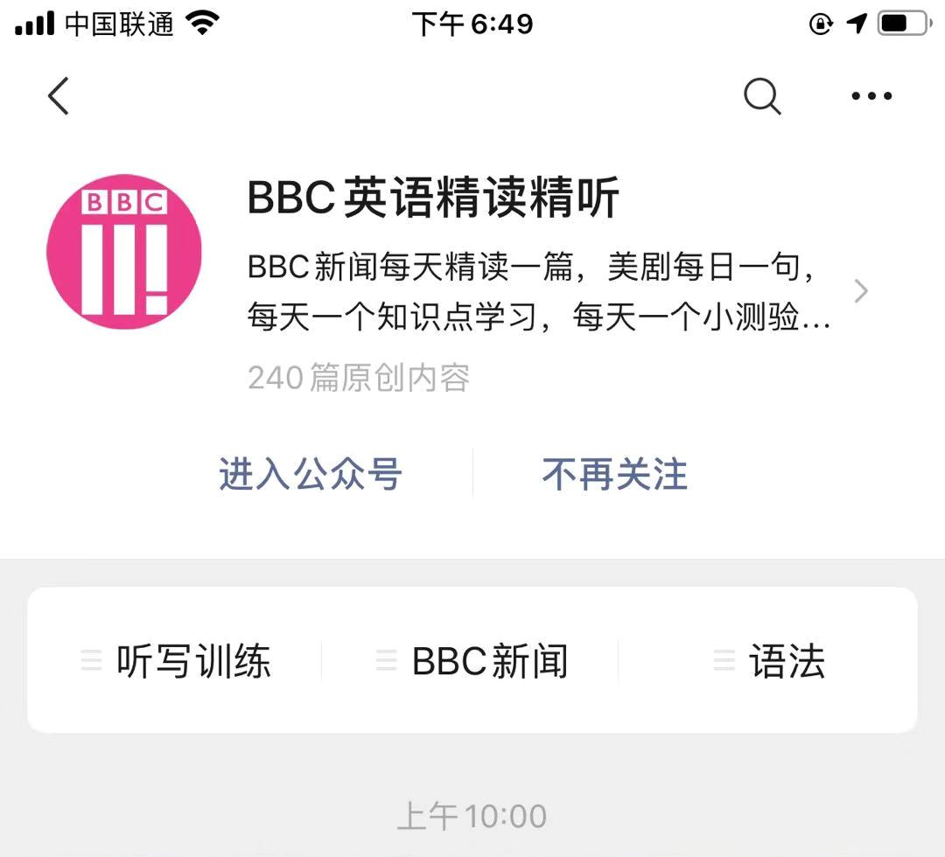

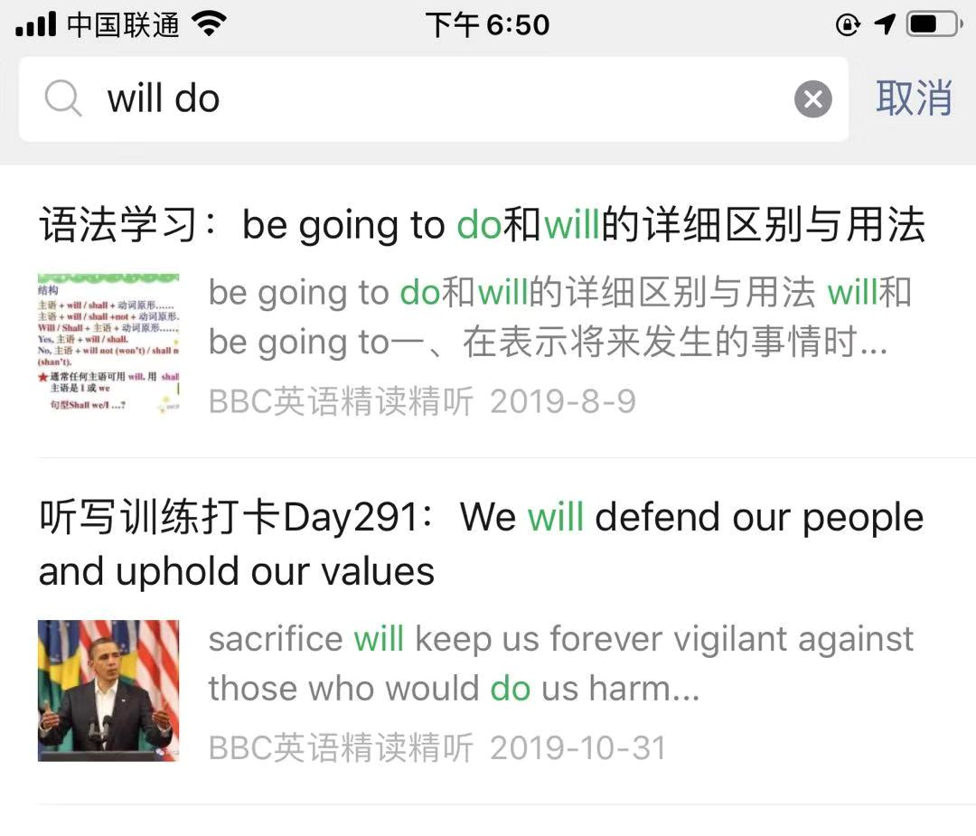
二、请同学们用手机扫下面二维码，关注公众号“BBC英语精读精听”，点开“搜一搜”，输入will do，可以查看will do 和be going to do用法的区别。

