**《二轮词汇复习》学习指南**

**【学习目标】**

1. 在语境中能准确理解具体词语的功能、词义的内涵和外延以及使用者的意图和态度等；

2. 运用构词法知识扩大词汇量，结合各种主题语境积累词块，构建不同词汇语义网，深度学习词汇；

3. 根据不同主题，梳理词语，并能选择运用恰当的词语，准确表达主题意义和观点等。

**【学法指导】**

1. 高三复习阶段的词汇学习重点是在语境中培养词块意识，并通过广泛阅读进一步扩大词汇量，提高运用词汇准确理解和确切表达意义的能力。

2. 以语篇为依托的词汇复习，将阅读和词汇学习结合能够避免孤立地记忆词汇。利用词语结构和文本的语境，理解词语的意义；借助词典等资源学习词语的用法，不断复现相关词汇。阅读时划出影响理解的关键词，阅读后重新阅读语篇，划出语篇中的动词搭配和短语等，注重一词多义、熟词新义的用法，读后积累词汇。如：

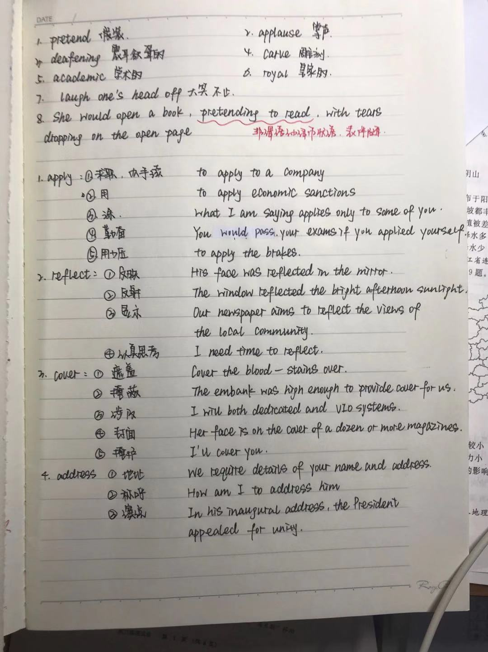

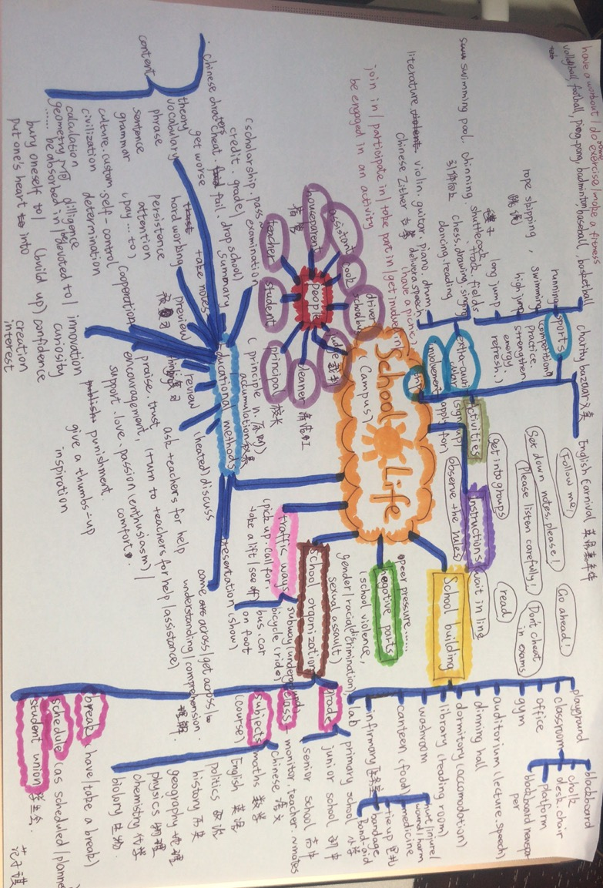3. 根据主题使用思维导图梳理词汇，注意词块呈现，利用话题构建词汇网，拓展词汇量，利用联想归类及积累词汇。如：

**【学习任务】**

**2019年东城区一模词汇复习**

1. 翻译下列词汇或短语

**(一)语法填空**

1. a growing number of
2. according to
3. give sb. the strength and energy we need
4. 在社交中发挥作用
5. become a trendy thing to do
6. 被……装饰

**（二）完形填空**

1. due
2. exhausted
3. 熬夜
4. 更糟糕的
5. accidentally
6. settle down
7. calm down
8. optimistic
9. chant
10. relieved
11. anxiety
12. get up one’s nerve
13. gradually
14. willingly
15. exactly
16. regretful

（三）阅读理解

1. massage
2. recover from an illness
3. guarantee
4. component
5. purchase
6. professional
7. be of the highest quality
8. inspect
9. urgently
10. status
11. uneasy
12. numb
13. diverse
14. fuel
15. swiftness
16. dominate
17. specialize
18. specific
19. split
20. species
21. resident
22. estimate
23. prediction
24. migration
25. evolution
26. distinction
27. constant
28. neutral
29. sceptical

30.报名参加

31. narrative

32. humanity

33. innovation

34. definition

35. foster

36. essential

37. capability

38. tolerance

二、 一词多义

1. 根据语境写出下列划线词的意思。

sharp

(1) But Brady barked a sharp warning. (Reading B) ___________________

(2) Was he still sharp enough to get them through this? ____________________

(3) We’ll gather at the school gate at 4o’clock sharp. ____________________

(4) The sharp knife is dangerous for a child. ____________________

(5) There's been a sharp rise in the rate of unemployment. ____________________

drive

1. Politicians who display a desperate need to be right and refuse to acknowledge mistakes or uncertainty are often driven by a secret shame. ( 七选五) ____________________
2. It's a 2-hour drive from Birmingham. ____________________

(3) The noise outside almost drove him mad. ____________________

(4) He still has plenty of drive and ambition. ____________________

2. 根据语境选词填空，注意正确形式。

lie ，lay

（1）He wasn't telling the truth. He was ________.

（2) He felt tired, so he went and ______ down for a rest.

（3）There in full view _________ the answer sheet for the test! (Cloze).

（4) Don't _____the glass on the corner of the table.

（5) Have your hens ______ eggs yet?

（6） I’m sorry I _______to you.

三、语法填空

1. I was just about to give in _________ my pencil ___________(accidental) fell and broke. (Cloze)

2. Finally, I decided to finish the test _______ my own, without __________(cheat)!

3. You can only imagine my shock when I learned that I ___________ (pass) the test!

4. Last fall, I happened to overhear a student __________ (tell) the others he had decided not to sign up ______ an introductory philosophy course. ( Reading D)

5. Those ______ succeed have made countless _____________(mistake).

四、英译汉（长难句）

1. Whether we are celebrating important occasions or just relaxing with friends, eating is an important social pastime.

__________________________________________________________________________________________________________________________________________

2. Now not only can my conscience(良心) rest easy, but I don’t have to worry about getting caught and meeting a sad ending like Romeo and Juliet.

__________________________________________________________________________________________________________________________________________

仿写： Not only…but also

__________________________________________________________________________________________________________________________________________

3. That’s why sharks and other predatory fish(掠食鱼) dominate near the equator, but colder waters are the kingdom of whales and seals.

__________________________________________________________________________________________________________________________________________

仿写：That’s why….

__________________________________________________________________________________________________________________________________________

4. Releasing ourselves from the desire to protect our image, we’re freed to sail gracefully through our successes and failures—and enjoy our precious life.

__________________________________________________________________________________________________________________________________________

五、 书面表达

1. 我很高兴你对北京的变化感兴趣。让我告诉你过去这些年的发展。

__________________________________________________________________________________________________________________________________________

2. 最引人瞩目的变化是交通的迅速发展。

__________________________________________________________________________________________________________________________________________

3. 如果没有政府的举措和新技术的运用，这些都不可能发生。

__________________________________________________________________________________________________________________________________________

4. 第一天早上，医生给我们作讲座，告诉我们志愿者的角色。

__________________________________________________________________________________________________________________________________________

5. 随后，我在微信朋友圈里分享了在医院的照片，很快收到朋友们的点赞。

__________________________________________________________________________________________________________________________________________

**2019年朝阳区一模词汇复习**

一、翻译下列词汇或短语。

**(一)语法填空**

1. be rescued from
2. walk along a steep cliff at the edge of the sea
3. blow off
4. call the police rescue service
5. I can’t thank the woman enough.
6. 鼓励某人做某事
7. 挣钱
8. originally

**（二）完形填空**

1. go up and down
2. catch up with sb.
3. 爬塔
4. 期待某人做某事
5. 减慢速度
6. 时不时
7. 好奇的
8. tell the truth
9. be disappointed
10. embarrassed
11. attach…to
12. show sb. sympathy
13. explore
14. confirm
15. witness
16. reaction
17. signal
18. be content with
19. pour
20. burst

（三）阅读理解

1. decline
2. offer hope for
3. challenge
4. a long-term project
5. make a donation
6. restore wild nature
7. open up new chances for doing sth.
8. spread
9. warn people of the nature ecology
10. convince people to change their mid
11. an educational non-profit-making organization
12. inspiration
13. turn down
14. thunderstorm
15. create chances for students to accomplish something amazing
16. provide unexpected help
17. study technical knowledge
18. be doubtful about sth.
19. take on a further challenge
20. become a public figure
21. unbelievable tasks
22. 竞争
23. mental athlete
24. be fundamentally different from
25. memorize numbers
26. 依靠
27. date back to
28. recommend that sb. (should) do sth.

30. fantastical

31. bring up children alone

32. have a neutral or slightly positive effect on sth.

33. indicate

34. controversial

35. fight an urge to do sth.

36. exposure to sth.

37. chew and swallow the food

38. prevent sb. from doing sth.

39. psychological effects

40. look into

二、英译汉（长难句）

1. There I was surprised to see the attendant (工作人员) selling him a ticket as if he were any other visitor.

__________________________________________________________________________

2. The secret, he believes, is having a dream in the first place, and that starts with learning experiences that inspire kids to build careers.

__________________________________________________________________________

__________________________________________________________________________

3. The scientists examined whether their brains were fundamentally different from everyone else’s or whether they were simply making better use of memorizing abilities we all possess.

__________________________________________________________________________

__________________________________________________________________________

4. The British psychoanalyst John Bowlby believes that separation from parents during the sensitive “attachment” period from birth to three may scar a child’s personality and lead to psychological problems in later life.

__________________________________________________________________________

__________________________________________________________________________

三、书面表达

1. 我推荐你谈谈所参加的中国传统文化课程。

__________________________________________________________________________

__________________________________________________________________________

2. 我希望我的建议对你有帮助。祝你成功！

__________________________________________________________________________

__________________________________________________________________________

3. 上月，我校举办了“绿色出行，从我做起”活动，起到教育作用。

__________________________________________________________________________

__________________________________________________________________________

4. 我们都认为环保对我们的生活很重要。

__________________________________________________________________________

__________________________________________________________________________

5. 通过这次活动，我们认识到保护环境是我们的责任。

__________________________________________________________________________

__________________________________________________________________________

**2019年海淀区一模词汇复习**

一、翻译下列词汇或短语。

1. despite
2. gravity
3. spot v.
4. echo
5. vision
6. take …for granted
7. detect
8. keep track of
9. imperfection
10. turn up
11. turn away
12. intention
13. instruction
14. reflection
15. preference
16. expression
17. solution
18. approach
19. title
20. martial art
21. routine
22. diligence
23. dedication
24. showcase
25. motivated
26. considerate
27. come to rescue
28. recognition
29. via
30. selfie
31. automatically
32. consequence
33. acquire
34. inquire
35. assess
36. personality trait
37. vocational
38. significantly
39. restrict
40. nature
41. finance
42. skeptical
43. concerned
44. optimistic
45. consciously
46. associate…with
47. reflect
48. generate
49. mimic
50. stroke
51. plastic surgery
52. compensatory
53. overall well-being

二、翻译句子

1. If she knew anything about my life, she never would have had the urge to ask me that question.

__________________________________________________________________________________________________________________________________________

2. Learning Chinese martial arts opened a gateway for him to better understand Chinese culture because he could hear a lot of ancient Chinese kung fu-related stories.

__________________________________________________________________________________________________________________________________________

3. You reflect on your emotional feelings and then you generate some sort of recognition judgment, and the most important thing that results in is that you take the appropriate action—you approach the person or you avoid the person.

______________________________________________________________________________________________________________________________

4. Regardless of your fitness level when you start playing sports, you’ll notice an increase in your overall fitness once you’re involved.

 _________________________________________________________________________________________________________________________________________

**答案与解析**

**2019年东城区一模词汇复习**

一、翻译下列词汇或短语

**(一)语法填空**

1**. 日**益增长的

2. 根据

3. 给了我们需要的力量和能量

4. play a role in our social interactions

5. 成为趋势

6. be decorated with

**(二）完形填空**

1. due adj.预期的；到期的
2. Exhausted adj.精疲力尽的
3. 熬夜 stay up late
4. 更糟糕的 worse
5. accidentally adv.意外地
6. settle down 定居、平静下来、集中精力做...
7. calm down 平静下来
8. optimistic adj.乐观的；积极的
9. chant n./v.（反复）吟唱
10. relieved adj.感到宽慰的；放心的
11. anxiety n.焦虑；紧张
12. get up one’s nerve 鼓起（某人的）勇气
13. gradually adv.逐渐地
14. willingly adv.愿意地
15. exactly adv.确切地
16. regretful adj.后悔的

（三）阅读理解

1. massage 按摩
2. recover from an illness从疾病中康复过来
3. guarantee v.保证
4. component n.成分 adj.构成的
5. purchase v.购买
6. professional adj.专业的
7. be of the highest quality 品质一流
8. inspect v.检查
9. urgently adv.紧急地
10. status n.地位；状态
11. uneasy adj.不容易的
12. numb adj.麻木的
13. diverse n.多样的
14. fuel n.燃料；v.点燃
15. swiftness n.迅捷
16. dominate v.支配；控制；影响；在...拥有重要位置
17. specialize v.擅长;专攻于...
18. specific adj.具体的
19. split v./n.分裂;裂口
20. species n.物种
21. resident n.居民 adj.当地的
22. estimate v.估计
23. prediction n.预测
24. migration n.移民；迁徙活动
25. evolution n.演化；演变
26. distinction n.区别
27. constant adj.连续的
28. neutral adj.中立的
29. sceptical adj.持怀疑态度的;质疑的

30.报名参加 sign up for

31. narrative adj.叙述的；叙事的

32. humanity n.人类

33. innovation n.创新

34. definition n.定义

35. foster v.培育；促进

36. essential adj.关键的；重要的

37. capability n.能力

38. tolerance n.忍耐力；宽容

二、一词多义

1. sharp

(1) 刺耳的、尖锐的 (2) 灵敏 (3)整点 (4) 锋利的 (5) 明显的

drive

(1) 驱使 (2) 驾车、驾驶 (3) (4) 动力

2. (1) lying (2) lay (3) lay (4) laid

(5) lied

三、语法填空

1. when, accidentally

2. on, cheating

3. had passed

4. telling, for

5. who, mistakes

四、翻译句子

1. 无论是庆祝重要时刻还是和朋友放松，吃都是重要的社交娱乐。

2. 不仅我的良心安宁，而且我也不用担心作弊被抓，遭遇罗密欧与朱丽叶的悲剧结果。

仿写：Not only could I enlarge my knowledge, but also I did realize how profound and brilliant the Dunhuang Culture was!

3. 这就是为什么鲨鱼和其他捕食鱼主宰赤道地区，而寒冷地带是鲸鱼和海豹的王国。

仿写：I devoted myself to studying, and that’s why I deserve the scholarship.

4. 从保护形象的想法中解脱出来，我们就能自由地优雅地经历成功与失败，享受我们宝贵的生活。

五、书面表达

1. I’m very glad to know that you are interested in the changes in Beijing. Let me tell you some of the developments during the past few years.

2. The most impressive one is the rapid development of transportation.

3. All these couldn’t have happened without the measures taken by the government

and applications of new technology.

4. On our first morning, a doctor gave us a lecture, informing us of our roles as volunteers.

5. Later I shared my picture in the hospital on WeChat Moments. In no time, I received lots of likes from my friends. Some even expressed their great interest in the voluntary work. Actually, I had the most amazing experience doing very simple things for others.

**2019年朝阳区一模词汇复习**

**一、词义**

**（一）语法填空**

1. be rescued from 从….中被解救
2. walk along a steep cliff at the edge of the sea 沿着海边一个陡峭的悬崖走
3. blow off 吹掉
4. call the police rescue service寻求警察救助服务
5. I can’t thank the woman enough. 我对那个女人不胜感激
6. 鼓励某人做某事encourage sb. to do
7. 挣钱 earn money
8. originally起初，原来

**（二）完形填空**

1. go up and down 上上下下，波动
2. catch up with sb.赶上
3. 爬塔climb the tower
4. 期待某人做某事expect sb. to do
5. 减慢速度 slow down
6. 时不时now and then
7. 好奇的curious
8. tell the truth说实话
9. be disappointed感到失望
10. embarrassed尴尬的
11. attach…to使…贴在，使相关
12. show sb. sympathy对某人展示出同情
13. explore探索
14. confirm确认
15. witness见证
16. reaction反应
17. signal标志
18. be content with对…感到满足
19. pour倒出
20. burst爆裂

**（三）阅读理解**

1. decline减少
2. offer hope for 为…提供希望
3. challenge挑战
4. a long-term project一个长期的项目
5. make a donation进行捐赠
6. restore wild nature恢复野生的大自然
7. open up new chances for doing sth.为做某事开通新的机会
8. spread传播
9. warn people of the nature ecology警示人们自然生态
10. convince people to change their mid说服人们改变他们的思想
11. an educational non-profit-making organization一个教育性的非营利组织
12. inspiration灵感
13. turn down 拒绝，关小（声音）
14. thunderstorm雷雨
15. create chances for students to accomplish something amazing为学生创造机会去完成一些神奇的事情
16. provide unexpected help提供出乎意料的帮助
17. study technical knowledge学习技术性的知识
18. be doubtful about sth.对某事感到怀疑
19. take on a further challenge接受一个进一步的挑战
20. become a public figure成为一个公众人物
21. unbelievable tasks难以置信的任务
22. 竞争compete
23. mental athlete精神运动
24. be fundamentally different from和….完全地不同
25. memorize numbers记住数字
26. 依靠depend on=count on=rely on
27. date back to
28. recommend that sb. (should) do sth.

30. fantastical回溯至

31. bring up children alone独自抚养孩子长大

32. have a neutral or slightly positive effect on sth. 对某事有一个中立或很微小的积极影响

33. indicate暗示

34. controversial有争议的

35. fight an urge to do sth.对抗做某事的冲动

36. exposure to sth.面临某事

37. chew and swallow the food咀嚼并吞下食物

38. prevent sb. from doing sth. 阻止某人做某事

39. psychological effects心理作用

40. look into考察、研究

二、英译汉（长难句）

1.我很震惊的看到工作人员卖给了他一张票，就好像其他的游客一样

2. 他相信那个秘密是获得第一名的梦想，并且开始学习那些激励孩子们建立事业的经历。

3. 科学家们检查了他们的大脑是否根本上和其他任何人的不一样，或者他们是否只是简单的更好地运用了我们都拥有的记忆力。

4.英国心理学家John Bowlby相信，在出生到三岁之间敏感的“联系期”与父母分离，可能为孩子的性格造成创伤，并为他们之后的生活带来心理问题。

三、书面表达

1. I recommend that you talk about the courses on Chinese traditional culture you’ve attended.

2. I really hope my advice will be helpful. Wish you a great success.

3. Last month, our school organized an activity named “Green Travel, Start with Me”, which has played an educative role.

4. All of us held the same view that environmental protection is so important for our life.

5. Through the activity, we find it our duty to protect the environment. I hope more and more people will join us in green travel.

**2019年海淀区一模词汇复习**

**一、翻译词汇、短语**

1. despite prep.即使，尽管n伤害轻视
2. gravity n重力，地心引力
3. spot v.认出，弄脏
4. echo vt反射，重复vi随声附和
5. vision n视力；美景vt想象
6. take …for granted认为…是理所当然
7. detect vt察觉；探测
8. keep track of 追踪
9. imperfection n不完美；瑕疵
10. turn up 出现，音量调大
11. turn away避开；解雇
12. intention n意图；目的；意向
13. instruction n指令，命令
14. reflection n反射；沉思
15. preference n偏好
16. expression n表现，符号，语句
17. solution n解决方案
18. approach v走进；处理；几乎达到（某水平或状态）n方法，接近，路径
19. title n标题，头衔
20. martial art 武术
21. routine n常规，惯例
22. diligence n勤奋，勤勉
23. dedication n奉献，献身，赠言
24. showcase n展示（本领，才华或优良品质）的场合；玻璃柜台
25. motivated adj有动机的；有积极性的
26. considerate adj体贴的，考虑周到的
27. come to rescue 前来救援
28. recognition n识别；承认；赞赏
29. via prep经由，通过，凭借
30. selfie n自拍照
31. automatically adv自动地；机械地；无意识地
32. consequence n结果；重要性；推论
33. acquire vt获得，捕获
34. inquire vt询问；查究vi询价
35. assess vt评定；估价’
36. personality trait 人格特质
37. vocational adj职业的，行业的
38. significantly adv显著地
39. restrict vt限制，约束
40. nature n自然；性质
41. finance n财政；金融vi筹措资金vt负担经费
42. skeptical adj怀疑的
43. concerned adj有关的；关心的
44. optimistic adj乐观的；乐观主义的
45. consciously adv自觉地；有意识地
46. associate…with 联合；与…联系在一起；和…来往
47. reflect vt反映；反射；反思vi反射；深思
48. generate vt使形成；发生
49. mimic vt模仿n模仿者，小丑adj模仿的，模拟的
50. stroke n（游泳或划船的）划；中风；（打、击等的）一下；冲程（成功的）举动；尝试vi轻抚；敲击vi击球，指挥划桨
51. plastic surgery 整形外科
52. compensatory adj补偿的，赔偿的
53. overall well-being 全面健康

二、翻译句子

1. 她如果知道我的故事，她恐怕不会问我那个问题。

2. 学习中国武术为他打开了解中国文化的大门，因为他听到很多有关中国功夫的故事。

3. 你会反思你的感受，并激发你的认知判断，而且最重要的是会让你才去适合的行动，要么接近要么回避他人。

4. 无论开始运动时，你的健康水平如何，一旦你开始健身，一定会注意到身体会有全面提升。