**《书面表达—情景作文写作》二轮复习解题指导 学习指南**

**【学习目标】**

1. 运用恰当的句式，词汇和语法叙述，完整描述所发生的事情。

2. 通过运用衔接词和过渡句使行文流畅，条理清楚，逻辑清晰。

3. 使用恰当的词汇准确描述图中情景，使文章内容充实，语意连贯。

**【学法指导】**

1. 意识到写作部分主要考查学生以书面形式表达意义、传递信息、再现生活经历的能力。学习写作的目的是为了在真实的语境中用书面语言进行恰当得体的沟通和交流。

2. 在情景作文的训练中要关注文章的题目，内容，也要正确使用恰当的句式，准确的词汇，适当的衔接词来完成写作任务。

**【学习任务】**

（朝阳区一模）

假设你是红星中学高三的学生李华。请根据以下四幅图的先后顺序，介绍上个月你参加学校组织的“绿色出行，从我做起”活动的完整过程，并以“Green Travel in My Family”为题，给校刊“英语角”写一篇英文稿件。词数不少于60。

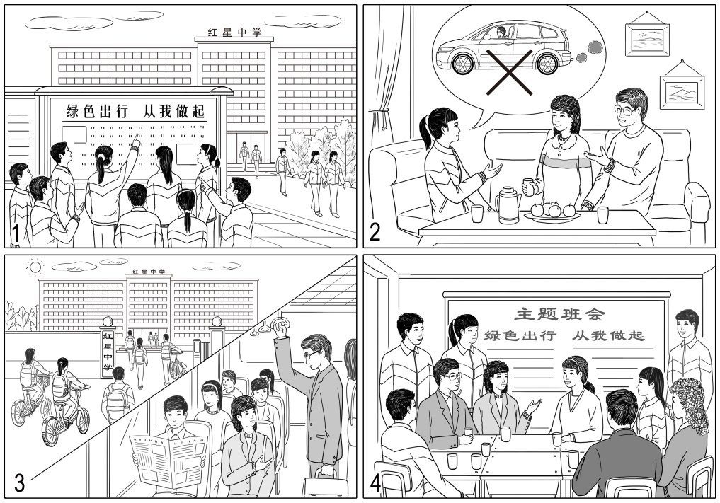

**Green Travel in My Family**

_______________________________________________________________________________

（海淀区一模）

假设你是红星中学高三学生李华，请根据以下四幅图的先后顺序，以“A New Way to Explore the Forbidden City”为题，用英语写一篇短文向校刊“英语园地”投稿，记述上周末你带英国朋友Jim游览故宫的全过程。

注意：词数不少于60。

提示词：二维码 QR code

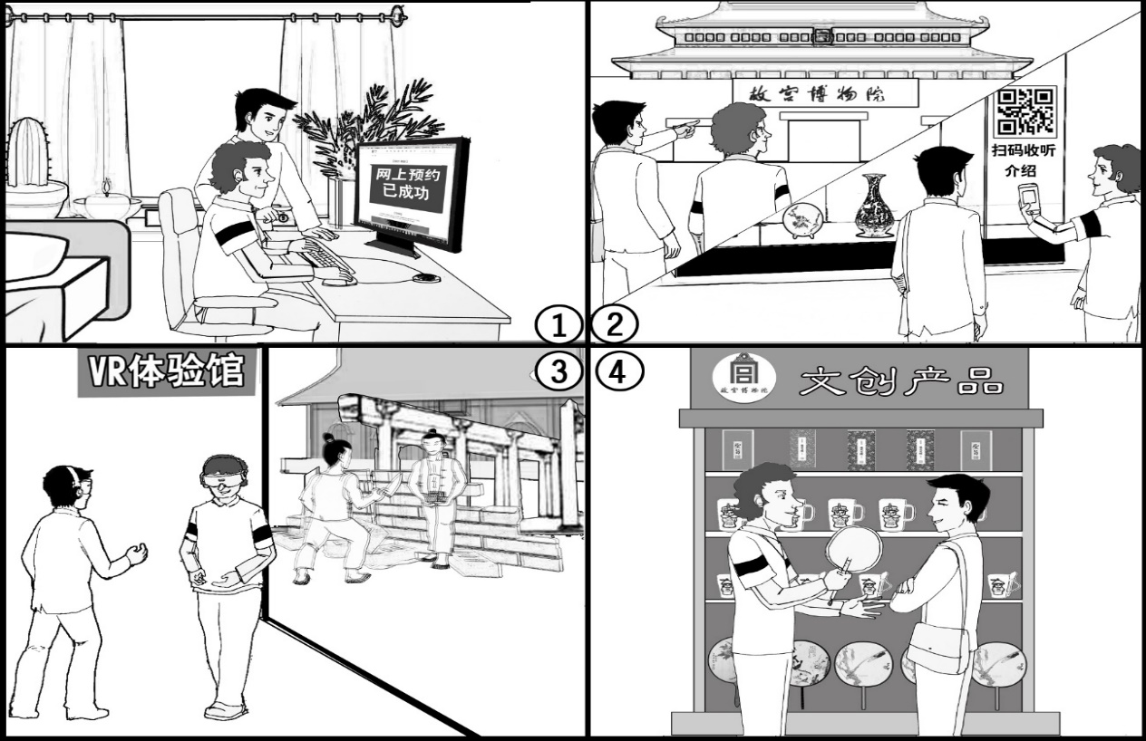

（东城区一模）

假设你是红星中学学生李华。你和同学在寒假期间去医院参加了志愿者活动，请按照以下四幅图的先后顺序，给校刊英语角写一篇英文稿件，介绍此次经历。

注意：词数不少于60。

提示词：自助挂号机 self-service registration machine

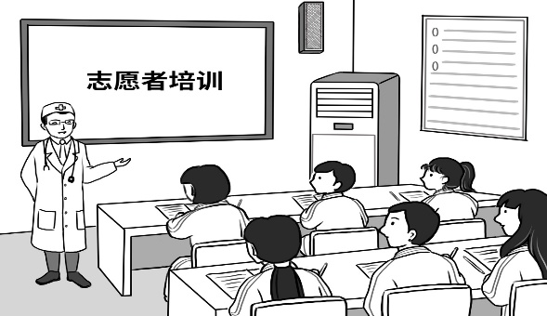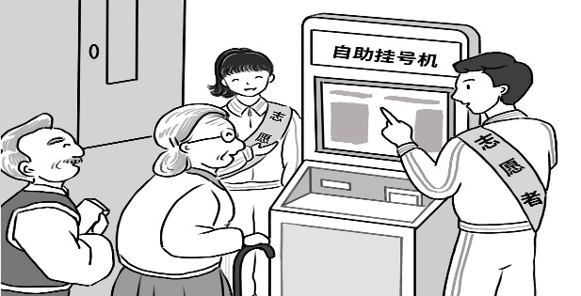

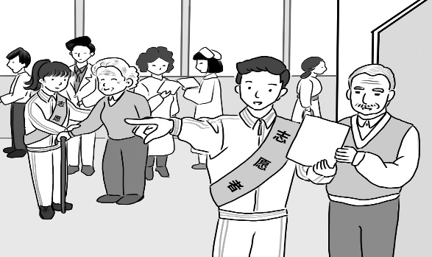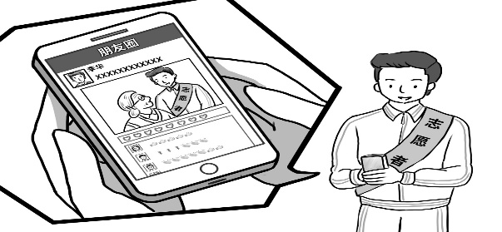

（西城区一模）

假设你是红星中学高三年级学生李华. 请根据以下四幅图的先后顺序,写一篇英文周记,记录上周你制作以 “我眼中的改革开放40年”为主题的小报的全过程。

注意：词数不少于60。

提示词：改革开放四十年 40 years of China’s reform and opening-up

改革开放四十周年展览exhibition commemorating the 40th

anniversary of China’s reform and opening-up

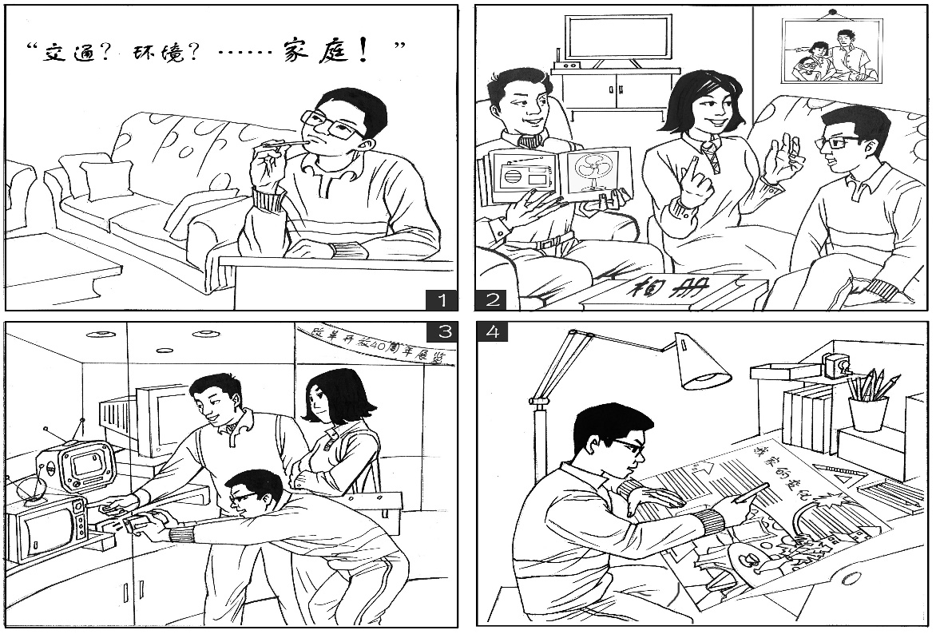

情景作文题目

|  |  |
| --- | --- |
|  | 主题 |
| 朝阳 | 绿色出行 |
| 海淀 | 游览故宫（突出科技创新） |
| 东城 | 志愿活动 |
| 西城 | 改革开放40年 |

**各区范文**

朝阳一模

Green Travel in My Family

Last month, our school organized an activity named “Green Travel, Start with Me”, which has played an educative role.

Seeing the proposal on the bulletin board, my classmates and I were deeply interested and had a heated discussion. Everyone expressed their willingness to participate. After getting home, I talked to my parents about my ideas. They were very supportive, saying they wouldn’t drive to work from the next day. In the following weeks, as we promised, I went to school by bike every day, while my parents went to work by bus. Tired as we were, we all felt happy. Last Friday, a class meeting was held as scheduled. Some parents were invited, including my father and mother. We shared our experiences and thoughts during the activity. All of us held the same view that environmental protection is so important for our life.

Through the activity, we find it our duty to protect the environment. I hope more and more people will join us in green travel.

海淀一模：

Last weekend, my friend Jim and I tried a new way to explore the Forbidden City, which left me a deep impression.

To avoid wasting time on the spot for the tickets, we tried making reservations online. The whole process just took us several minutes before the message popped out that the tickets had been successfully booked.

The next day’s visit amazed both of us. On arriving, impressed by the magnificent architecture, we couldn’t wait to start our exploration. While wandering around the galleries, we were attracted by the delicate chinaware. To our excitement, we could scan the QR code to listen to the introduction, which gave us a deeper insight into their history.

In the afternoon, we had a unique experience in the VR theatre. With the VR goggles on, we found ourselves back to the time when the palace was being constructed. As we “built” the wall brick by brick, we realized how much effort was put into accomplishing the grand work of architectural art.

Before we left, I led Jim to the souvenir center for cultural creative products. All the cups, notebooks and other products there bear certain elements of royal life. Jim was satisfied with his final choice of a Chinese fan. After this visit, I found the Forbidden City both traditional and modern because our rich and profound history was made alive here!

东城一模：

Last winter vacation, my classmates and I worked as volunteers in a hospital.

On our first morning, a doctor gave us a lecture, informing us of our roles as volunteers. It was the first time for me to know the daily routines in a hospital.

The next morning, fully prepared, we went to different posts and started our job. Together with my classmates, I assisted some patients when they didn’t know how to use the self-service registration machine. For senior citizens, we helped them register to save them the trouble.

Besides, I showed people the way to different consulting rooms. For those elderly patients, we accompanied them all the way until it was their appointment time. They really appreciated our help.

Later I shared my picture in the hospital on WeChat Moments. In no time, I received lots of likes from my friends. Some even expressed their great interest in the voluntary work. Actually, I had the most amazing experience doing very simple things for others.

西城一模：

Last week I participated in a school activity about making a poster entitled “40 years of China’s reform and opening-up in my eyes”.

On Friday evening, I was wondering what topic to choose for my poster. Many ideas popped into my head like “transportation”, “environment”, but I finally decided on “great changes in my home”. Immediately I turned to my parents for help. Hearing that, they took out some photo albums and began their talk. Mom told me about what our home looked like twenty years ago while dad showed me some photos taken at that time. It was the first time I had seen an old-fashioned electric fan and tape recorder. Seeing my curious expression, my parents suggested a visit the next day to the exhibition commemorating the 40th anniversary of China’s reform and opening-up.

At the exhibition, we were amazed by the brilliant achievements made in the past four decades. In the daily life area, what attracted me most was the evolution of electric appliances, especially TV sets, from the clumsy small ones to the modern high-tech ones. Dad pointed at one TV, saying his family had a similar one when he was a kid. Considering these TVs could be used on my poster, I took some photos. With all the material collected, I got down to my poster, on which I wrote about the great changes in my home and also included some pictures.

My home is just one example. I am sure lots of Chinese families resemble mine, benefiting from China’s reform and opening-up. How proud I feel about the great changes!