**《阅读理解—议论文》二轮复习解题指导 学习指南**

**【学习目标】**

1. 识别议论文的文体特点；

2. 归纳议论文的论点、段落大意；

3. 分析作者的态度或者观点；

4. 总结议论文的写作手法和论证结构

5. 运用所学解题策略，突破深层次理解题。

**【学法指导】**

1. 议论文是英语中的重要文体，在阅读理解体裁中占有一定的比例。

议论文一般由**论点、论据和论证**过程组成。通常，议论文都要提出**论题、观点、**提供充分的**证据**，使用一定的**逻辑方法**证明观点或得出结论。

议论文的写法常见有以下三种形式：

写法1：正方(甲方)，反方(乙方)，我认为……

写法2：提出问题，分析问题，解决问题

写法3：描述现象，分析现象，进行评论。

写法4：论点，理由(证据)，重申论点。

2. 议论文的内容涵盖自我、社会、自然等各个方面。在这类体裁的文章中把握好论点、论据和论证很重要。此类体裁的文章中题目涉及细节题（local & global）、猜测词意题、推理判断题、主旨大意题，大部分是考察学生深层次理解的题型。在阅读这类文章的时候，我们要在理解文章事实的基础上，体会作者的观点或者态度，领悟弦外之音，抓住文章的主旨大意，做出合理的推理和判断。

3. 阅读小技巧：

　关注文中标志类或指示类的信息。

　　①表示并列关系：and, also, coupled with……

　　②表示转折关系：but, yet, however, by contrast, contrary to……

　　③表示因果关系：therefore, thereby, consequently, as a result……

　　④表示递进关系：in addition to, besides, what’s more, moreover，furthermore……

　　⑤表示重要性的词：initially, above all, first of all……

**【学习任务】**

**阅读下列短文，从每题所给的A、B、C、D四个选项中，选出最佳选项。**

**（朝阳一模D篇）**

**Early or Later Day Care**

Many young parents are confused about whether their children should have early day care, and there have always been different views on this subject.

The British psychoanalyst John Bowlby believes that separation from parents during the sensitive “attachment” period from birth to three may scar a child’s personality and lead to psychological problems in later life. Some people have drawn the conclusion from Bowlby’s work that children should not be subjected to day care before three because of the parental separation it causes, and many people do believe this.

According to Bowlby, a great deal of psychological harm can occur when young children are separated from their parents. If they are left without touch for a while, they will have a higher stress level. Parents’ influence on their children’s well-being may never be greater than during the earliest years of life, when [a child’s brain is developing](https://www.livescience.com/20820-stress-alters-brain-kids.html) rapidly and when nearly all of her or his experiences are shaped by parents and the family environment.

However, there are critics. Some anthropologists (人类学家) point out that the love affair between children and parents found in modern societies does not usually exist in traditional societies. There has been a long history of the fact that father and mother did not bring up their children alone. Plato, around 394 B.C., argued that a system of early child care would free women to participate in society. Results from Israeli and Dutch studies show that child-raising duties are more evenly distributed among a broader group of people.

Besides, studies have reported that early day care has a neutral or slightly positive effect on children’s development. They learn the benefits of being socially smart, understanding the concept of sharing and caring. They promote concentration skills, which is very important in their learning. There are games where children are taught basic language and mathematical skills through stories and everyday examples.

Common sense tells us that early day care would not be so widespread if children had problems with it. But Bowlby’s analysis raises the possibility that it has delayed effects. The possibility that such care might lead to more mental illness 15 or 20 years later can only be explored by the use of statistics. Whatever the long-term effects, parents sometimes find the immediate effects difficult to deal with. Children under three dislike leaving their parents and show unhappiness. At the age of three almost all children find it easy to go to the nursery. The matter, then, is far from being clearly known, though experience and available evidence indicate that early day care is reasonable for young children.

42. The passage mainly argues whether ______.

A. children over three will accept school education

B. children under three should be sent to nursery schools

C. the family relationship is different in traditional societies

D. early day care should be totally replaced in modern societies

43 Which of the following supports Bowlby’s theory?

A. Early day care wouldn’t be so popular if it had negative effects.

B. Separation from parents for young children is common in history.

C. Parents find the immediate effects of early day care difficult to deal with.

D. Studies show early day care has a positive effect on children’s development.

44. The author’s attitude towards early day care is that ______.   
 A. children under three should stay with their parents  
 B. it has potential benefits for both children and parents

C. the bad effect of it on children will disappear as they grow up  
 D. it is controversial and the settlement calls for the use of statistics

45. Which of the following shows the development of ideas in the passage?

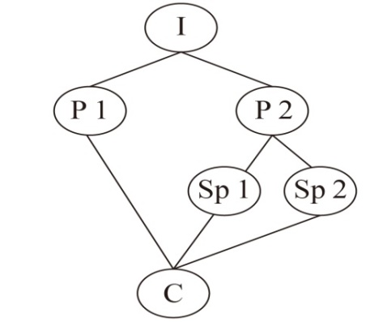

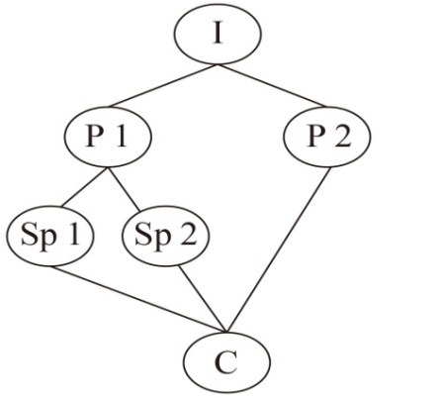

A. B.

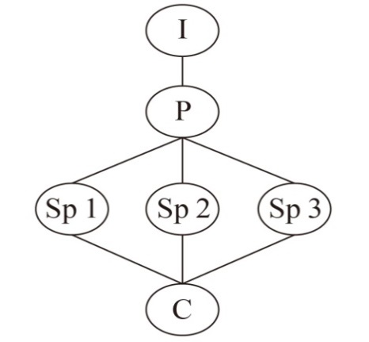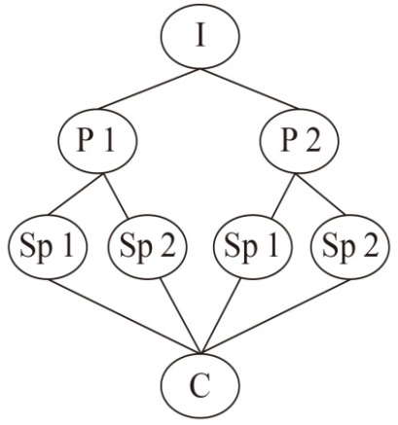

C. D.

I: Introduction P: Point Sp: Sub-point (次要点) C: Conclusion

**（海淀一模C篇）**

GOING TO UNIVERSITY is supposed to be a mind-broadening experience. That statement is probably made in comparison to training for work straight after school, which might not be so encouraging. But is it actually true? Jessika Golle of the University of Tübingen, in Germany, thought she would try to find out. Her result, however, is not quite what might be expected. As she reports in *Psychological Science* this week, she found that those who have been to university do indeed seem to leave with broader and more inquiring minds than those who have spent their immediate post-school years in vocational (职业的) training for work. However, it was not the case that university broadened minds. Rather, work seemed to narrow them.

Dr. Golle came to this conclusion after she and a team of colleagues studied the early careers of 2,095 German youngsters. The team used two standardized tests to assess their volunteers. One was of personality traits, including openness, conscientiousness（认真）and so on. The other was of attitudes, such as realistic, investigative and enterprising. They administered both tests twice—once towards the end of each volunteer’s time at school, and then again six years later. Of the original group, 382 were on the intermediate track, from which there was a choice between the academic and vocational routes, and it was on these that the researchers focused. University beckoned for 212 of them. The remaining 170 chose vocational training and a job.

When it came to the second round of tests, Dr. Golle found that the personalities of those who had gone to university had not changed significantly. Those who had undergone vocational training and then got jobs were not that much changed in personality, either—except in one crucial respect. They had become more conscientious.

That sounds like a good thing, certainly compared with the common public image of undergraduates as a bunch of lazybones. But changes in attitude that the researchers recorded were rather worrying. In the university group, again, none were detectable. But those who had chosen the vocational route showed marked drops in interest in tasks that are investigative and enterprising in nature. And that might restrict their choice of careers.

Some investigative and enterprising jobs, such as scientific research, are, indeed beyond the degreeless. But many, particularly in Germany, with its tradition of vocational training, are not. The researchers mention, for example, computer programmers and finance-sector workers as careers requiring these traits. If Dr. Golle is correct, and changes in attitude brought about by the very training Germany prides itself on are narrowing people’s choices, that is indeed a matter worthy of serious consideration.

38. Which of the following can best replace “beckoned for” in Paragraph 2?

A. Examined. B. Attracted. C. Organized. D. Recognized.

39. What can we learn from the research?

A. The degreeless have not changed in personalities.

B. Going to university is a mind-broadening experience.

C. Working straight after school narrows people’s minds.

D. College students pride themselves on their education.

40. According to the last two paragraphs, .

A. college students enjoy a very good public image

B. the undergraduates have changed significantly in attitude

C. the degreeless are much better at dealing with challenging tasks

D. people show less interest in investigative jobs due to vocational training

41. What is the author’s attitude towards the finding?

A. Concerned. B. Optimistic. C. Unclear. D. Sceptical.

**（东城一模D篇）**

Last fall, I happened to overhear a student telling the others he had decided not to sign up for an introductory philosophy course. The demands of his major, he said seriously, meant he needed to take “practical” courses, and “enlightenment” would simply have to wait. For now, employability was the most important.

The students’ conversation fits into a larger alarming narrative about the role of the humanities in higher education. In a time of dizzying technological achievement and of rapid scientific innovation, sceptics of the humanities may question the usefulness of studying Aristotle, the Italian Renaissance or Chinese fiction.

Actually, I regret not interrupting that student to argue for taking that introductory philosophy course. I would have started by reminding him that, for much of America’s history, college graduates were not considered truly educated unless they had mastered philosophy, literature, political theory and history. The key role of higher education was to invite students into the conversations about matters like what it means to be alive and the definition of justice. Fostering engagement with these subjects is still an essential part of the university’s function in society.

I would have also mentioned to the student that he was misinformed about the job market. It is true that many employers are looking for graduates with specialized technical skills, but they also look for other capabilities. As the world is transformed by artificial intelligence, machine learning and automation, the unique human qualities of creativity, imagination and moral reasoning will be the ultimate coin of the realm. All these skills are developed in humanities courses.

Further, I would have argued that while a degree anchored in the sciences is an important precondition for many jobs, it is not the only route. Look no further than the founders of companies such as LinkedIn, Slack and Flickr, who are among the many tech businesspersons with degrees in the humanities, and who credit that training for their success.

Contrary to the widely held belief that humanities majors have a hard time getting jobs, recent studies show that those with humanities degrees are successful in the workplace, experiencing low rates of unemployment and reporting high levels of job satisfaction. The ratio between average median(中位数) incomes for humanities degree holders and those with business, engineering, and health and medical sciences degrees has been shown to narrow over the course of a career.

The case for the humanities can also be understood in less transactional terms and more as a foundational preparation for a life well lived. A humanities education plays a vital role in encouraging citizens to lead an examined life. It fosters critical thinking, self-reflection, empathy and tolerance, the usefulness of which only becomes more apparent as one navigates life’s challenges.

By all means, students should take courses they think practical and follow their interests, but if they also make a point of studying the literature of the Renaissance, or researching into modern poetry, or even taking introductory philosophy, we will all benefit.

42. What do the students’ conversation show?

A. Students feel employment difficult.

B. Students think philosophy less important.

C. Students find scientific innovation amazing.

D. Students consider university courses unsatisfying.

43. What does the underlined part in Paragraph 4 probably mean?

A. Highly valued. B. Equally applied.

C. Strictly assessed. D. Greatly improved.

44. The author may agree that humanities _____.

A. discover students’ artistic ability

B. prepare students for graduation

C. raise awareness of social status

D. provide great insights into life

45. Which of the following shows the development of ideas in the passage?

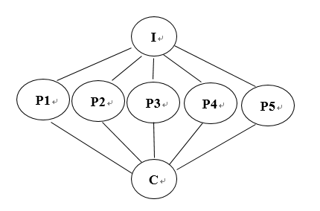

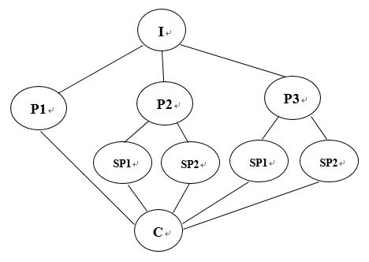

A B

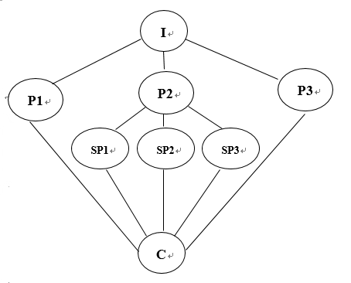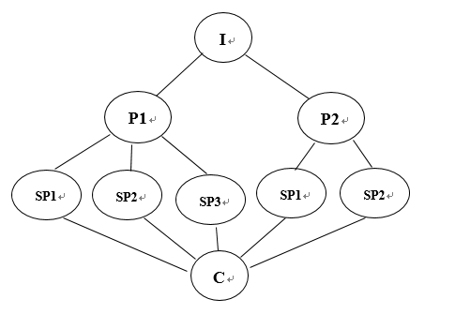

C D

I: Introduction P: Point Sp: Sub-point(次要点) C: Conclusion

**（西城一模D篇）**

We talk continuously about how to make children more “resilient (有恢复力的)”, but whatever we’re doing, it’s not working. Rates of anxiety disorders and depression are [rising](https://sites.psu.edu/ccmh/files/2018/02/2017_CCMH_Report-1r4m88x.pdf) rapidly among teenagers. What are we doing wrong?

Nassim Taleb invented the word “antifragile” and used it to describe a small but very important class of systems that gain from shocks, challenges, and disorder. The immune (免疫的) system is one of them: it requires exposure to certain kinds of bacteria and potential allergens (过敏原) in childhood in order to develop to its full ability.

Children’s social and emotional abilities are as antifragile as their immune systems. If we overprotect kids and keep them “safe” from unpleasant social situations and negative emotions, we deprive (剥夺) them of the challenges and opportunities for skill-building they need to grow strong. Such children are likely to suffer more when exposed later to other unpleasant but ordinary life events, such as teasing and social rejection.

It’s not the kids’ fault. In the UK, as in the US, parents became much more fearful in the 1980s and 1990s as cable TV and later the Internet exposed everyone, more and more, to those rare occurrences of crimes and accidents that now occur less and less. [Outdoor play](https://onlinelibrary.wiley.com/doi/full/10.1111/j.1741-3737.2001.00295.x) and [independent mobility](http://www.psi.org.uk/children_mobility) went down; screen time and adult-monitored activities went up.

Yet free play in which kids work out their own rules of engagement, take small risks, and learn to master small dangers [turns out to be vital](http://www.journalofplay.org/issues/3/4/article/decline-play-and-rise-psychopathology-children-and-adolescents) for the development of adult social and even physical competence. Depriving them of free play prevents their social-emotional growth. Norwegian play researchers Ellen Sandseter and Leif Kennair warned: “We may observe an increased anxiety or mental disorders in society if children are forbidden from participating in age adequate risky play.”

They wrote those words in 2011. Over the following few years, their prediction came true. Kids born after 1994 are suffering from much higher rates of anxiety disorders and depression than did the previous generation. Besides, there is also a rise in the rate at which teenage girls are admitted to hospital for deliberately harming themselves.

What can we do to change these trends? How can we raise kids strong enough to handle the ordinary and extraordinary challenges of life? We can’t guarantee that giving primary school children more independence today will bring down the rate of teenage suicide tomorrow. The links between childhood overprotection and teenage mental illness are suggestive but not clear-cut. Yet there are good reasons to suspect that by depriving our naturally antifragile kids of the wide range of experiences they need to become strong, we are systematically preventing their growth. We should let go—and let them grow.

1. Why does the author mention the immune system in Paragraph 2?

A. To stress its importance.

B. To analyze the cause of anxiety.

C. To question the latest discovery.

D. To help understand a new word.

1. Parents overprotect children because ______.

A. they are concerned about their children’s safety

B. they want to keep children from being teased

C. parent-monitored activities are a must

D. children are not independent enough

1. According to the author, free play can ______.

A. promote children’s resilience

B. strengthen children’s friendship

C. reduce children’s risky behavior

D. develop children’s leadership skills

1. Which of the following does the author probably agree with?

A. Stop trying to perfect your child.

B. It takes great courage to raise children.

C. Prepare the child for the road, not the road for the child.

D. While we try to teach our children all about life, our children teach us what life is all about.

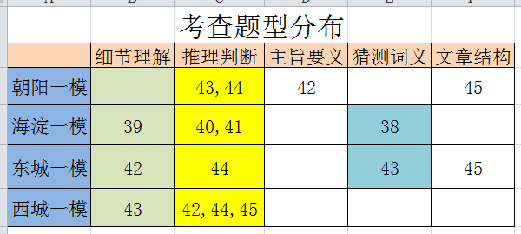

**答案与解析**

朝阳一模D篇

答案：BCDB

本文是一篇议论文，讨论了三岁之前的儿童是否应该被送去日间护理托儿所。文章分别介绍了支持与反对两种不同观点，并详细说明了具体的理由。

【42题详解】B

主旨大意题。根据文章第一段“Many young parents are confused about whether their children should have early day care, and there have always been different views on this subject.”可知本文是一篇议论文，讨论了三岁的儿童是否应该被送去日间护理托儿所。文章分别介绍了支持与反对两种不同观点。故B项正确。

【43题详解】C

推理判断题。根据第二段第一句 “The British psychoanalyst John Bowlby believes that separation from parents during the sensitive “attachment” period from birth to three may scar a child’s personality and lead to psychological problems in later life.” 可知John Bowlby认为三岁之前孩子与父母分开会给孩子的个性带来影响，并对孩子以后的生活带来精神方面的问题。而性格和精神方面的问题是难以处理的。故C项正确。

【44题详解】D

推理判断题。根据最后一段前两句“Common sense tells us that early day care would not be so widespread if children had problems with it. But Bowlby’s analysis raises the possibility that it has delayed effects.”可知作者认为三岁之前送孩子去托儿所的影响是存在争议的，很难说这种做法是正确的还是错误的。再根据第三句“The possibility that such care might lead to more mental illness 15 or 20 years later can only be explored by the use of statistics.”可知我们要根据具体的数据来分析这个问题。故D项正确。

【45题详解】B

文章结构题。本文是一篇议论文。第一段提出文章讨论的话题，也就是Introduction；第二三段解释英国精神分析专家John Bowlby反对三岁之前送孩子去托儿所的理由，也就是point1；第四五段是支持送孩子去托儿所的理由，也就是point2；四五段是两个次要点，也就是sp1和sp2；文章最后一段总结了最终的结论。所以B项与文章的结构相吻合。故B项正确。

**海淀一模C篇**

答案： BCDA

本文是一篇社会类议论文阅读。探讨Jessika Golle职业培训对人们的视野的影响，如果它是正确的，那么由于培训而带来态度上的变化减少了人们的选择，这就是一个值得认真考虑的问题。

【38题详解】B

猜测词义题。根据文章第二段Of the original group, 382 were on the intermediate track, from which there was a choice between the academic and vocational routes, and it was on these that the researchers focused. University beckoned for 212 of them. The remaining 170 chose vocational training and a job.可知，原始组中有382人就读中等学校，这些人是研究人员重点关注的对象。其中212名被大学录取，剩下的170人选择职业培训或参加工作。根据后句The remaining 170 chose vocational training and a job.从而可以猜测出beckoned for为“召唤；吸引”之意。故选B。

【39题详解】C

细节理解题。根据文章第一段As she reports in *Psychological Science* this week, she found that those who have been to university do indeed seem to leave with broader and more inquiring minds than those who have spent their immediate post-school years in vocational training for work. However, it was not the case that university broadened minds. Rather, work seemed to narrow them.可知，本周她在《心理科学》报告称，她发现和那些离校后马上进行职业训练的人相比，那些读过大学的人看起来确实在毕业后有更加开阔的探索性的思维。但大学能够开阔思维，其实并非如此。而是工作似乎会使思维狭隘。故选C。

【40题详解】D

推理判断题。根据文章最后两段，尤其倒数第二段中But those who had chosen the vocational route showed marked drops in interest in tasks that are investigative and enterprising in nature.可知，但是那些选择职业培训的人，他们对调查型和进取性任务的兴趣明显下降，从而可以推断出由于职业培训，人们对调查性工作的兴趣降低。故选D。

【41题详解】A

推理判断题。根据文章最后一段If Dr. Golle is correct, and changes in attitude brought about by the very training Germany prides itself on are narrowing people’s choices, that is indeed a matter worthy of serious consideration.可知，如果Golle结论正确，并且由于培训（德国人以此为傲）而带来态度上的变化缩小了人们的选择，这确实是一个值得认真考虑的问题，可以推断出，作者对这一发现持关注的态度。故选A。

**东城一模D篇**

答案：BADD

本文是一篇议论文。作者就“哲学课程是否没那么重要”展开了论述，提出自己的看法和论证依据。

【42题详解】B

细节理解题。根据第一段第二句The demands of his major, he said seriously, meant he needed to take “practical” courses, and “enlightenment” would simply have to wait. For now, employability was the most important.可知对话中学生提到他需要学习“实用”课程，而“启蒙”只能等一等。目前，就业能力是最重要的。可知学生的对话显示出学生认为哲学不那么重要。故选B。

【43题详解】A

猜测词义题。根据上文As the world is transformed by artificial intelligence, machine learning and automation, the unique human qualities of creativity, imagination and moral reasoning will be.可知人类独特的创造力、想象力和道德推理能力都是在人文学科课程中培养出来的，这些才是真正有价值的，故选A。

【44题详解】D

推理判断题。倒数第二段最后一句It fosters critical thinking, self-reflection, empathy and tolerance, the usefulness of which only becomes more apparent as one navigates life’s challenges.可知作者认为人们科学培养批判性思维、自我反省、同理心和宽容，只有当一个人应对生活中的挑战时，这些品质的作用才会变得更加明显。故人文科学提供了对生活的深刻见解。故选D。

【45题详解】D

文章结构题。根据文章结构首先通过学生的对话引入文章话题；然后分为三个论点；其中第二个论点中再展开了三个次要点。故D选项最符合文章结构。

**西城一模D篇**

答案：DAAC

本文是一篇议论文。文章论述的是“不要过分保护孩子”。作者认为“让孩子为路做准备，而不是为孩子准备路”。

【42题详解】D

推理判断题。根据第二段Nassim Taleb invented the word “antifragile" and used it to describe a small but very important class of systems that gain from shocks, challenges, and disorder. The immune (免疫的) system is one of them: it requires exposure to certain kinds of bacteria and potential allergens (过敏源) in childhood in order to develop to its full ability.“纳西姆·塔勒布发明了“抗脆弱”这个词，并使用它来描述一个很小但非常重要的系统类别，它从冲击、挑战和混乱中获益。免疫系统就是其中之一:它需要在儿童时期接触某些种类的细菌和潜在的过敏原，以充分发展其能力。”可知，作者在第二段中提到免疫系统是为了帮助理解一个新单词antifragile。故选D。

【43题详解】A

细节理解题。根据第四段中It's not the kids' fault. In the UK, as in the US, parents became much more fearful in the1980s and 1990s as cable TV and later the Internet exposed everyone, more and more, to those rare occurrences of crimes and accidents that now occur less and less.“这不是孩子们的错。在英国，就像在美国一样，父母们在20世纪80年代和90年代变得更加害怕，因为有线电视和后来的互联网让每个人越来越多地暴露在那些现在越来越少发生的罕见的犯罪和事故面前。”可知，父母过分保护孩子，因为他们担心孩子的安全。故选A。

【44题详解】A

推理判断题。根据第五段中Yet free play in which kids work out their own rules of engagement, take small risks, and learn to master small dangers turns out to be vital for the development of adult social and even physical competence.“然而，让孩子们自己制定参与规则、承担小风险并学会掌握小危险的自由游戏，对成人社交能力乃至身体能力的发展至关重要。”可知，作者认为，自由玩耍可以提高孩子的适应力。故选A。

【45题详解】C

推理判断题。根据最后一段中Yet there are good reasons to suspect that by depriving our naturally antifragile kids of the wide range of experiences they need to become strong, we are systematically preventing their growth. We should let go—and let them grow.“然而，我们有充分的理由怀疑，通过剥夺我们天生抗脆弱的孩子成长所需的广泛经验，我们正在系统性地阻止他们的成长。我们应该放手，让他们成长。”由此可知，作者会同意“让孩子为路做准备，而不是为孩子准备路”的观点。故选C。