**7年级英语第17课时**

**《听经典 学英语》拓展资源**

****The Gingerbread man 姜饼人的故事****

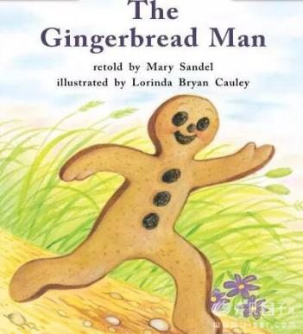Once upon a time,a little old woman and a little old man lived deep in the woods.

One day, the little old woman said,"Let's make a gingerbread man."

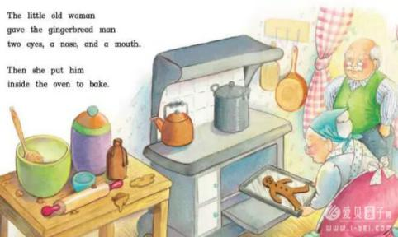So they made the gingerbread, and they cut out a man.

The little old woman gave the gingerbread man two eyes, a nose, and a mouth.

Then she put him inside the oven to bake.

"I'm hungry!"said the little old man.

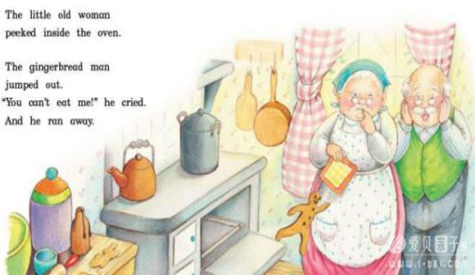"Is the gingerbread man ready to eat?"

"I'll look,"said the little old woman.

The little old woman peeked inside the oven.

The gingerbread man jumped out.

"You can't eat me!"he cried.

And he ran away.

"Come back!"cried the little old woman.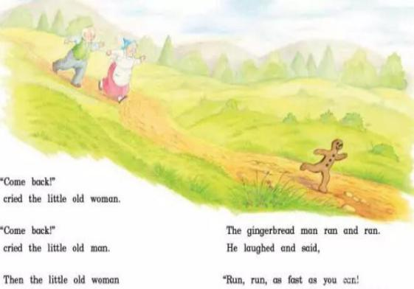

"Come back!"cried the little old man.

Then the little old woman and the little old man ran after the gingerbread man.

The gingerbread man ran and ran.

****He laughed and said: “Run, run! As fast as you can!”

...(To be continued)

***Look at the picture, can you imagine(***想象***):***

*What happened to the gingerbread man in the end？*



**请同学们扫右边的二维码，跟有趣的视频一起学习吧！**

***Word bank：***

bake v. 烘焙 peek v. 偷窥，偷看

oven n. 烤箱 gingerbread n.姜饼

in the woods 森林里