**小学英语六年级上第四单元 （第十二课时）**

**小试牛刀**

1. I often have English classes ___________ Sunday.

|  |  |  |
| --- | --- | --- |
| A. in | B. on | C. at |

正确答案：B

2. --- What’s the weather like __________ summer in Beijing.

--- It’s very hot.

|  |  |  |
| --- | --- | --- |
| A. in | B. on | C. at |

正确答案：A

3. 看图片，选出正确选项。

|  |  |  |
| --- | --- | --- |
|  | A. Gunpowder | B. The Compass |

正确答案：A

4. 看图片，选出正确选项。

|  |  |  |
| --- | --- | --- |
|  | A. Papermaking | B. Printing |

正确答案：B

5. 看图片，选出正确选项。

|  |  |  |
| --- | --- | --- |
|  | A. saw a film | B. visited the museum |

正确答案：A

6. 读句子选择正确的图片。

|  |  |
| --- | --- |
| The Wright brothers invented the plane. | |
| A. | B. |

正确答案：A

7. 读句子选择正确的图片。

|  |  |
| --- | --- |
| I flew to Hainan with my parents. | |
| A. | B. |

正确答案：B

8. 根据图片选择正确答案。

--- How did you go to Chaoyang Park with your cousin yesterday

afternoon?

--- We ________________Chaoyang Park.

|  |  |  |
| --- | --- | --- |
| A. rode a bike to | B. drove to | C. walked to |

正确答案：C

9. 根据图片回答问题。

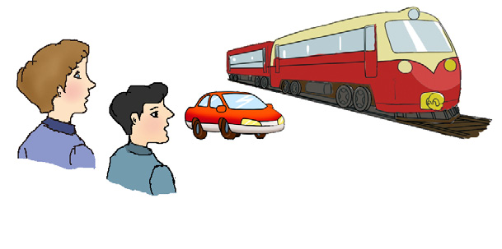---Who invented those vehicles?

--- ______________________________.

A. Some old people did.

B. Some clever people did.

C. Some young people did.

正确答案：B

10. 根据图片回答问题。

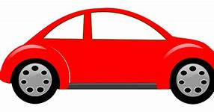 ---How did you go to the train station?

--- ___________________________________.

A. We went there by subway.

B. We walked there.

C. We drove there.

正确答案：C