小学英语六年级上第四单元 （第十一课时）
小试牛刀
1. I went to the beach ___________________.
A. every year | B. next year | C. last year
正确答案：C
2. I ______________ last week.
A. do some shopping | B. did some shopping | C. will do some shopping
正确答案：B
3. They _______________ next month.
A. saw a film | B. will see a film | C. see a film
正确答案：B
4. 看图片，选出正确选项。
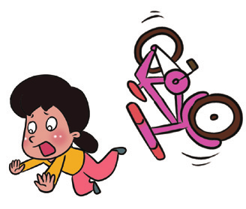 | A. fell off the bike | B. fell off the stairs
正确答案：A
5. 看图片，选出正确选项。
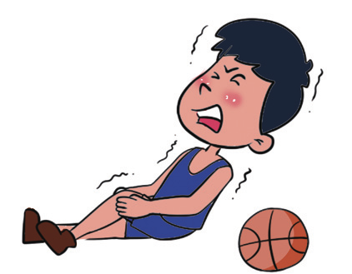 | A. hurt his leg | B. hurt his arm
正确答案：A
6. 看图片，选出正确选项。
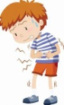 | A. had a headache | B. had a stomachache
正确答案：B
7. I went to the hospital because I wanted to ________________________.
A. grow stronger | B. win the race | C. take a blood test
正确答案：C
8. I hurt my neck because I wanted to ________________________.
A. practice kungfu | B. win the race | C. take an X-ray
正确答案：A

9. I had a high fever. The doctor said ________________________.
A. I should take some medicine and have a good rest.
B. I should take an X-ray first.
C. I should stop eating too much candy.
正确答案：A
10. The little piggy had a stomachache. The vet said he should _______________.
A. eat more food
B. stop eating too much and exercise more
C. stop doing more exercise
正确答案：B

