**小学英语五年级上第四单元（第十二课时）**

**小试牛刀**

1. Thanksgiving的正确理解是

A. 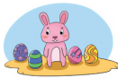

正确答案：B

2. Christmas的正确理解是

C. 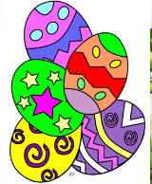

正确答案：A

3. People eat moon cakes on this day. The whole family gets together and enjoys the bright full moon.

A. 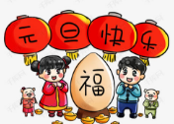 B. 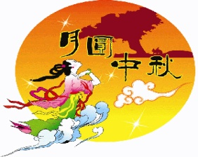 C. 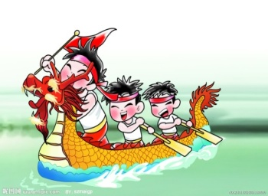

正确答案：B

4. It’s a traditional festival in China. People eat *jiaozi* and watch the fireworks on this day.

A. 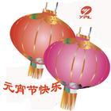 B. 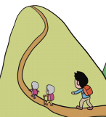

正确答案：C

5. It’s on the ninth day of the ninth month in the Chinese calendar. It’s a holiday for the old.

正确答案：A

6. Children like this holiday very much. They dress up at night and knock on doors for candies.

C. 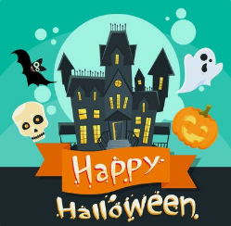

正确答案：C

7. Children have an Easter egg hunt on this day.

C. 

正确答案：C

8. When is the Lantern Festival?

A. It’s on the first day of the first month in the Chinese calendar.

B. It’s on the fifteenth day of the first month in the Chinese calendar.

C. It’s on the fifteenth day of the eighth month in the Chinese calendar.

正确答案：B

9. Can you tell me more about the Dragon Boat Festival?

A. People have dragon boat races and eat *zongzi*.

B. Families get together and eat turkey.

C. People climb mountains.

正确答案：A

10. Which one is the traditional festival in China?

A. The Mid-Autumn Festival B. Thanksgiving C. Easter

正确答案：A