**小学英语五年级上第四单元（第十一课时）**

**小试牛刀**

1. A ________ is a person who helps another person or group with a job they are doing.

A. player B. helper C. worker

正确答案：B

2. clean the house的正确理解是

A. 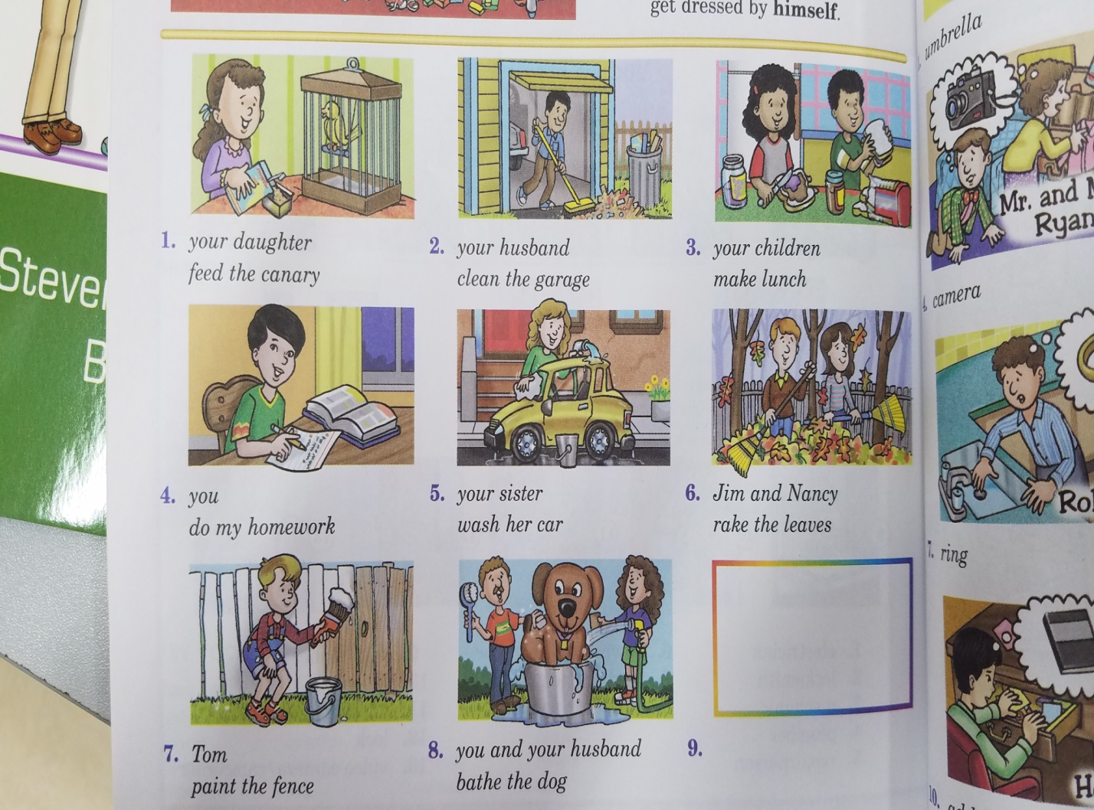 B. 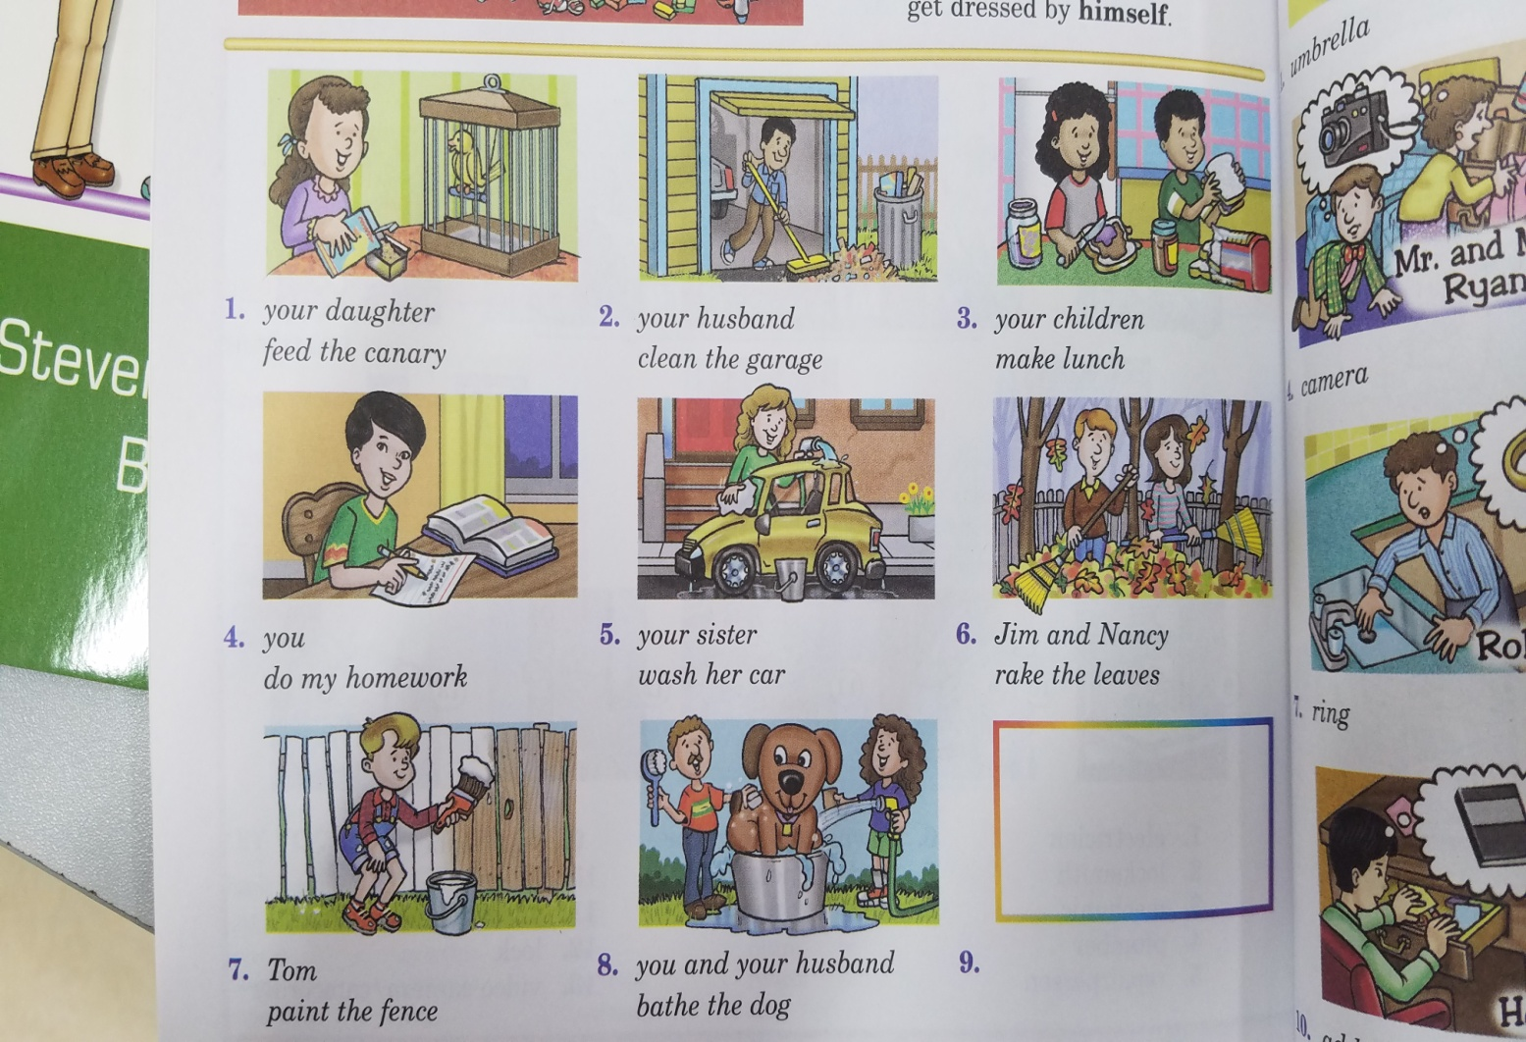 C. 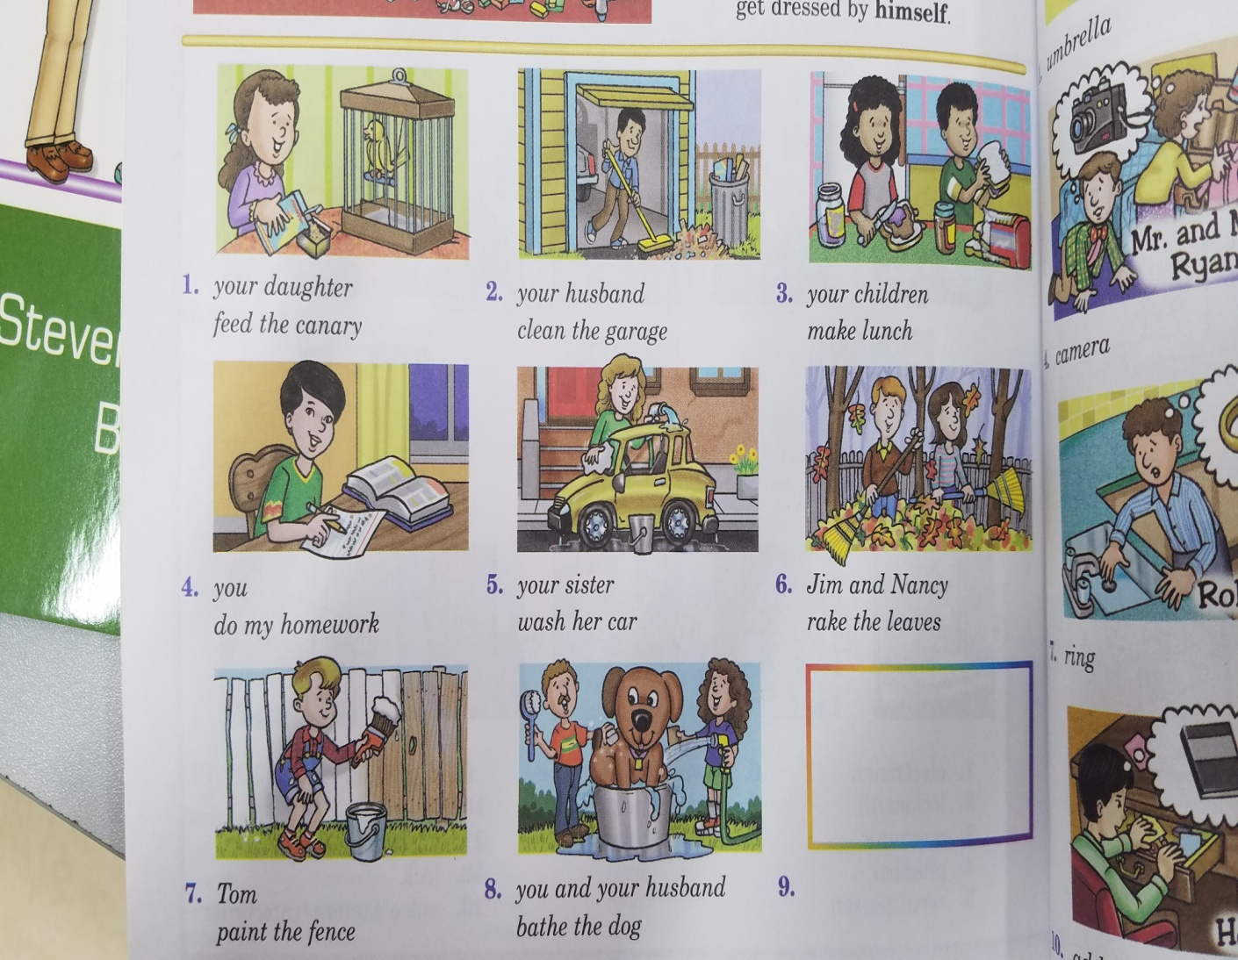

正确答案：A

3. wash the dishes的正确理解是

A. 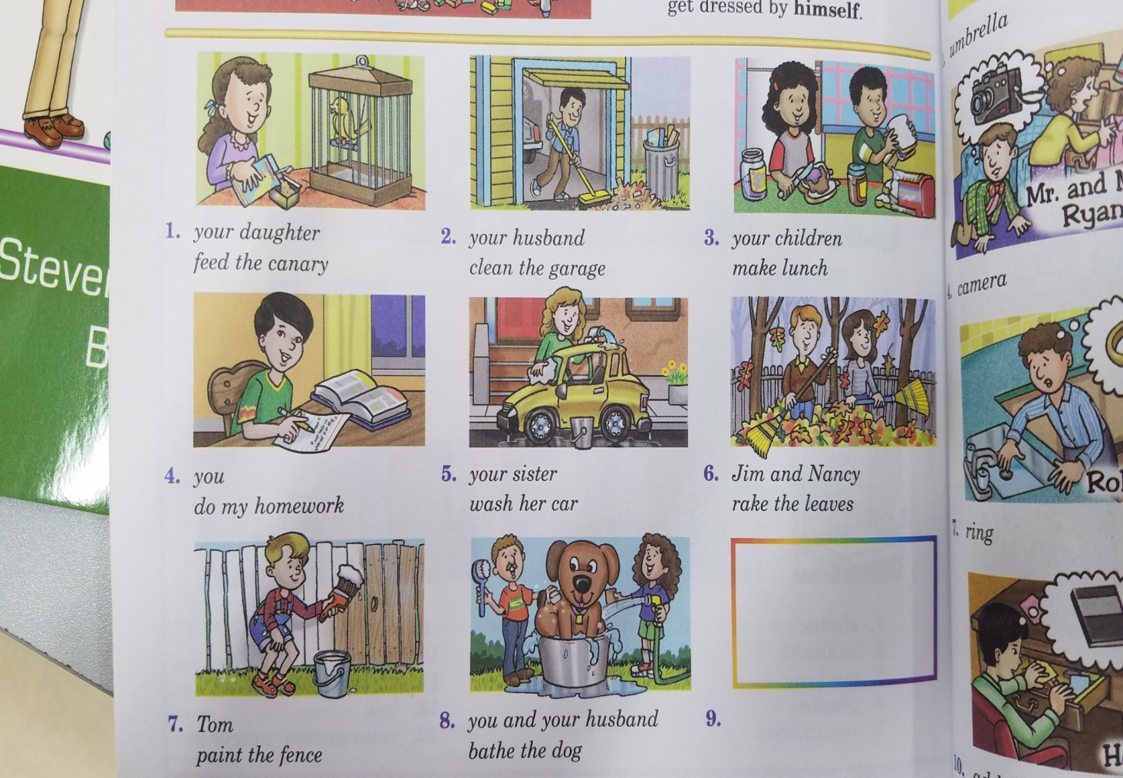 B. 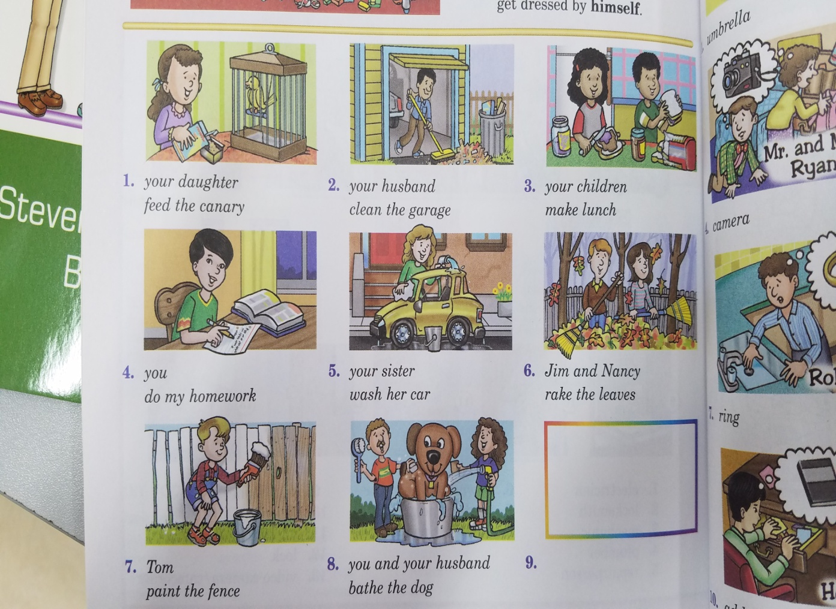

正确答案：C

4. We can help our friends do homework.

A. 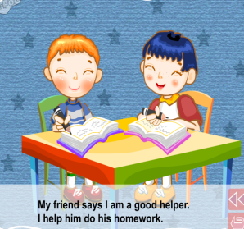 B. 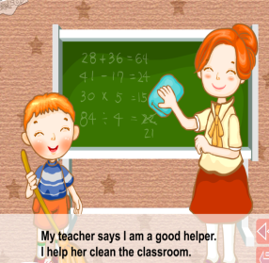 C. 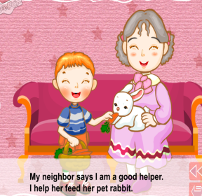

正确答案：A

5. We can help our little brother cross the street.

A. 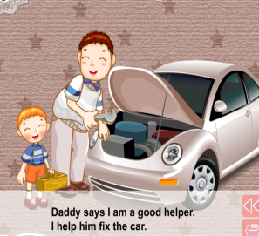 B. 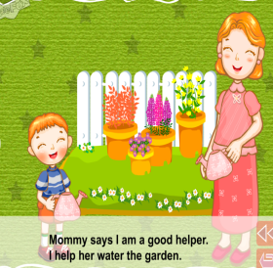 C. 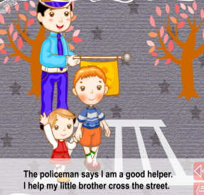

正确答案：C

6. Let’s help Kate look for her umbrella.

A. 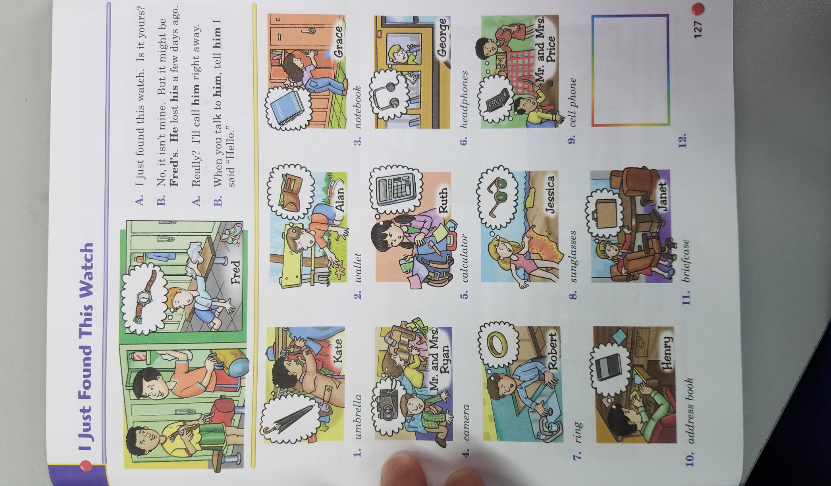 B. 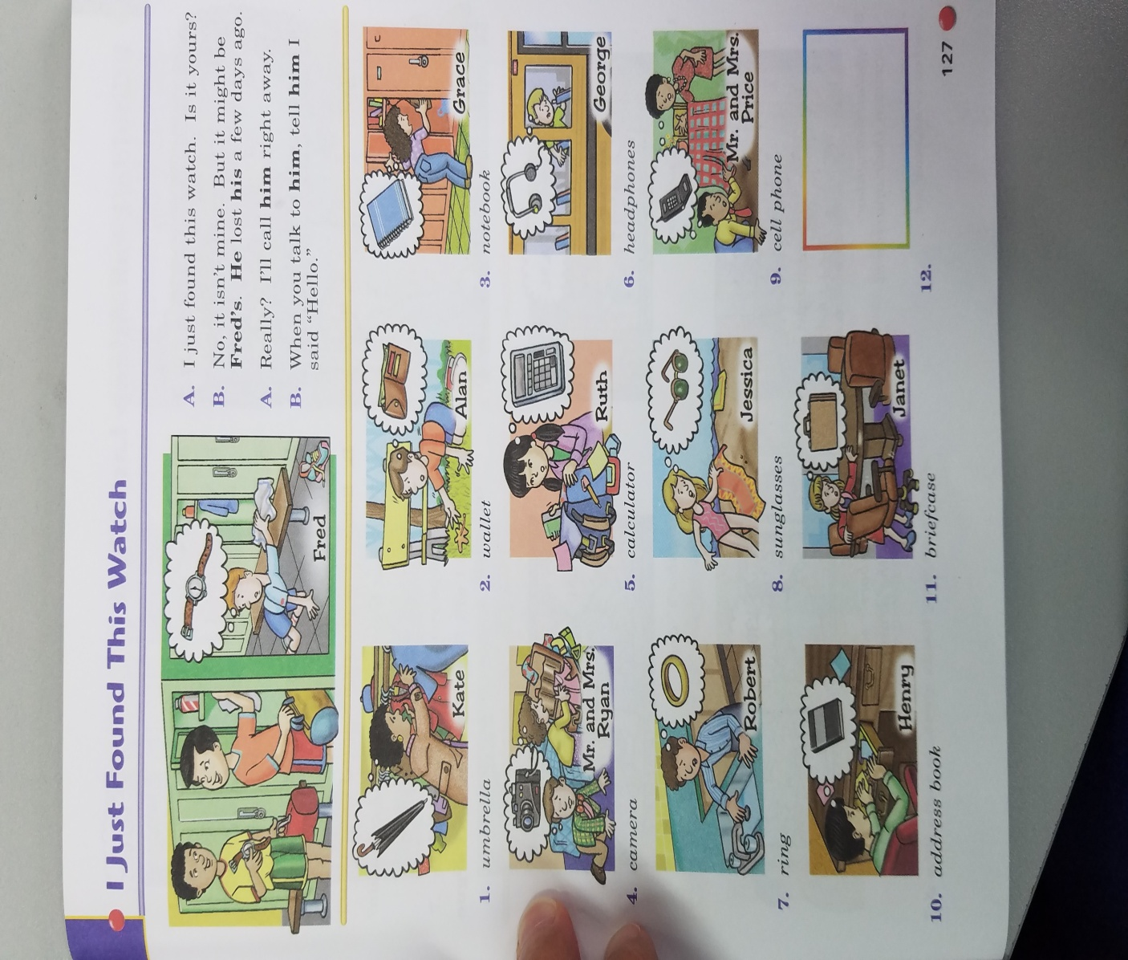 C. 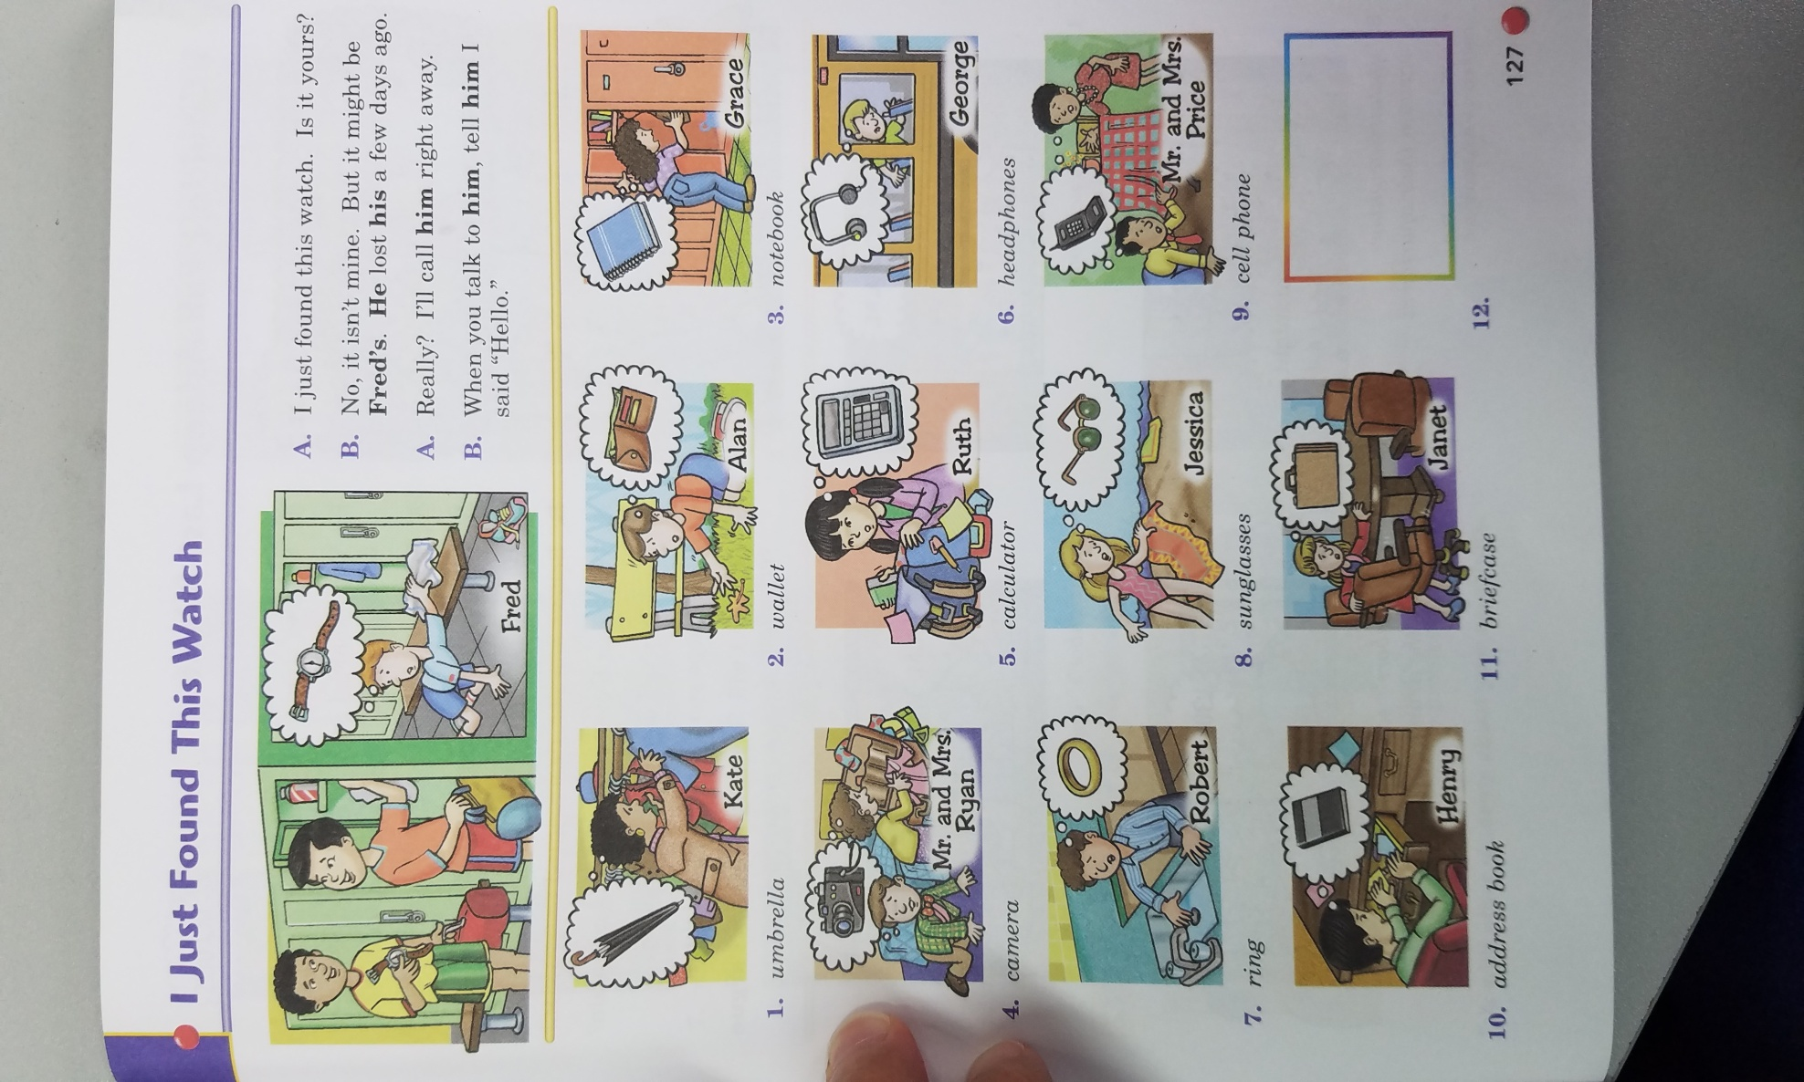

正确答案：C

7. What can we do to help others at home?

A. We can help our teacher hold the books.

B. We can help our neighbour walk the dog.

C. We can help our mum wash the clothes.

正确答案：C

8. What can we do to help others outside?

A. We can help old people cross the street.

B. We can help our dad wash the car.

C. We can help our little brother put his toys away.

正确答案：A

9. Tom is a good helper. It means __________.

A. He never helps others.

B. He always helps others.

C. He always plays with others.

正确答案：B

10. If we can’t help others, what can we do?

A. We can do nothing.

B. We can try to find other people to help them.

C. We can ask them to do it by themselves.

正确答案：B