**小学英语四年级上第七单元（第11课时）**

**小试牛刀**

1. __________the weather in Beijing?
2. What’s B. How’s

正确答案： B

1. _________

A. Ice can become water.

B. Water can become ice.

正确答案： B



1. How’s the weather?
2. It’s snowing.
3. It’s raining.

正确答案： B

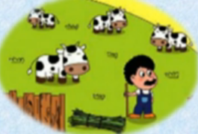

1. Where does he live?
2. He lives in a farm.
3. He lives on a farm.

正确答案：C

1. A fish_________ in a river.

A. live B. lives

正确答案：B



1. 看图片，选句子_________
2. They live to the lake.
3. They live by the lake.

正确答案：B

阅读短文，判断正误

We find different kinds of animals in the world. Some animals, such as tigers and bears live in big forest. Some animals, such as giraffes and zebras live on the grassland. Some animals, such as camels（骆驼）live in the desert. Some animals, such as fishes live in the lake, river or sea. Some others like sheep and dogs are kept by men. Cows and pigs are useful to men's food. Dogs and cats are our pets. There are all kinds of animals in the world. We need get on well with animals.

1. Tigers live in the desert.

A. √ B. ×

正确答案：B

1. Sheep and cows aren’t kept by men.

A. √ B. ×

正确答案：B

1. Fishes live in the lake, river or sea.

A. √ B. ×

正确答案：A

1. We mustn't get well with animals.

A. √ B. ×

正确答案：B