**小学英语四年级上第六单元（第10课时）**

**小试牛刀**

1. 下列图片与词义相符的是 salad
2. 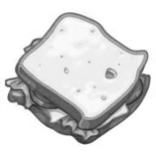 B.

正确答案：A

1. Here _____ your change.

A. am B. is

正确答案： B

1. – How _____ is it?

– It’s twenty yuan.

A. old B. much

正确答案： B

1. 判断下列句子与图片是否相符

I’d like a glass of juice.

A. 相符 B. 不相符

正确答案： B

1. 选择正确答语

-- Here is the money.

-- ________________.

A. Here is your change. B. It’s eighteen yuan.

正确答案： A

1. 与juice属于同类单词的选项是

A. soy milk B. meatballs

正确答案： A

1. 与sandwich不属于同类单词的选项是

A. hot dog B. water

正确答案： B

1. 中餐与西餐的上菜顺序相同

A. 正确 B. 不正确

正确答案：B

1. 阅读对话，回答问题：

Zip: Welcome! What would you like for dinner?

Tom: I'd like some fish and soup.

Zip: Here you are. Would you like some beef and chicken?

Tom: I'd like some chicken. I don't like beef. Can I have some noodles?

Zip: Sorry. We have no noodles now, the fish is eight yuan, fish and soup are thirteen yuan, the beef is ten yuan, and chicken is, too. Here's the bill（帐单）.

Tom likes beef.

A. Yes B. No

正确答案：B

1. The bill is forty-one yuan.
2. Yes B. No

正确答案：A