小学英语三年级上第七单元 （第12课时）
小试牛刀
1. 看图片，选择图片代表的节日所在的月份。
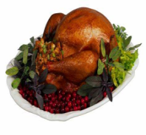 | 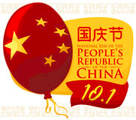 | 
( ) | ( ) | ( )
- In October | - In November | - In January
正确答案：B A C

- When is New Year’s Day?
- It’s on January 1st.
- It’s in January or February.
- It’s in December.
正确答案：A

- 听第24课课文录音，选择正确答案。
---What holiday are they talking about?
---They are talking about _________ .
A. Halloween
B. Christmas
C. Thanksgiving
正确答案：B

4. 听第24课课文录音，选择正确答案。
---What is Yangyang’s Christmas gift?
---It’s ________ .
- a pink skirt B. a brown bear C. a Christmas tree
正确答案：B
- 听第24课课文录音，选择正确答案。
---What is Lingling’s Christmas gift?
---It’s ________ .
- a pink skirt B. a brown bear C. a Christmas tree
正确答案：A

- 听第24课课文录音，选择正确答案。
---I like the ________ balls.
---They are ________, silver, and red.
- colorful; gold B. colorful; blue C. gold; colorful
正确答案：A

7. 读句子，选择正确的节日。
It’s a big Chinese holiday. It’s in January or February.
It’s ________ .
- Chinese New Year B. New Year’s Day C. Halloween
正确答案：A

8. 读句子，选择正确的节日。
It’s an American holiday. It’s in December. Santa comes with gifts for children.
It’s ________ .
A. New Year’s Day B. Thanksgiving C. Christmas
正确答案：C

- 读句子，选择正确的节日。
It’s a Chinese holiday. It’s on the first day of October.
It’s ________ .
A. our National Day B. Chinese New Year C. Halloween
正确答案：A

10. 看图选择正确的词语。
- a ball | 
- a gift

- a star
正确答案：C A B

