小学英语三年级上第七单元 （第11 课时）
小试牛刀
1. 听第23课课文录音，选择正确答案。
---What are they talking about?
---They are talking about _________.
- Holidays.
- Sara's holidays.
- Chinese.
正确答案：A

- When is Thanksgiving？
- It’s in November.
- It’s in October.
- It’s in January or February.
正确答案：A

- When is Chinese New Year?
- It’s in January.
- It’s in February.
- It’s in January or February.
正确答案：C

- When is Christmas?
- It’s in December 24th .
- It’s on December 25th .
- It’s in November.
正确答案：B

- Is Halloween a Chinese holiday?
- Yes. B. No.
正确答案：B

- Is our National Day in October?
- Yes. B. No.
正确答案：A

7. 听第25课课文录音，选择正确答案。
---Happy Chinese New Year.
--- .
- The same to you.
- Have some candy.
- It’s in January or February.
正确答案：A

8. 听第25课课文录音，选择正确答案。
Let’s Chinese New Year.
- say B. celebrate C. welcome.
正确答案：B

- 听第25课课文录音，选择正确答案。
Look! The red , big and bright.
- trees B. balls C. lanterns
正确答案：C

- 看图片，选择正确的单词。
 | 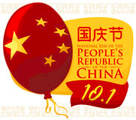 | 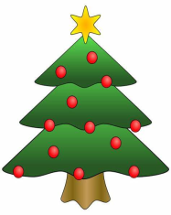
( ) | ( ) | ( )
- National Day | - Christmas | C.Chinese New Year
正确答案：C A B

