**小学英语三年级上第六单元（第十课时）**

**小试牛刀**

1. 下图数列中所缺的两个数字分别是
2. fifty; thirty B. thirty; fifty

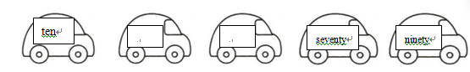

正确答案：B

1. 下图数列中所缺的两个数字分别是

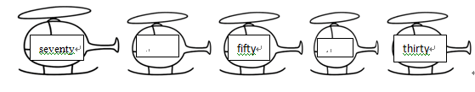

A. sixty; forty B. forty; sixty

正确答案：A

1. Fifty plus ten is ________.

A. sixty B. forty

正确答案：A

1. One hundred minus ten is ________.
2. seventy B. ninety

正确答案：B

1. What is thirty plus fifty and minus ten?

A. 70 B. 80

正确答案：A

1. 阅读短文, 回答问题：

I like collecting. I have twenty books, twelve pencils, thirty rulers, forty markers and fifteen erasers. I collect eighty cards, too.

What is my hobby?

A. Collecting B. Shopping

正确答案：A

1. How many markers do I have?

A. Fifteen. B. Forty.

正确答案：B

8. How many cards do I have?

A. Fifteen. B. Eighty.

正确答案：B

9. How many kinds of things do I collect in the passage?

A. Five. B. Six.

正确答案：B

10. 说一说: What do you collect? How many such kinds of things do you have?