- 请你为下面的单词选择正确的图片。
monkey
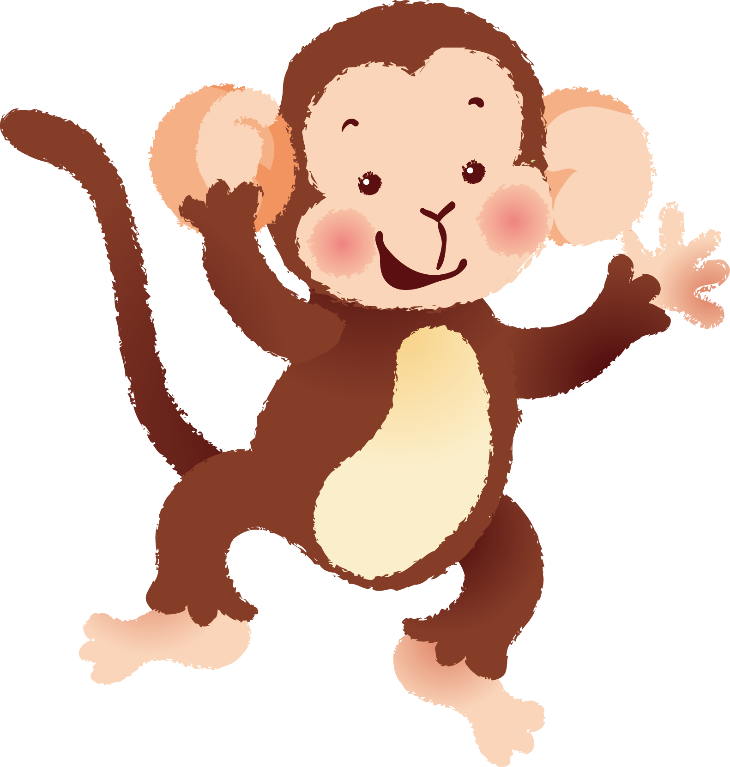 | 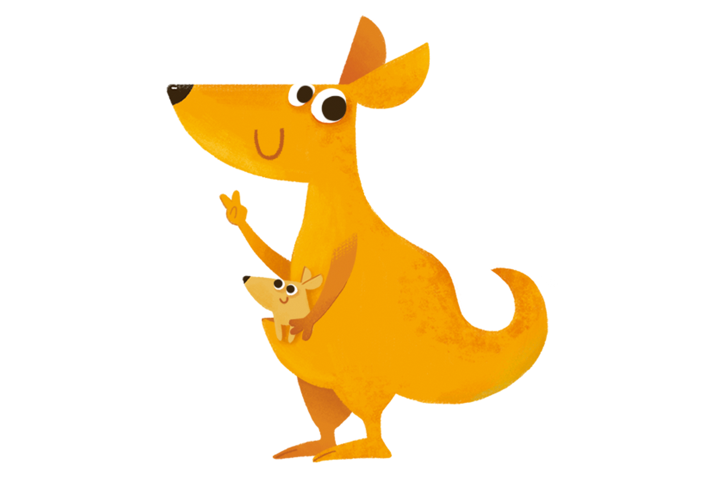 | 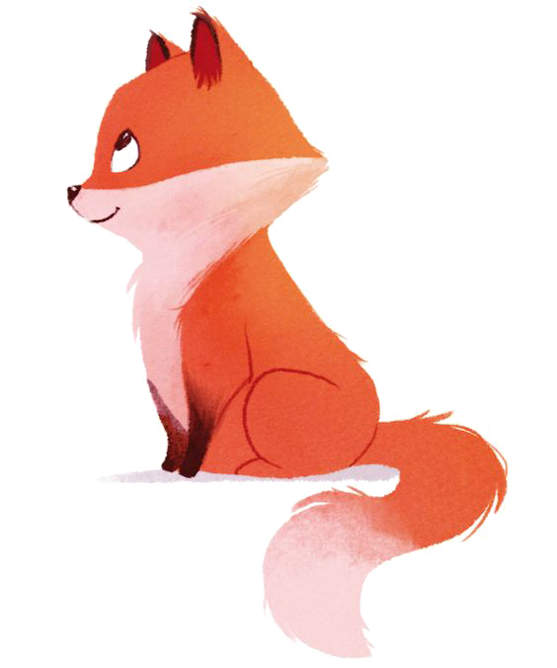
A | B | C
正确答案：A
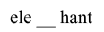
- 这个单词中所缺的字母是什么?请你选择正确的答案。
- f B. h C. p
正确答案：C

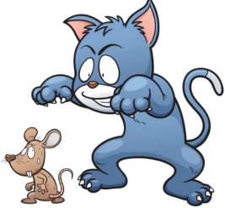
3. 请你选择与图片相符的句子。
- The dog chased the cat.
- The rat chased the cat.
- The cat chased the rat.
正确答案：C

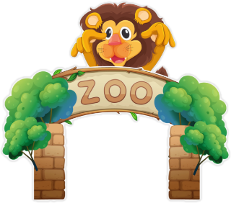
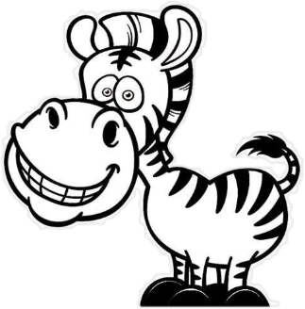
4. 读句子，根据图片选择正确的答语。
-How many zebras are there in this zoo?
- Yes, there are two.
- No, there aren’t.
- There are three.
正确答案：C

5. 根据句子描述，选择正确的图片。
-There are many animals in the zoo.
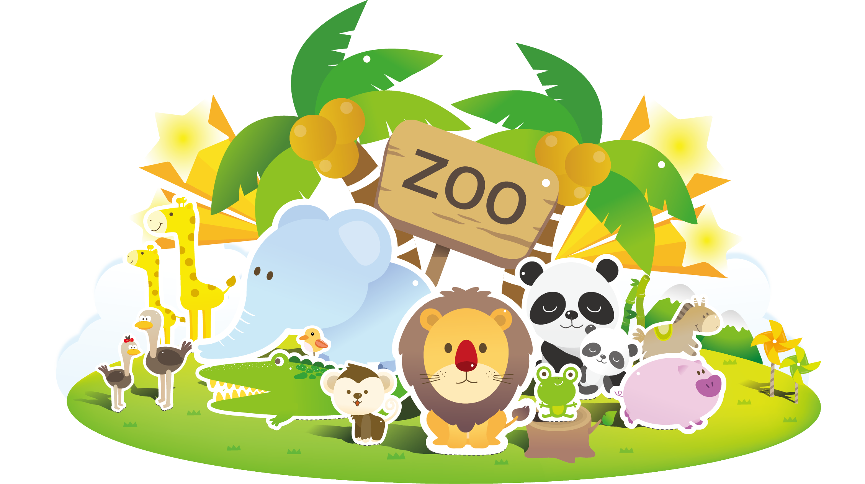 | 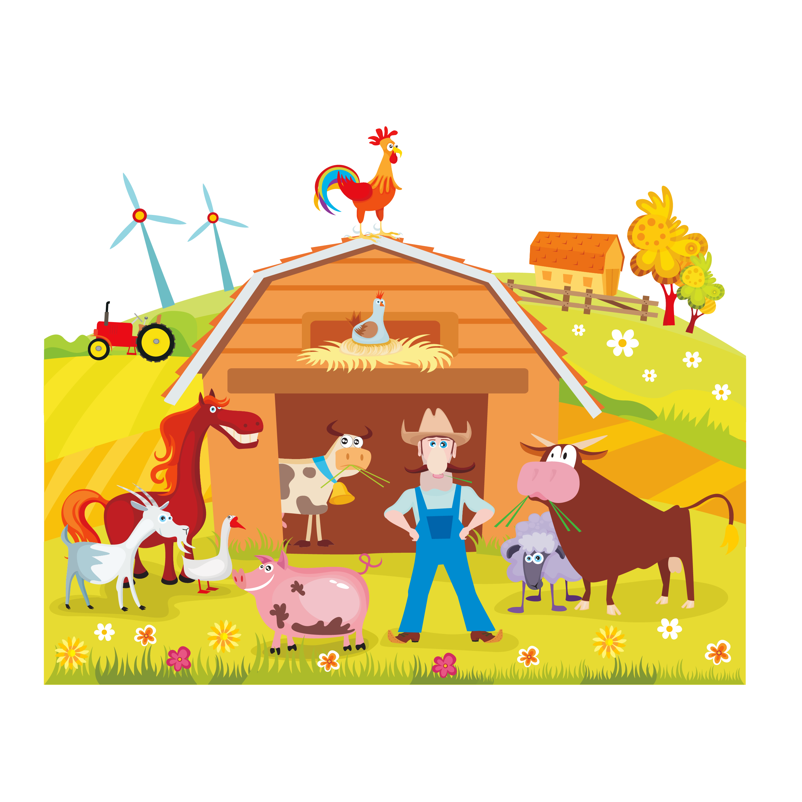 | 
A | B | C
正确答案：A
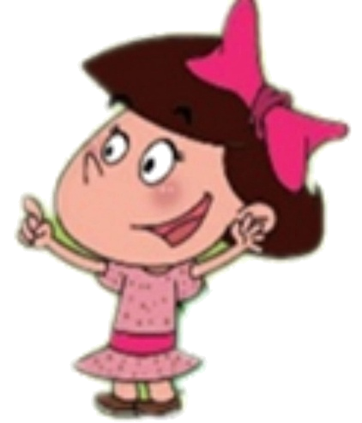

6. 根据图片，选择正确的句子。
- I like big animals.
- Guoguo likes small animals.
- Guoguo likes big animals.
正确答案：B

7. 请你选择一个正确的单词，将句子补充完整。
There are three ____ in the zoo.
- tiger B. cat C. tigers
正确答案：C

- 请根据图片信息，猜猜这个小姑娘在说什么?

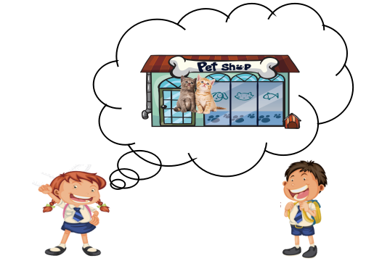

- There are many animals in the zoo.
- There are two baby cats in the pet shop.
- I go to the farm with my grandpa.
正确答案：B

9. 请你根据宝宝的答语，正确选择妈妈的问题。
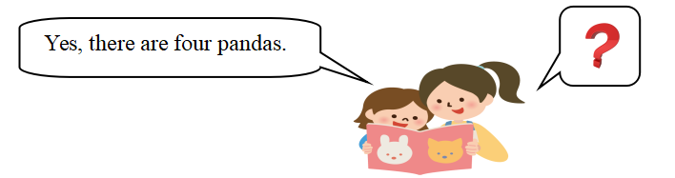

- Are there monkeys in the zoo?
- Do you like small animals?
- Are there pandas in this zoo?
正确答案：C

10.阅读短文, 根据短文内容，从下列选项中选择一个正确的句子。

   | It’s Sunday today.  Mike goes to see his grandparents.  He is very happy.
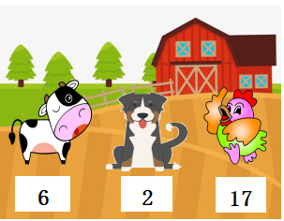 | His grandparents have a big farm.  There are six cows, seventeen hens and two dogs. They are so cute.

- There are sixteen cows.
- There are seventy hens.
- There are two dogs.
正确答案：C

