1. 请选择正确的单词，将句子补充完整。
Look ______ the four baby cats.
A. of B. like C. at
正确答案：C
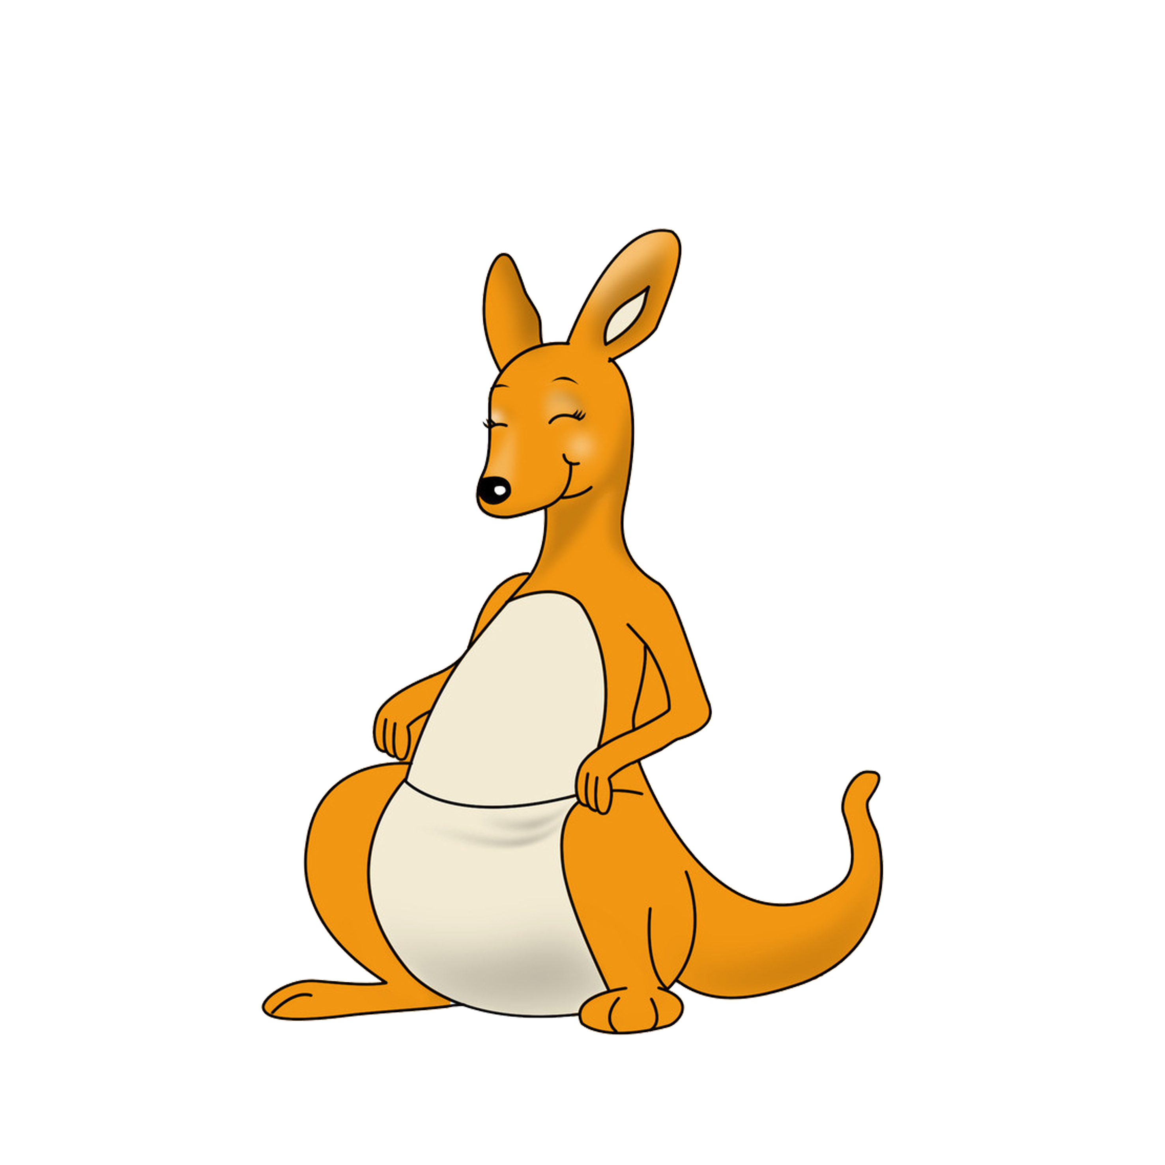
2. 这幅图的英文表达是下面哪个词？

A. bear B. kangaroo C. giraffe
正确答案：B

- 根据图片，选择正确的答语。
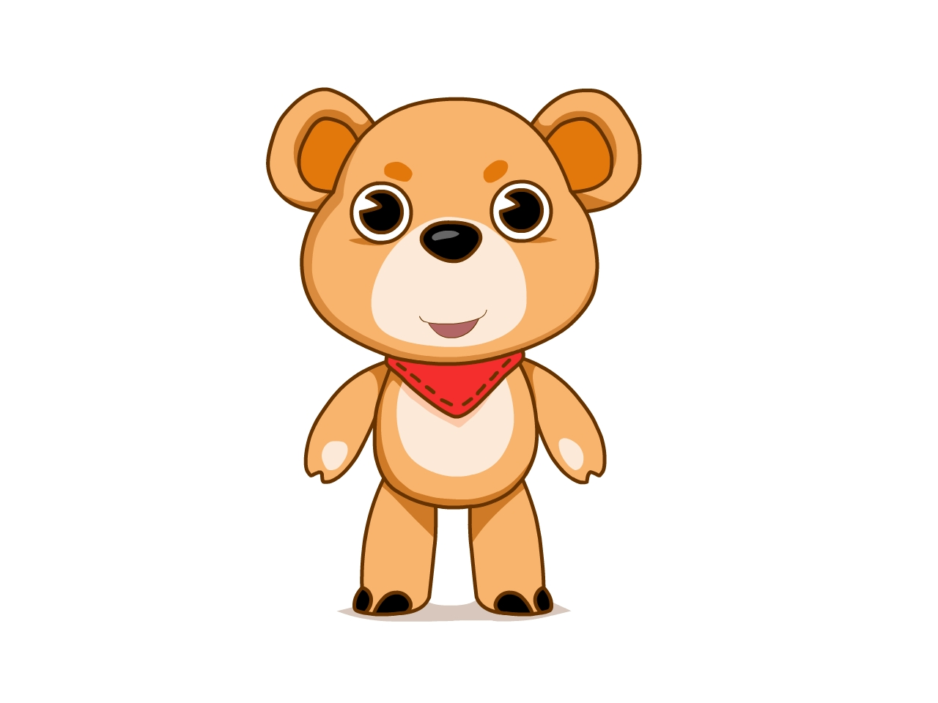
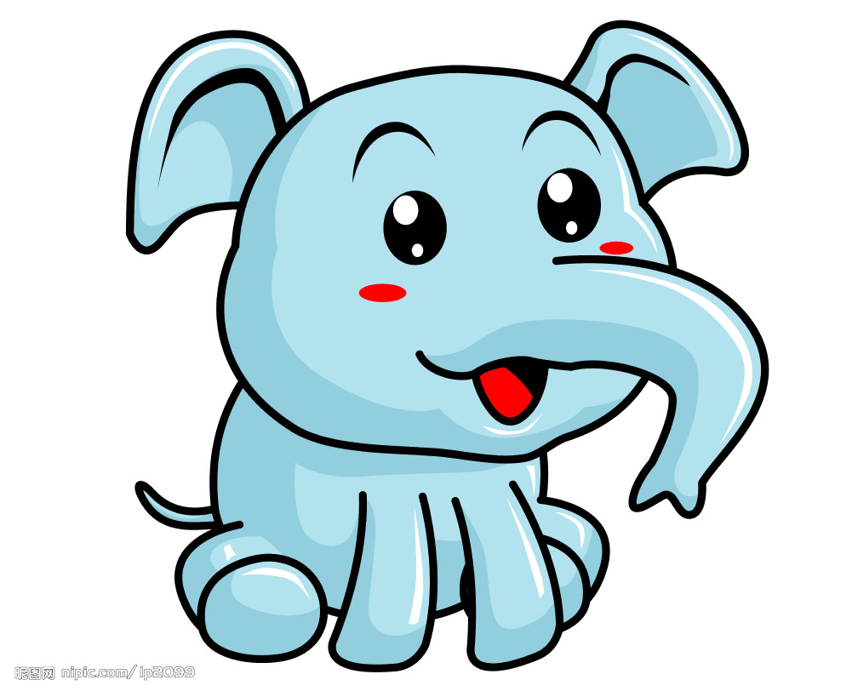
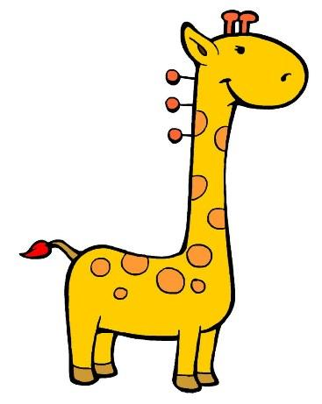
-There are so many toys. Are there zebras?
A. No, there aren’t. There are bears, elephants and tigers.
B. Yes, there are.
C. No, there aren’t. There are bears, elephants and giraffes.
正确答案：C

- 根据句子描述，选择正确的图片。
-I am an animal. I am big and tall. I have a long neck.
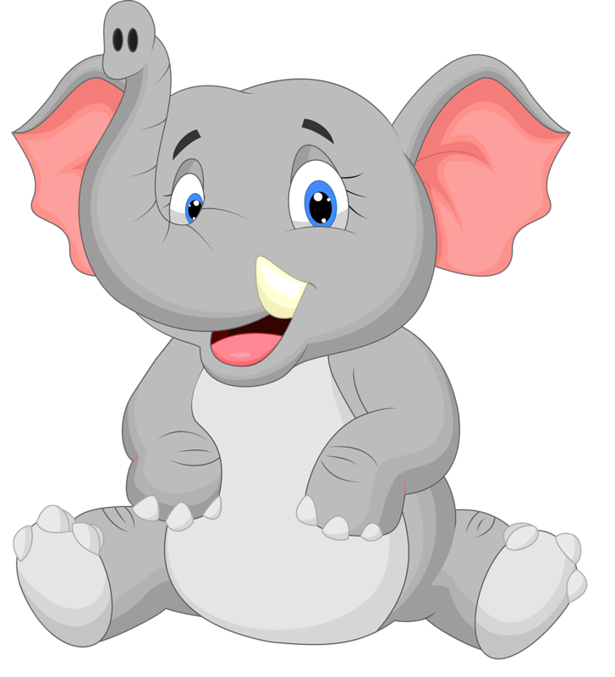 | 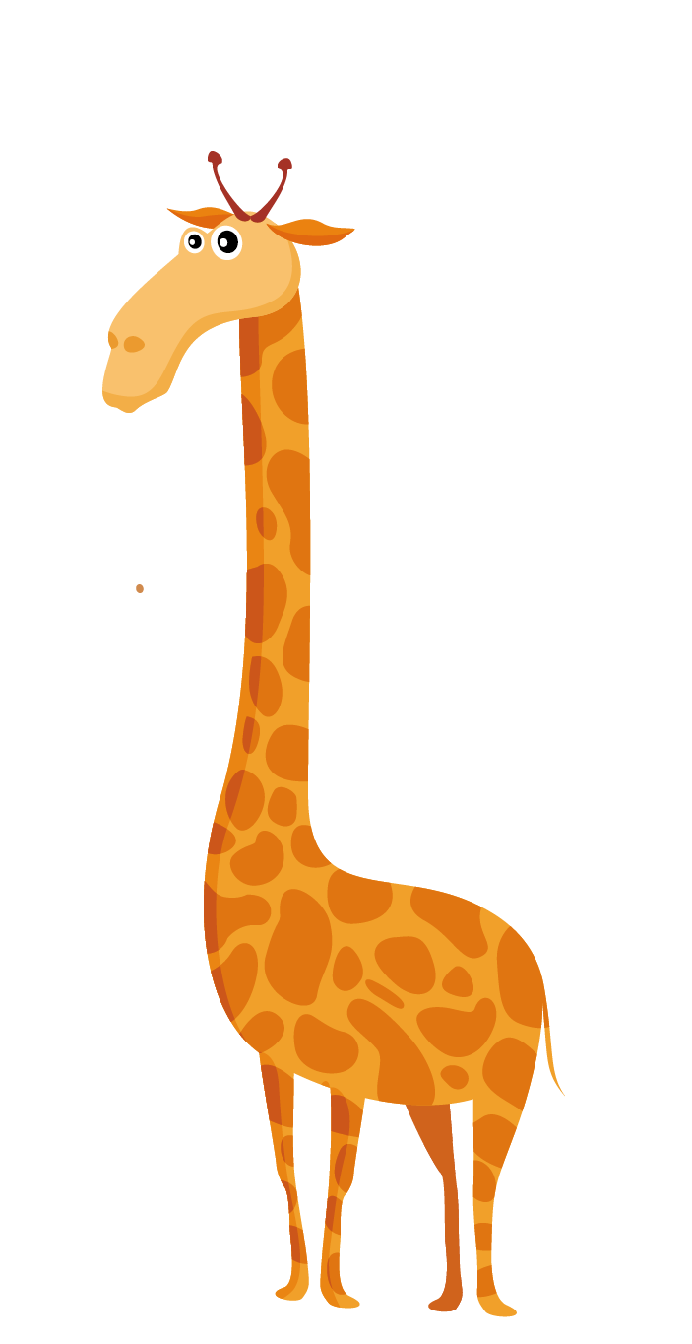 | 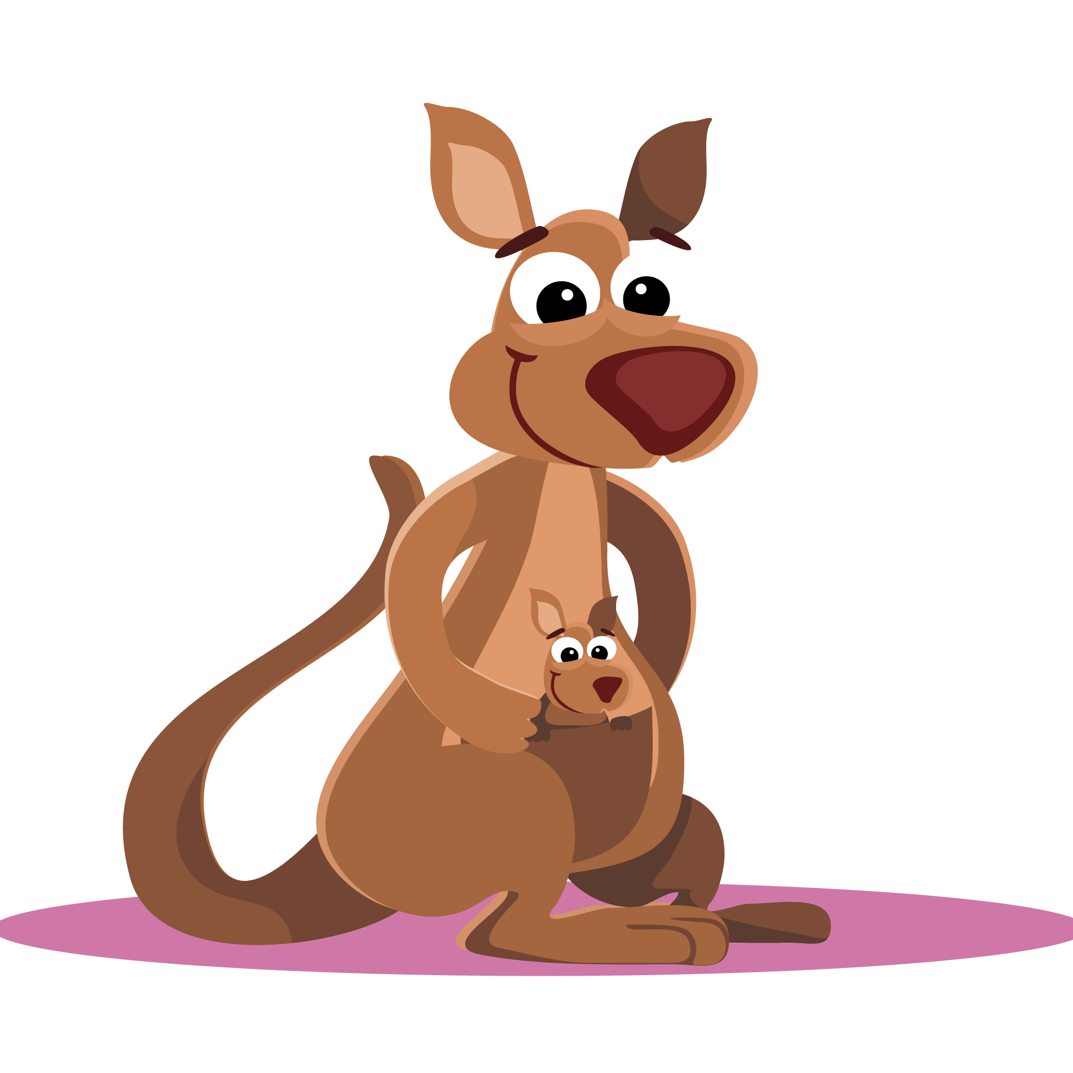
A | B | C
正确答案：B

- Lucy如何回答Ann的问题呢？请你选择一个正确的答语。

Do you like tigers?
D

_


A. Yes, I do. I like big animals.
B. There are two tigers.
C. No, there aren’t.
正确答案：A

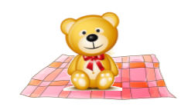
- 请你选择一个和图片相符的句子。
- The dog is sitting on the mat.
- The bear is sitting on the mat.
C. The bear is sitting on the chair.
正确答案： B

- 读句子，根据句子的提示，选择正确的图片。
-Lily likes big animals. It has a long nose. It’s very strong. What animal is it?
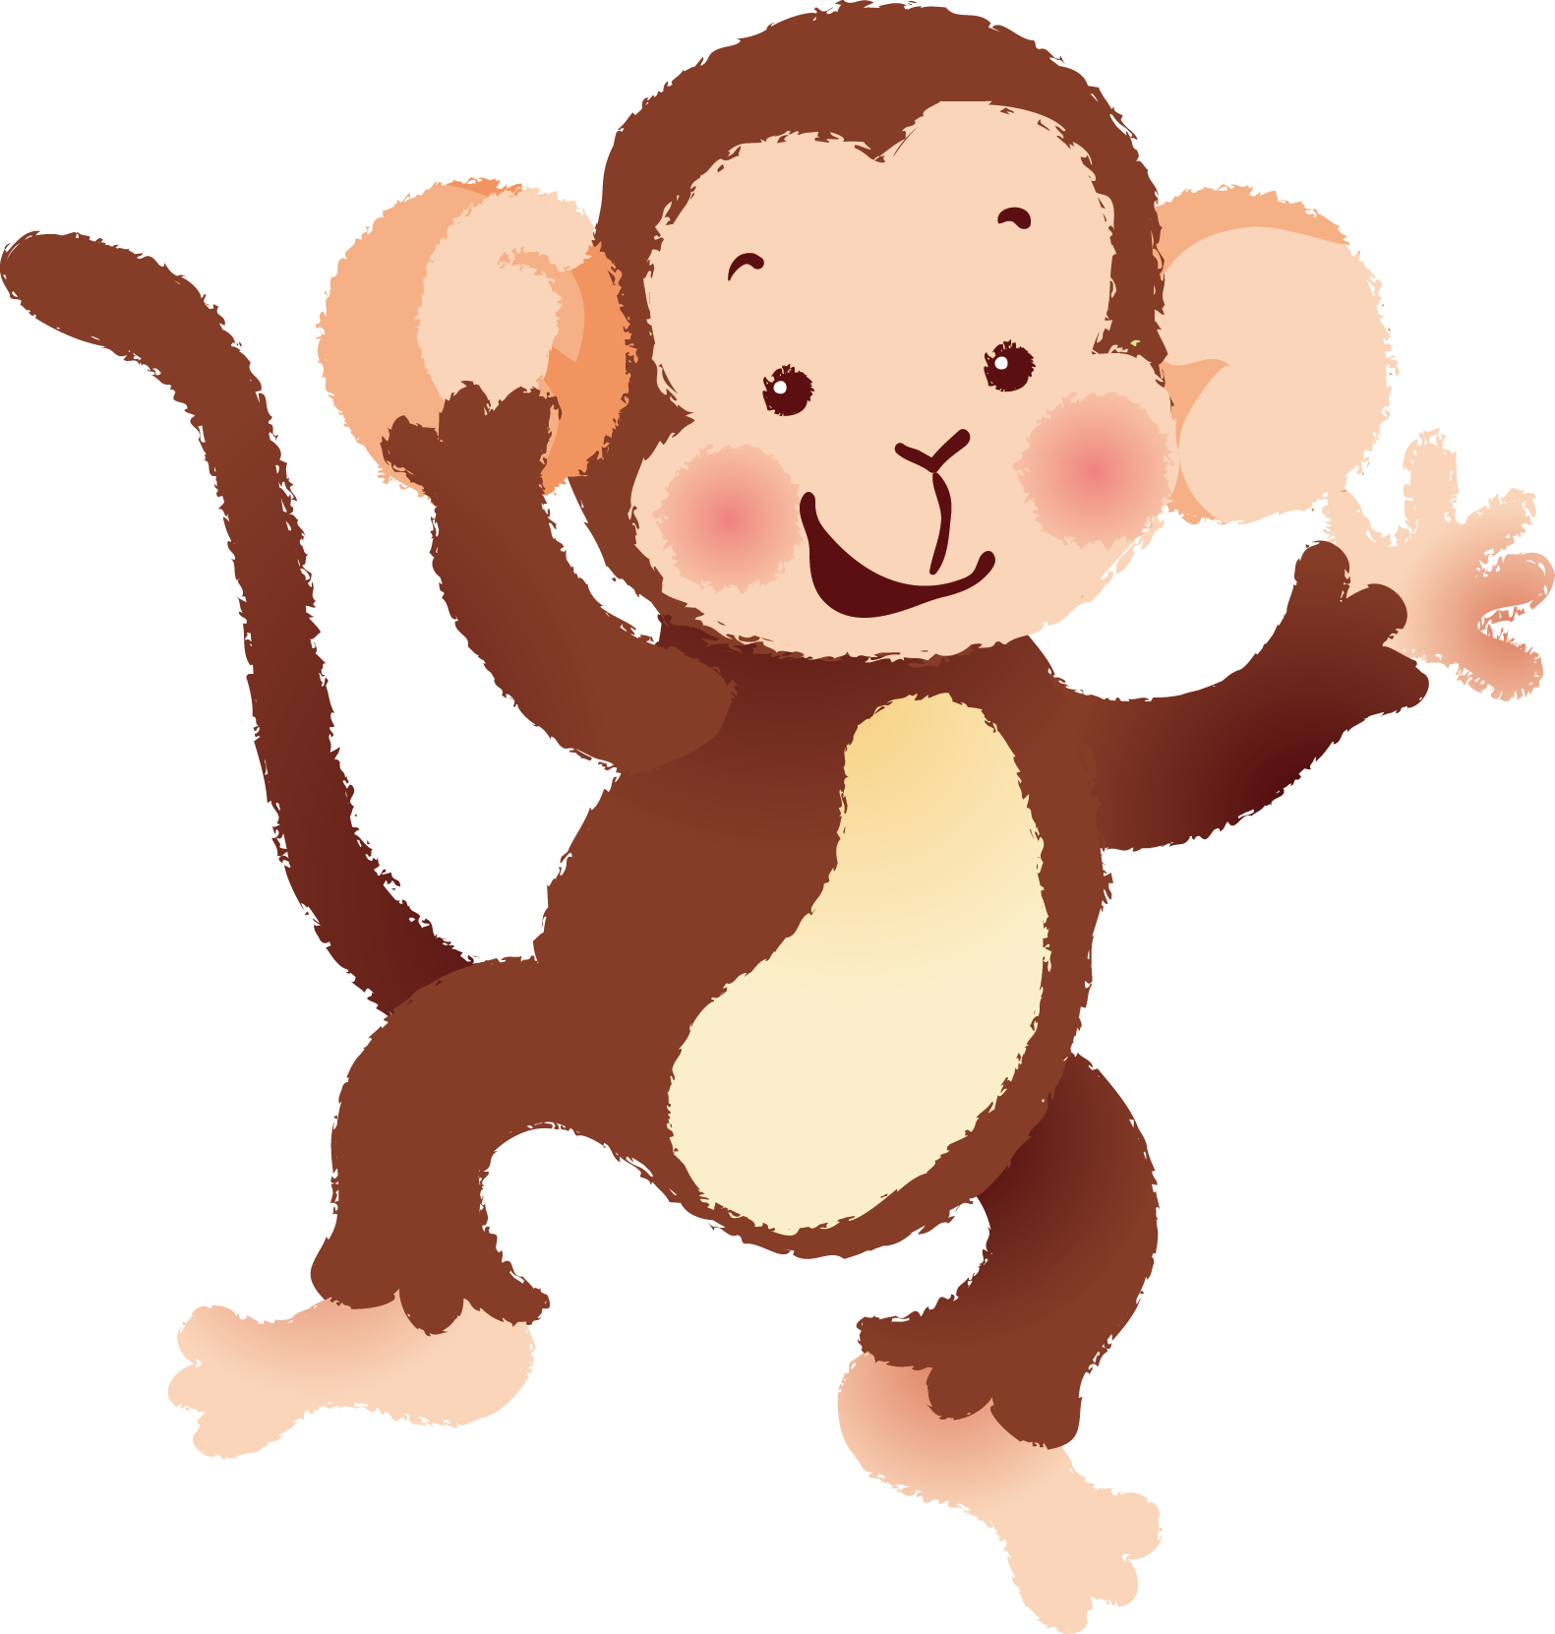 | 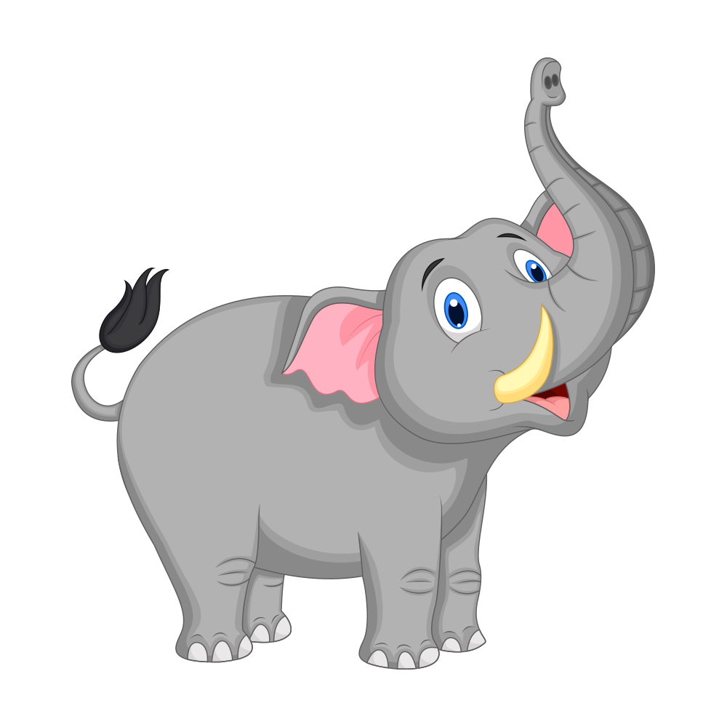 | 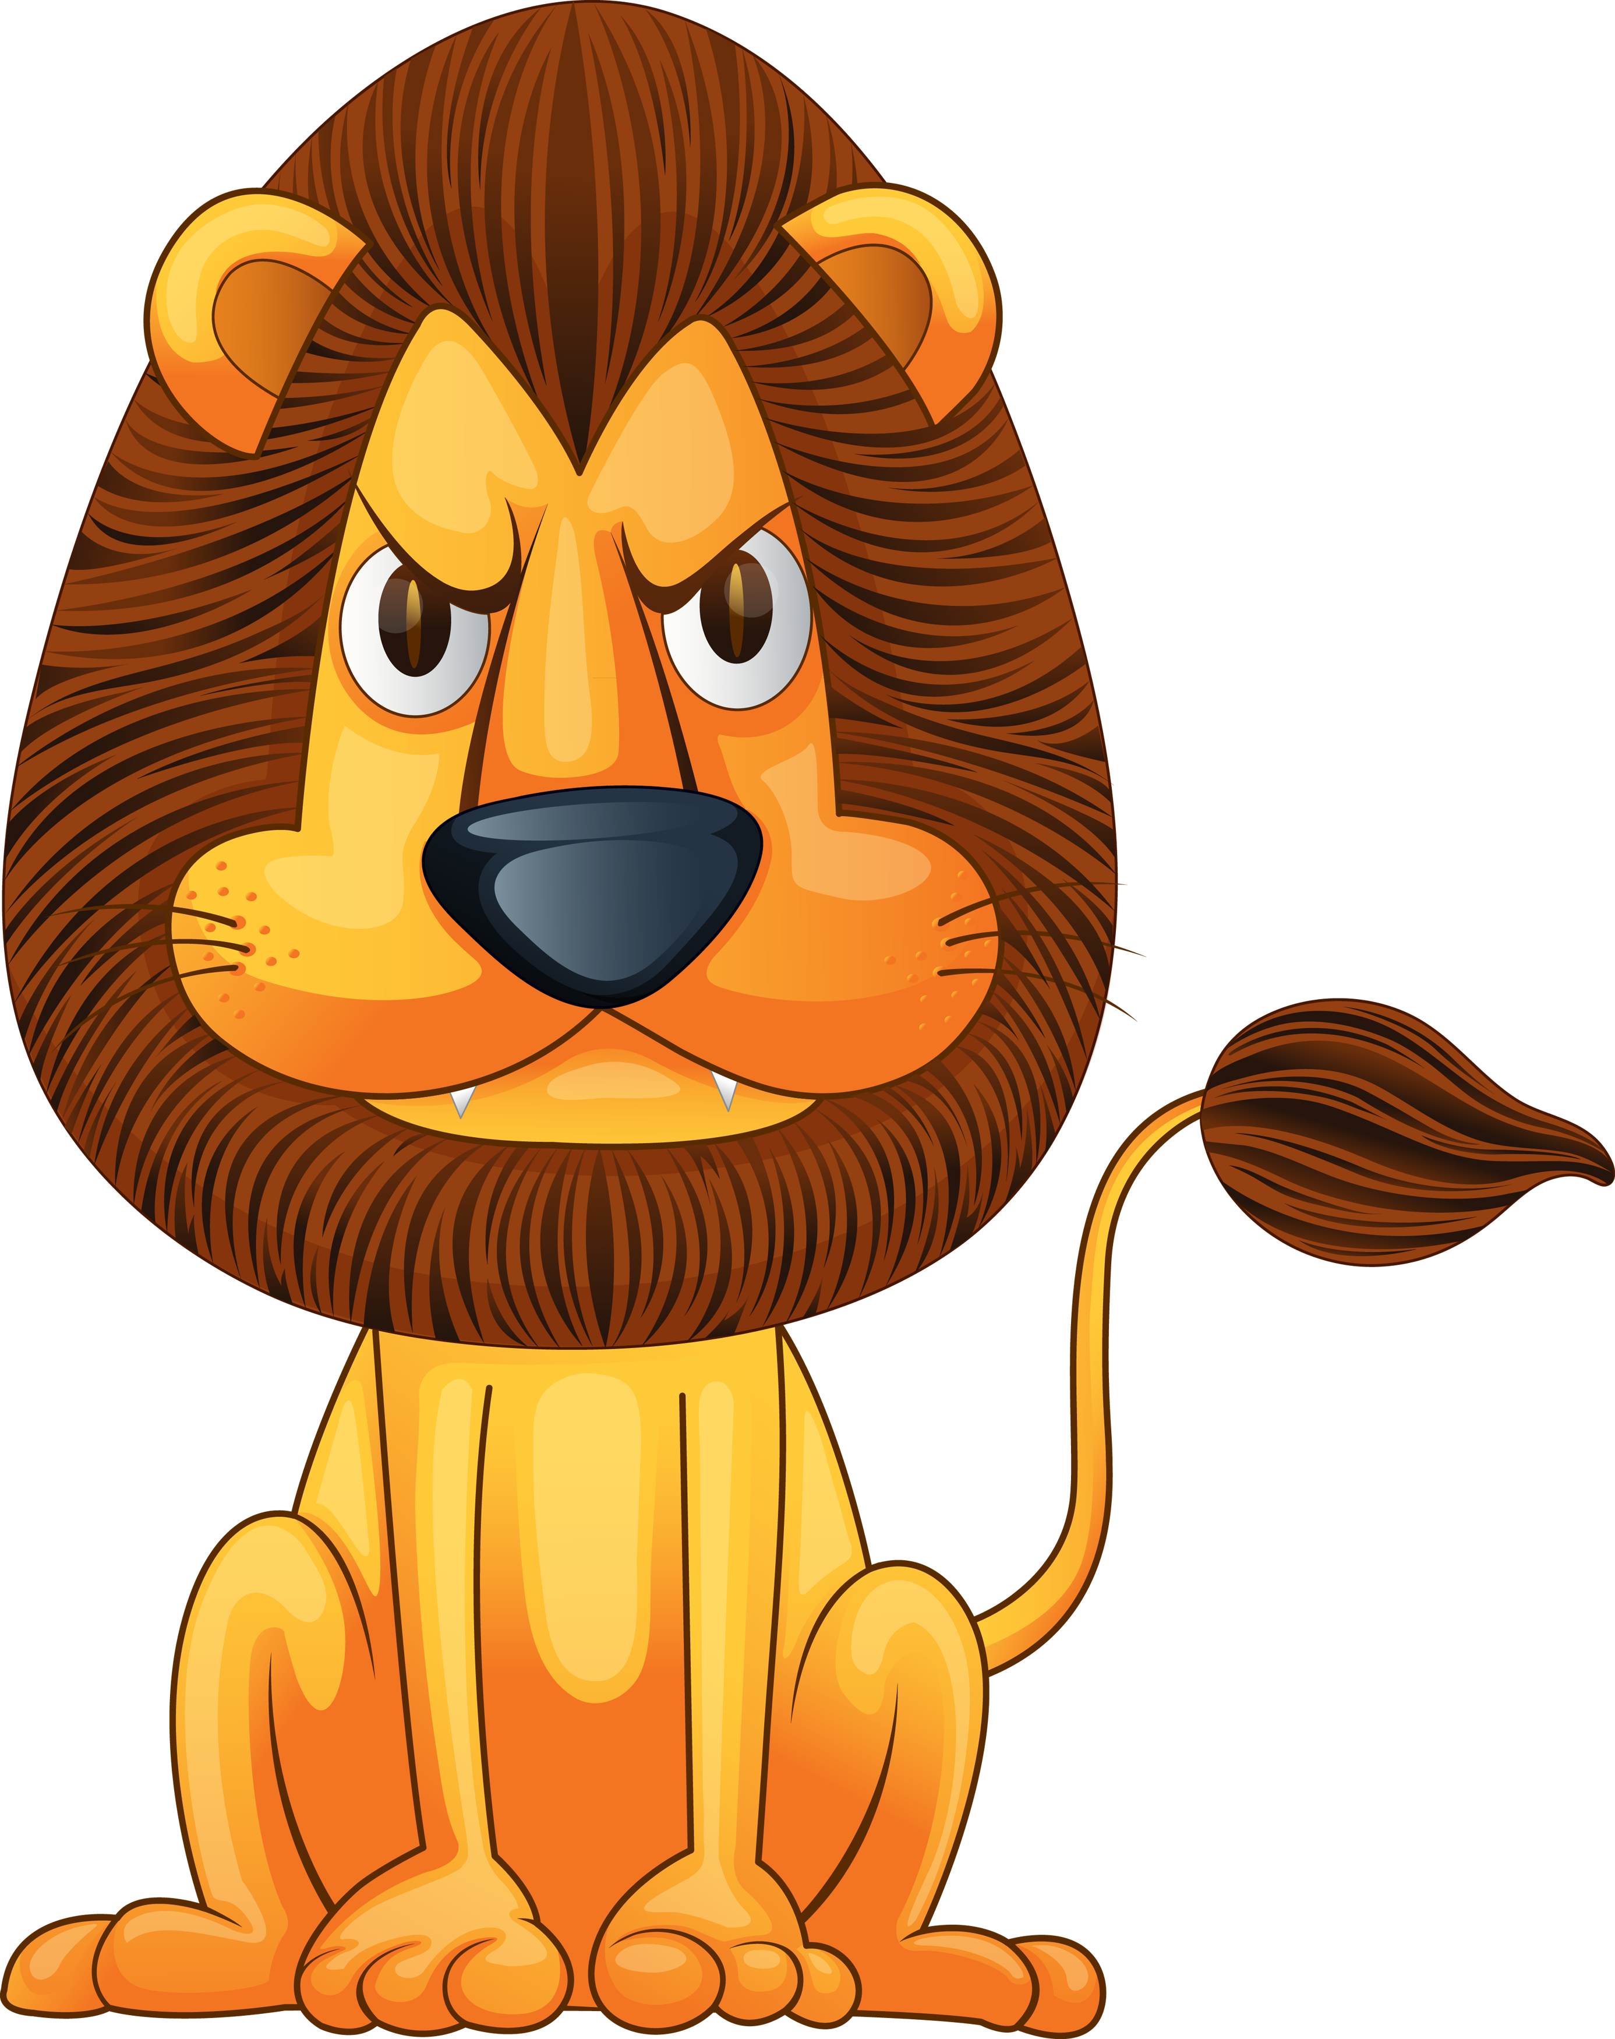
A | B | C
正确答案：B


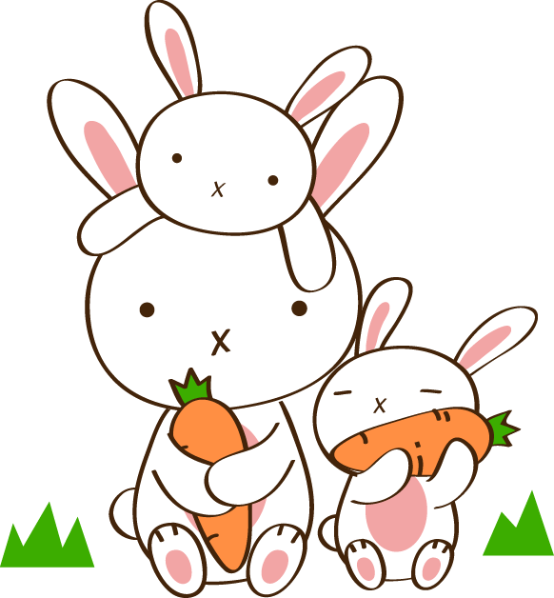

- 根据图片，选择正确的单词将对话补充完整。
-Do you like ________?
-Yes, I do. I like ______, too.
A. cats, zebras
B. cats, rabbits
C. rabbits, dogs
正确答案：B

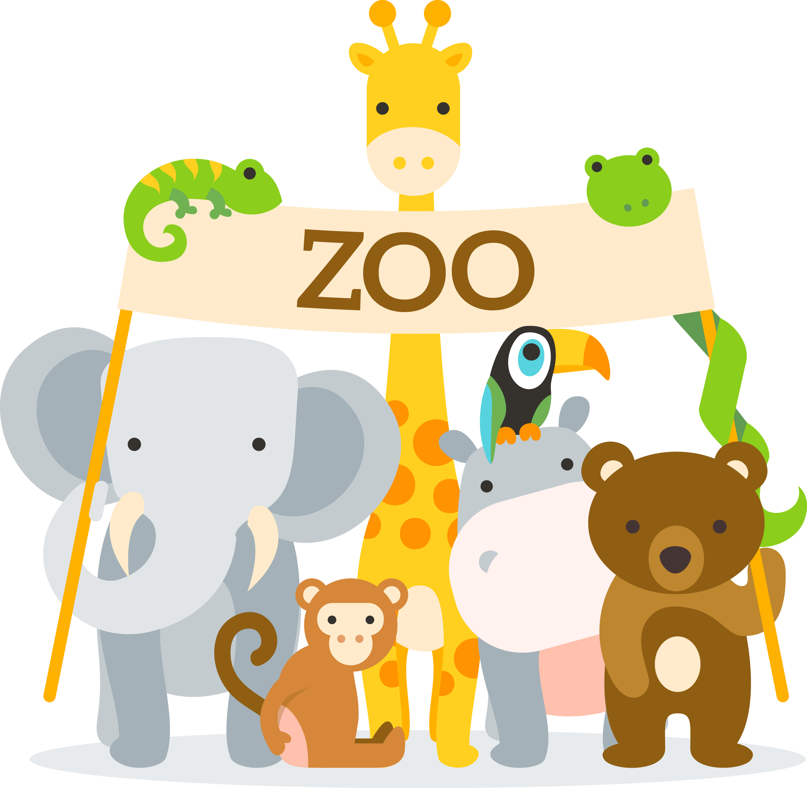
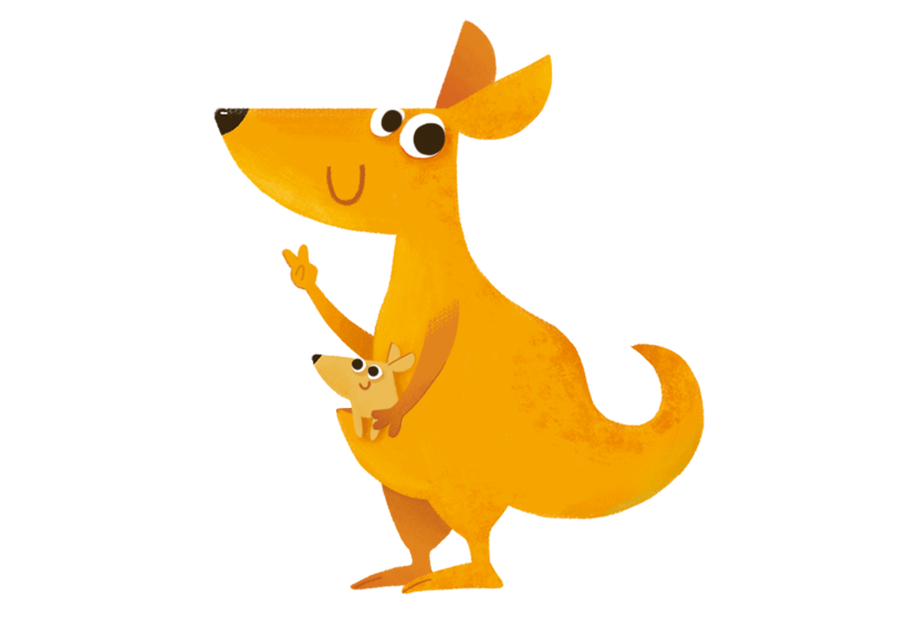
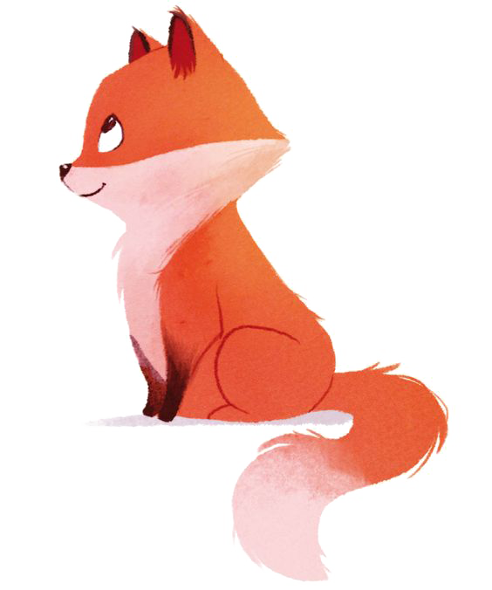
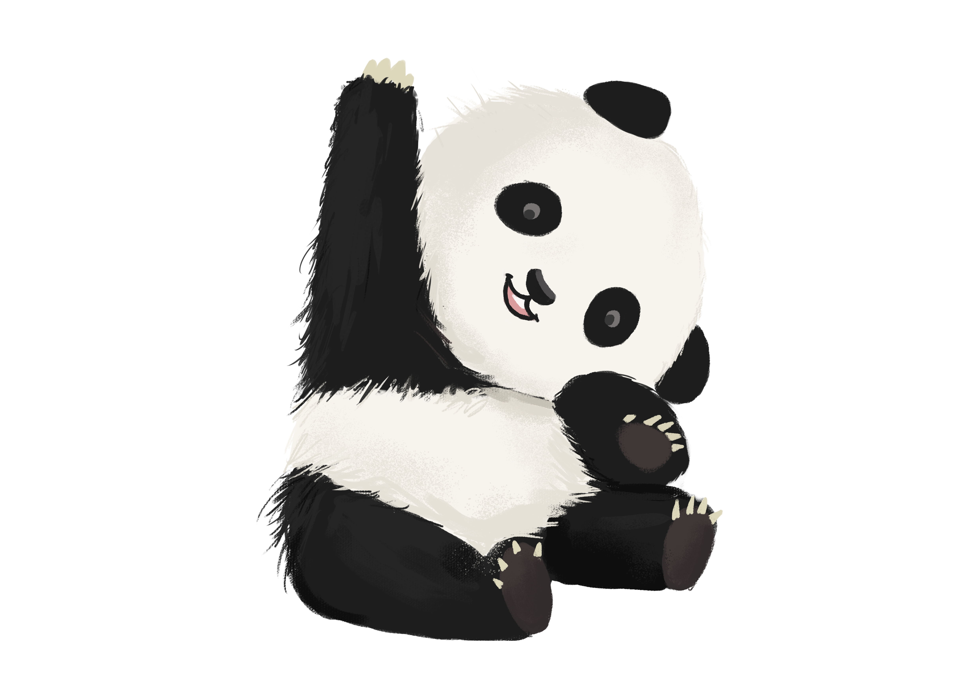
- 下面哪句话的信息在图片上没有显现？
A. There is an elephant.
B. The giraffe is tall.
C. There are four baby cats.
正确答案：C

- 阅读小短文，判断句子对错，对的打√，错的打×。
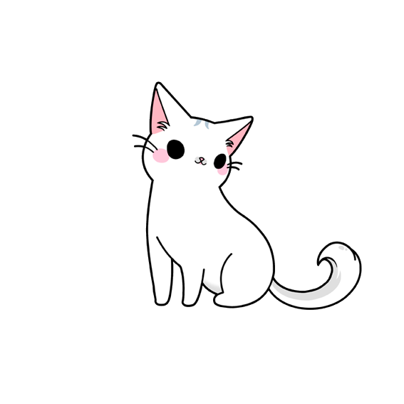

Jack has a dog. It is small and fat. It likes to eat hot dogs. I have a cat. My cat’s name is Kitty. She is white. I go to Jack’s home with Kitty. They like to play together. They are so cute.

（ ）Kitty is a dog. She is white.
A. × B. √
正确答案：A

