**课题： Unit 5 Lesson 3(1)——学习任务单**

**【学习目标】**

1. **获取有关南极点争夺赛的事实性信息；**
2. **梳理斯科特队到达南极和返程过程中的情感变化；**
3. **分析并评价斯科特队在此次南极比赛中的得与失。**

**【学法指导】**

1. **通过关注每段中心句和关键词，获取文章的主要信息。**
2. **研读文本时，要关注文本的主线，即行文的逻辑。**
3. **通过结合上下文语境，猜测词义，推断人物内在情感。**

Task 1.Read the text and underline the answers to these questions.

1. Who took part in the race?
2. When did the race begin?
3. What was the result?

Task 2. Add more information about the two exploration teams on the map.

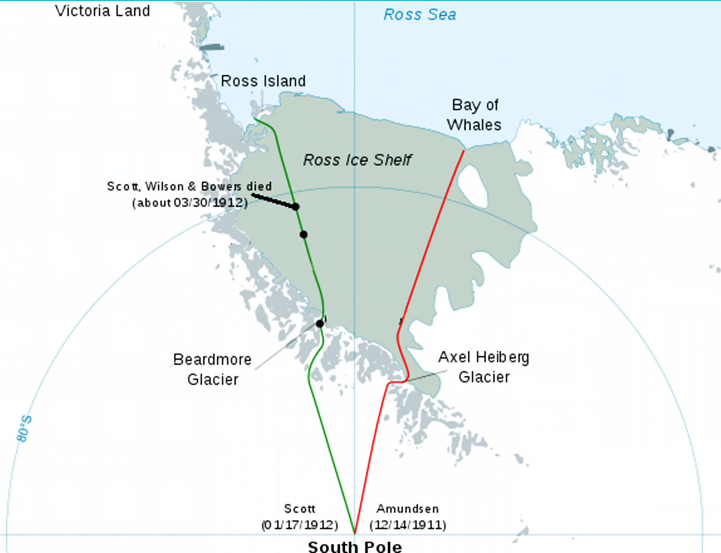

Task 3. Summarize the change of feelings on Scott’s team’s return journey. Give your reasons.

Occasions: feelings: Reasons:

Task 4. Think and voice your opinions.

1. Why do you think Scott’s team lost the race? Can you give any suggestions for better preparation?
2. Would you say that Scott’s team were losers? Why or why not?