1.果果第一次来到毛毛家，毛毛是怎么把果果介绍给妈妈的呢？

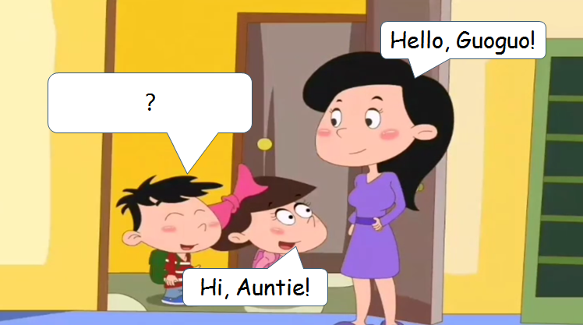

1. My name is Guoguo.
2. Mum, this is my friend, Guoguo.
3. Good afternoon, Mum.

正确答案：B

2.初次见面的Lala和Kate，是怎么相互打招呼的呢？请你帮助拉拉做出回答。

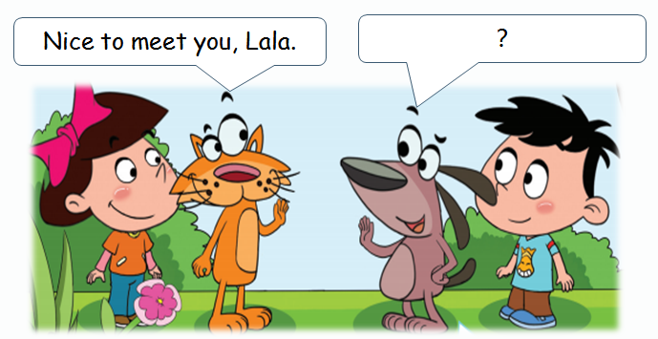

1. Nice to meet you, too.
2. I’m fine, thank you.
3. This is my friend, Maomao.

正确答案：A

3.班里来了一位新同学Lily，你会怎么和她打招呼呢？

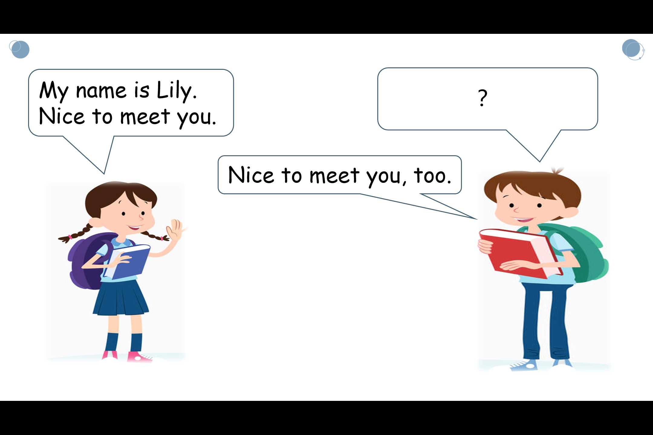

1. Hi, my name is Andy. What’s your name?
2. How are you?
3. This is my friend, Baobao.

正确答案：A

4.如果你是小男孩安迪，你会怎样把自己的朋友洋洋介绍给新同学Lily呢？

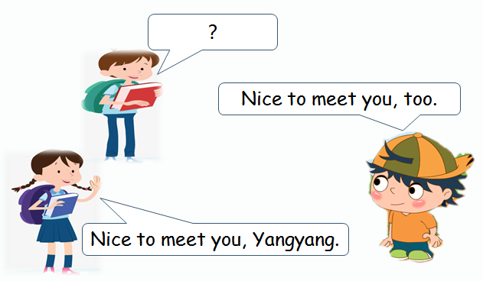

Andy

1. What’s your name?
2. This is my friend, Yangyang.
3. Good afternoon, Yangyang.

正确答案：B

5.Kate想把朋友Lala介绍给小鱼认识，她是怎么说的呢？

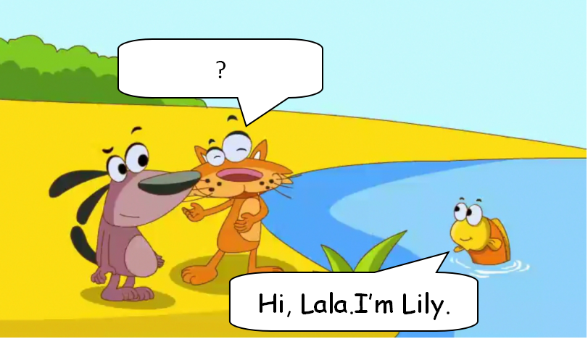

1. Hi, little fish. My name is Kate.
2. Hi, little fish. This is my friend, Lala.
3. How are you, little fish?

正确答案：B

6. 读小诗，回答问题。

I see the moon,

[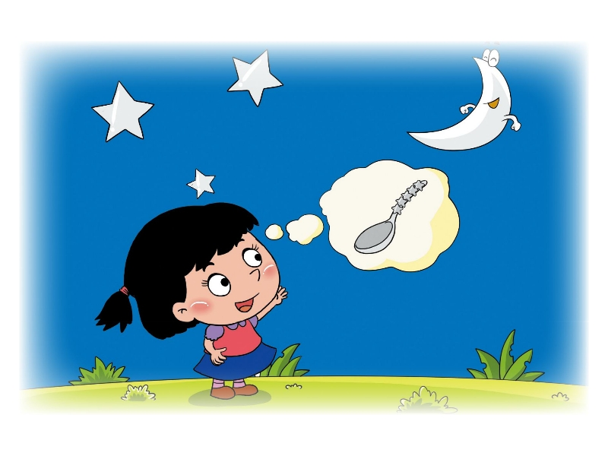](L14Lets.swf) Like a big spoon.

I see the moon,

Like a silver spoon.

请问我看到的月亮像什么物品呢？

A. moon

B. spoon

C. dish

正确答案：B

1. 请选出与图片对应的单词:

[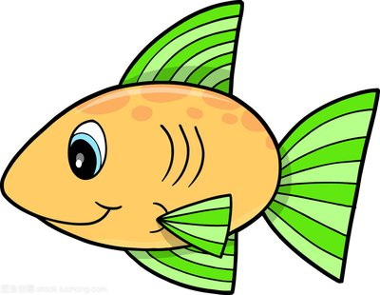](https://stock.tuchong.com/image?imageId=253773374031134783&source=360tusou)

1. a dish B. a fish C. a cat

正确答案：B

1. 请选出与图片对应的单词:

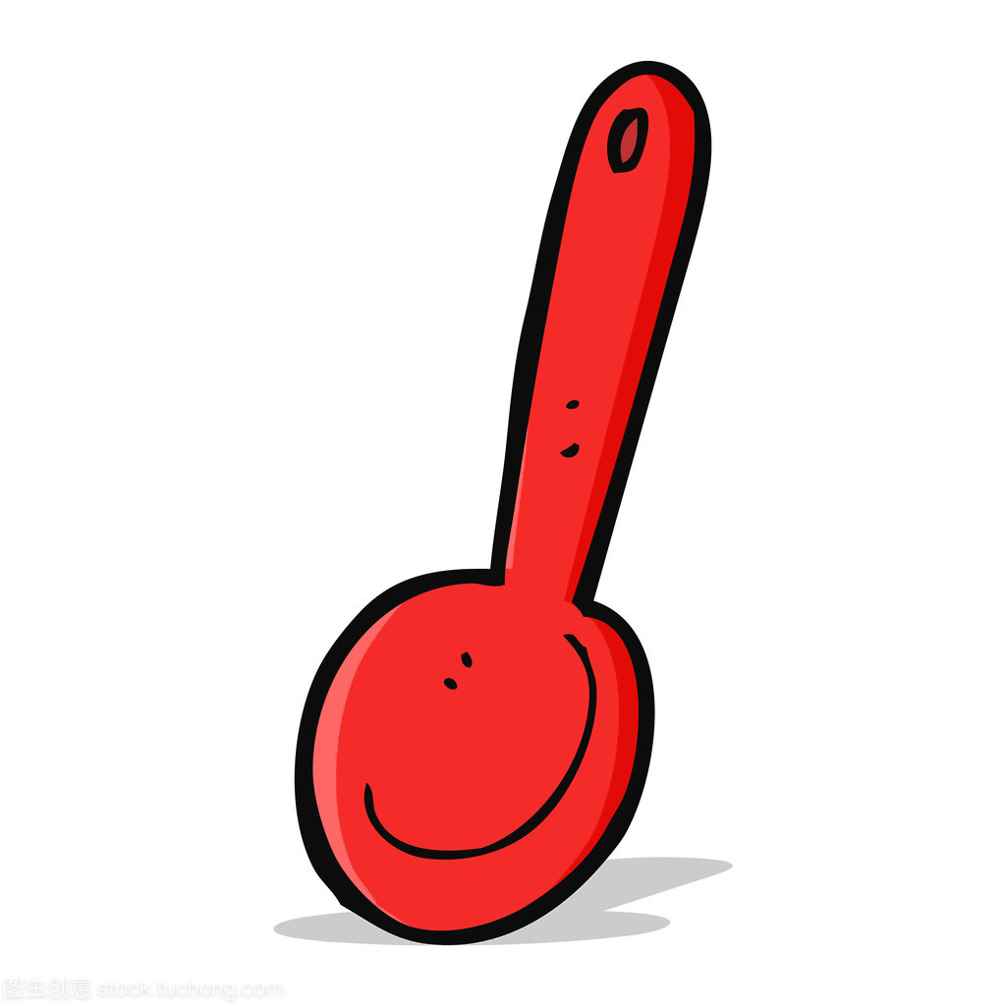

1. a cup B. the moon C. a spoon

正确答案：C

1. 请选出与单词对应的图片:

eyes

A.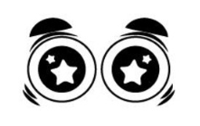B.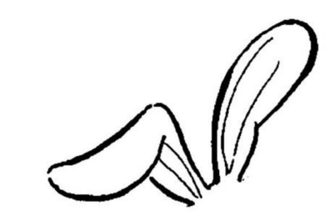C.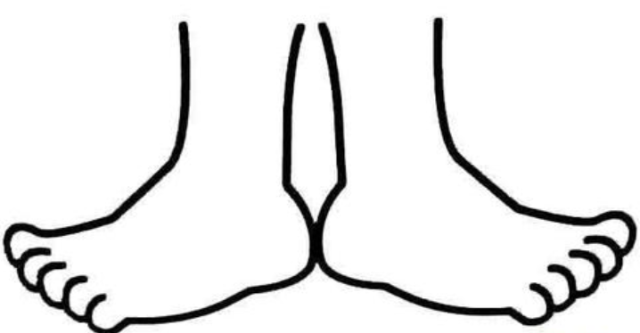

正确答案：A

1. 请选出与句子对应的图片:

Good night, close your eyes.

1.  B.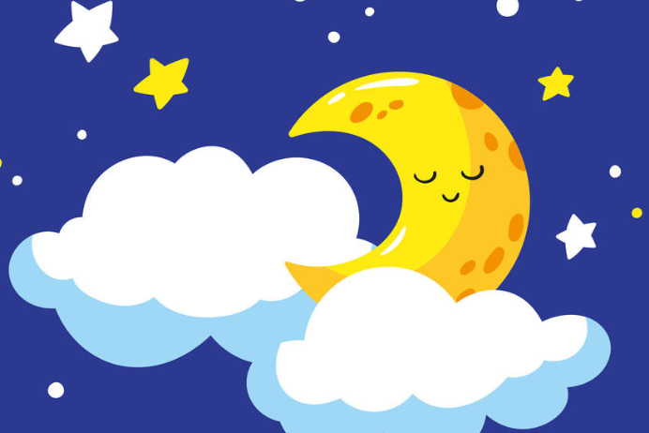 C.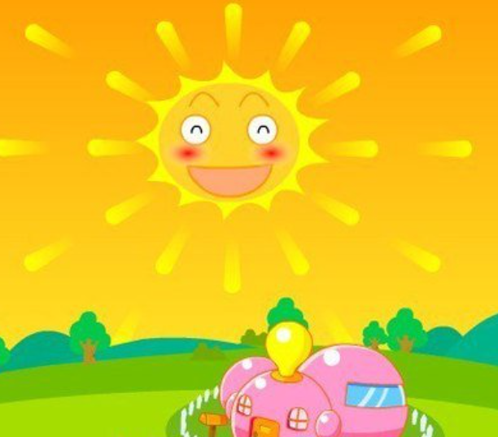

正确答案：B