**《语法填空》二轮复习解题指导 学习指南**

**【学习目标】**

1. 在语篇中准确运用语法知识；

2. 在语篇中运用所学语法知识与解题策略，正确地理解和使用时态语态、非谓语、复合句三大高考重点内容。

**【学法指导】**

1.意识到语言使用中的语法知识是“形式一意义一使用”的统一体，学习语法的最终目的是在语境中有效地运用语法知识来理解；

2.在语篇中理解和正确使用高考三大核心考察点：时态语态、非谓语动词、复合句。

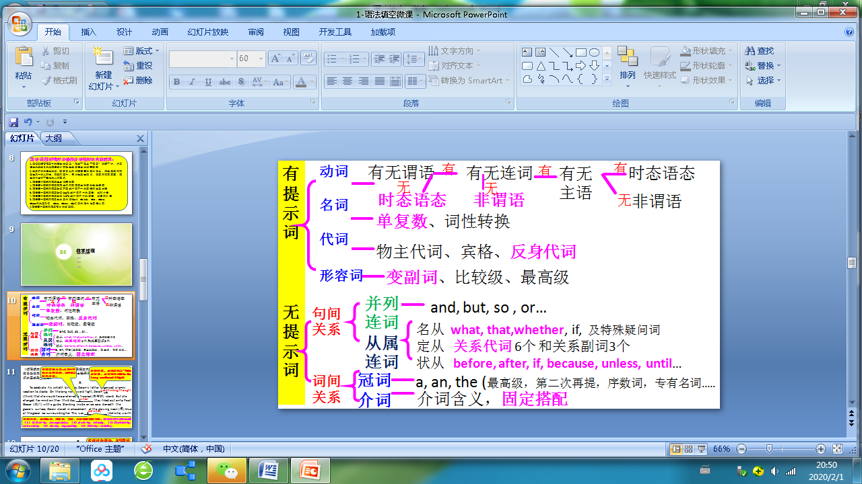

**【学习任务】**

阅读下列短文，根据短文内容填空。在未给提示词的空白处仅填写 1个适当的单词，在给出提示词的空白处用括号内所给词的正确形式填空。

2019朝阳一模

**A**

John Carter was rescued from the sea near his holiday home yesterday. The accident happened while he __1__ (walk) along a steep cliff at the edge of the sea. He was blown off by a strong wind and __2__ (fall) into the sea, 30 meters below. Luckily, a woman saw him in the sea soon afterwards and she called the police rescue service. Mr. Carter was taken to hospital with a __3__ (break) arm. “I’m very lucky to be alive,” he said. “I can’t thank the woman enough.”

**B**

Many elephants can paint. In fact, elephants in zoos sometimes draw on the ground __4__ a stick. Seeing this, some trainers teach the elephants __5__ they can hold paintbrushes, and encourage them to choose colors and paint. Of course, not every painting is good. Just like humans, only some elephants are very creative. Now, an online gallery sells paintings by these elephant artists. By doing this, the gallery hopes to earn money __6__ (protect) elephants.

**C**

Golden Gate Park is in San Francisco, California. It is one of the largest urban __7__ (park) in the United States. Over one million colorful flowers, trees and other plants grow in the park. But originally most of the park __8__ (cover) in sand. After a lot of work, it was finally built in 1870. Today, there are many people __9__ (visit) the park every day. They play basketball, soccer, golf and many other sports there. The park is closed in many places to traffic so people can walk, cycle, or skate __10__ (free).

**海淀区一模**

**A**

Old Tom had four sons. He wanted them 1 (learn) not to judge things too quickly. So he sent them to look at an apple tree in different seasons. The first son went in winter, the second in spring, the third in summer, and the youngest in autumn. When they all came back, he called them together to describe 2 they had seen. The sons had different 3 (opinion). Tom then told them that they shouldn’t judge a tree, or a person, by only one season.

**B**

Everyone 4 (love) snow. But when school stays open despite the snow, it can be really annoying. However, there is one upside of going to school 5 a cold winter day: you might be smarter. So far, researchers who study the brain 6 (find) that cold temperatures make us think more quickly since messages travel faster among our brain cells. So the scientists say 7 (hang) out on a cold morning may boost the result of any test that day.

**C**

A black hole is a spot in space that has 8 (power) gravity. Its gravity is so strong that it pulls everything nearby into it, stars, planets and other things. Black holes form when a star dies. When that happens, a huge amount of matter crowds into a very small space, 9 becomes very dense. Black holes 10 (talk) about in 1783 first. That year, one scientist said that in the universe, there might be places with strong gravity to trap light, although he didn’t use the term “black hole”.

**东城区一模**

**A**

Tons of waste is being left on Mount Qomolangma by a 1 (grow) number of

visitors, which bothers many people. A team will deal with the task 2 the climbing

season ends this May, by which time there will be fewer visitors.Garbage

3 (collect) on Qomolangma requires two to three years of training, according to Cering Dandar, a mountaineer and guide.

**B**

Food is one of the most basic and important daily needs. It gives us the strength and energy we need 4 (work) and play. Food also plays a role in our social interactions. Whether we 5 (celebrate) important occasions or just relaxing with friends, eating is an important social pastime. It is also an important part of our culture. 6 a particular people like to eat can tell us a lot 7 a country’s geography, history and traditions.

**C**

Going to museums has become a trendy thing to do during the holidays in China. A popular choice this Spring Festival was the Palace Museum, 8 a special exhibition was staged to provide a virtual royal experience for visitors. The entire museum

9 (decorate) with newly-restored ancient royal lanterns and spring couplets, including a set of the Chinese character “Fu” 10 (write) by five Qing Dynasty emperors.

**西城区一模**

**A**

I often help my mom cook and baked chicken is my favorite thing to make. One day, when mom was sick, I tried to make the chicken all by myself. I washed the chicken and put it in a pan in the oven 1 (bake). When the bell rang to tell me the chicken was done, I opened the oven door. Guess what? The chicken was not cooked! I started to laugh. I forgot to turn 2 the oven! Did you know what I did next? I 3 (order) pizza. Mom was happy I “cooked” by myself and we could eat the pizza together.

**B**

Chocolate was first used as a drink over 3,500 years ago in Central America. It was very popular with the Mayans and the Aztecs. In fact, cocoa beans were very important to people there. That was 4 they were used as money. In the beginning, cocoa 5 (plant) in Ecuador, which was, for a long time, the world’s number-one producer of cocoa beans. It is still one of the top 6 (producer) of the beans, but nowadays more than 70 per cent of cocoa beans come from West Africa.

**C**

Wallace’s giant bee is the world’s 7 (large) bee, with a body the size of a human thumb and wings that can spread to about 2.5 inches. That may sound 8 (frighten), but the bee isn’t likely to hurt anyone. It uses its large jaws (嘴) to collect a sticky goo, called resin, from trees. The bee 9 (make) its home in termite mounds (白蚁丘) found on trees, using the resin to protect its nest from the termites. Until recently, the bee had been seen by scientists only 10 (two), once in 1868 and again in 1981.

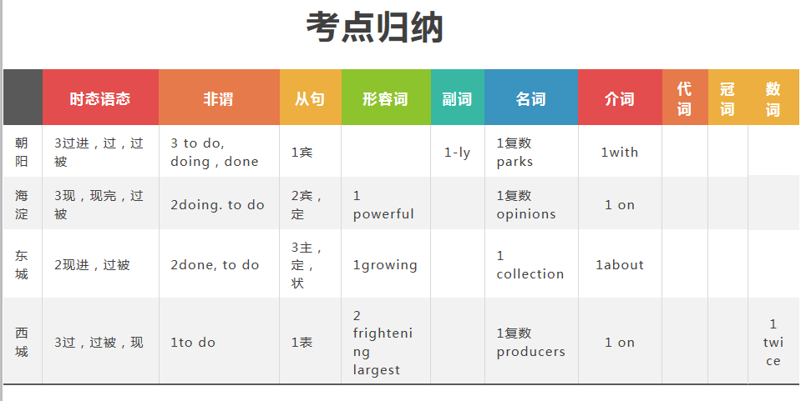

**答案与解析**

**朝阳一模：**

1 was walking考查动词的时态。根据 happened可知,时间为过去,此处表示“正走在……时”,应用过去进行时,因此填 was walking。

2 fell考查动词的时态。此处and连接两个并列谓语,前面为 was blown off,谓语动词应用一般过去时,故填fell。

3 broken考查非谓语动词。手臂被摔断,因此用过去分词 broken。

4 with考查介词。with后面加工具表示“用……”。

5 how考查宾语从句连词。设空处前后句子的结构都完整, 此处表示“如何”拿画刷。

6 to protect考查非谓语动词。此处表示目的,应用动词不定式。

7 parks考查名词。 one of 后面应加可数名词的复数。

8 was covered考查动词的时态和语态。本题根据 originally和后边的in1870可知,时间点在过

去,应用一般过去时;所给词 cover与 most of the park之间为被动关系,应用被动语态,因此填 was covered。

9. visiting考查非谓语动词。动词visit和被修饰词 many people之间是逻辑上的主动关系,因此用现在分词 visiting。

10.freely本题考查副词。设空处修饰动词“walk,cycle, or skate”,因此用free的副词形式 freely,意为“自由地”。

**海淀一模：**

1.to learn考查非谓语动词。want sb. to do sth.是固定用法,意为“想让某人做某事”。

2.what/ whatever考查宾语从句。句中作动词“seen”的宾语,意为“...的东西”或“……的任何东西”。

3.opinions 考查名词.opinion在此处意为“意见,看法”,是可数名词;根据空格前的“ different”可知,此处应用复数形式。

4 loves考查动词的时态和主谓一致。根据语境可知,此处叙述的是客观事实,应用一般现在时;且主语“ Everyone”表示单数概念,谓语动词应用第三人称单数形式。

5.on考查介词。表示在具体的某一天应用介词on。

6.have found考查动词的时态。根据时间状语“ So far”可知,此处应用现在完成时。

7 .hanging考查非谓语动词。分析句子结构可知,“________out on a cold morning”在宾语从句中作主语,应用hang的动名词形式表示一般性或抽象动作。

8.powerful考查形容词。此处应用形容词修饰名词“ gravity”。根据下一句中的“ so strong”可知,此处应指强大的引力。

9.which考查非限制性定语从句。分析句子结构可知,空格处引导非限制性定语从句,先行词是 space,指物,关系词在从句中作主语,应用 which引导该从句。

10. were talked考查动词的时态和语态。根据该句的时间状语“in1783”可知,此处叙述的是过去发生的事,应用一般过去时;主语“ Black holes”和谓语动词 talk about之间是被动关系,应用被动语态。

**东城一模：**

1.growing考查形容词。句意为:越来越多的游客在珠穆朗玛峰上留下了大量的垃圾,这让很多人感到困扰。此处应用形容词修饰名词number, growing意为“增加的,增长的”,符合语境 。

2.when/ after考查连词。根据语境可知,此处指一支团队将在今年5月登山季节结束后处理这项任务。此处可用after引导时间状语从句,表示“在5月登山季节结束之后”;也可以用when引导从句,表示“当5月登山季节结束时”。

3 collection考查名词。分析句子结构可知,“ Garbage _________ on Qomolangma”是本句的主语,空格处应填名词 collection;且谓语动词 requires是第三人称单数形式,所以此处应用名词collection的单数形式。

4. to work考查非谓语动词。句意为:食物为我们工作和玩耍提供了所需要的力量和能量。“ we need”是定语从句,先行词是“ strength and energy,"根据句意可知,此处应用动词不定式表示目的。

5.are celebrating考查动词的时态。句意为:不管我们是在庆祝重要的时刻还是正在和朋友享受休闲时光,饮食都是一种重要的社交消遣方式。or连接两个并列的谓语动词,根据or后面的谓语动词 relaxing可知,此处应用现在进行时,表示此刻动作正在进行。

6.What考查主语从句。分析句子结构可知,空格处引导主语从句,且在从句中作eat的宾语,意为“…的东西”,应用what引导该从句。注意首字母大写。

7. about考查介词。tell sb. about sth.是固定用法,意为“告诉某人某事”。

8 .where考查定语从句.句意为:今年春节最受欢迎的选择是故宫博物院,那里举办了一个特别的展览,为游客提供一次虚拟的皇家体验。分析句子结构可知,空格处引导定语从句,先行词是“the Palace Museum”,关系词在从句中作地点状语,应用 where引导该从句。

9. was decorated考查动词的时态和语态。根据语境和上一句中的“was”可知,此处叙述的是

过去发生的事,应用一般过去时; 动词“ decorate”与主语“The entire museum”之间是被动关系,应用被动语态。

10.written考查非谓语动词。分析句子结构可知,本句的谓语动词是was decorated,所以此处write要使用非谓语动词形式;且动词“ write”与“ Chinese characterFu”之间是被动关系,所以应用过去分词作后置定语,修饰“ Chinese character Fu”。

**西城一模：**

l. to bake考查非谓语动词。句意:我洗了鸡,把它放入烤箱的盘子里烤。由句意可知,此处填不

定式表示目的。

2.on考查介词。句意:我忘记打开烤箱的电源了! turn on打开。

3. ordered考查时态。句意:我点了披萨。由全文时态可知,用一般过去时。

4.why考查连词。句意:这就是可可豆曾经被用作钱币的原因。固定句型: That was why..这

就是……的原因。

5.was planted考查时态语态。句意:一开始,可可豆在厄瓜多尔种植。由句意可知,此处用被动

语态; 再由全文可知,应该用一般过去时。

6.producers考查名词。句意:厄瓜多尔仍然是可可豆最大的生产地之一。 One of后接名词的复数形式,表示“……之一”。

7.largest考查形容词。句意:华莱士巨蜂是世界上最大的蜂。由空前的the可知,此处填其最高级。

8. frightening考查形容词。句意:这听起来非常可怕,但是华莱士巨蜂不可能伤害人。 sound

是系动词,所以此处填形容词;主语that指物,故填 frightening。

9.makes考查时态。句意:华莱士巨蜂在白蚁丘中筑巢,利用树脂保护蜂巢遭白蚁破坏。由全文时态可知,此处填一般现在时。

10.twice考查数词。句意:直到最近,华菜士巨蜂也仅仅在1868年和1981年被科学家看到过两次。twice两次,两遍。