9年级英语第15课时 课时作业答案

一、请在题目原文做标注和笔记进行审题。

（本部分答案略）

二、请在以下空白处进行写作架构并做草图。

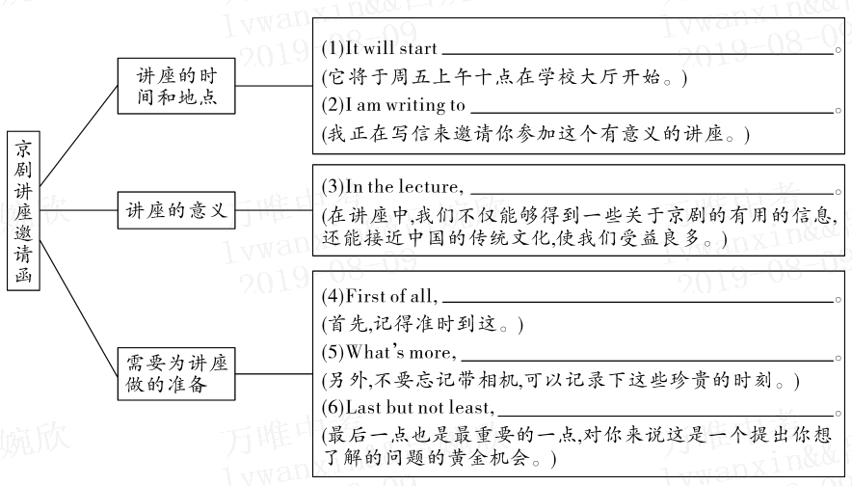 草图仅供参考

三、请在下面横线上完成文段写作。（参考范文）

Dear Peter,

How is it going?

There’ll be a lecture on Peking Opera in our school. It will start at 10 : 00 this Friday morning in the school hall. I am writing to invite you to take part in the meaningful lecture. In the lecture, we can not only get some useful information about Peking Opera, but also get close to the traditional Chinese culture which can benefit us a lot.

There are some suggestions for you to prepare for it. First of all, remember to be there on time. What’s more, don’t forget to bring a camera with you, which can record the precious moment. Last but not least, it’s a golden chance for you to come up with some questions that you are willing to learn about.

If there is anything that I can do, please let me know.

Yours,

Li Hua