**9年级英语第13课时 学习指南**

**【学习目标】**

本节课结束时，我们能够：

1. 通过题目和图片，预测文本内容；通读全文，获取文本大意；
2. 通过整体分析文本，理解文章主要情节和主人公的情感变化；
3. 根据文本主旨及上下文语境，选择最佳词汇补全文本；
4. 搜集并掌握文中出现的一词多义及熟词生义词汇。

**【学习任务单】**

**任务1、关注题目和配图，预测文本内容；通读全文，了解文章大意；**

**任务2、分析文本，画出文章的主要情节和人物的情感变化结构图：**

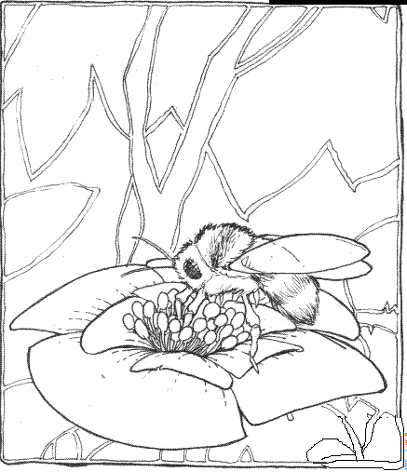**An Imperfect Painting**

My parents always wanted me to be “on top”, so from early on I had the __1___ to be the best in everything, from getting the highest score in a spelling test to running fastest in a race.

In middle school，I realized how many other smarter and faster people there were. It became ___2___ that I was not the best any more, but my parents still held on to their hope and forced me to try hard. To their disappointment, I became less confident and didn’t want to work harder because, to me, there was no point in making any more ___3___ if I was unable to be number one. My grades began to fall; I never practiced the piano; I ___4___ painting. It was all because my motivation(动力）to do anything had dropped much.

When high school started, I was at a new school in a new city. I __5__ to get back my motivation and start over. So I picked up my ever favorite hobby again and enrolled(报名)myself in the art course. ___6___ , our art teacher, Mr. Grady, gave us more freedom with our art projects. He would always encourage us to realize our potential(潜力).

My first painting was simply a bee sitting on a sunflower, I tried my best, but still found it was not ___7___ and could hardly get a good grade. But I showed it to Mr. Grady. He didn’t __8___ it in a rush. Instead, he gave me advice which only motivated me to work harder on it. For the first time I was happy with the ___9__ of my painting rather than disappointed about its imperfection. I finished all the other projects with higher grades, but I hung the first painting in my room at the end of the term.

My parents thought ____10___ me to be number one would motivate me. Instead, it discouraged me much when I was not number one, for I had gone to school only to get a grade, not knowledge, let alone progress. Actually, it is okay not to be the best at everything as long as you continue to try your best.

**任务3、补全文本，做出正确选择（可以先裸填，后看选项作答）：**

（ ）1 A. ability B. chance C. goal D. way

（ ）2 A. strange B. obvious C. acceptable D. impossible

（ ）3 A. efforts B. choices C. promises D. wishes

（ ）4 A. regretted B. considered C. continued D. stopped

（ ）5 A. failed B. refused C. decided D. waited

（ ）6 A. Naturally B. Similarly C. Normally D. Luckily

（ ）7 A. famous B. modern C. perfect D. special

（ ）8 A. name B. grade C. hang D. finish

（ ）9 A. progress B. meaning C. style D. title

（ ）10 A. instructing B. helping C. encouraging D. pushing

**任务4、Match the words and their meanings:（一词多义词汇注解搭配）**

1. obvious

A. 促使，推动，强迫

B. 指导，通知，教授，命令

C. 可以接受的，合意的

D. 明显的，显然的，平淡无奇的，毫不掩饰的

E. 阻止，使气馁，使灰心

2. instruct

3. acceptable

4. force

5. discourage

**今天你都有些什么收获？自己评价一下吧！想一想以后的完形练习中还需要加强哪方面的训练？加油吧！**

|  |  |  |  |
| --- | --- | --- | --- |
| **学习效果评价表——基于文本分析突破中考完形难点** | | | |
| **Questions 问题** | **Yes** | **Not all** | **No** |
| Can you predict the content according to the title and the picture?  你能否通过题目和图片预测文本内容，通读全文获取文本大意？ |  |  |  |
| Can you work out the main plots and the main character’s emotion by analyzing the context as a whole? 你能否通过整体分析文本，理解文章主要情节和主人公的情感变化？ |  |  |  |
| Can you choose the best word to complete the text according to the context?  你能否根据文本主旨及上下文语境，选择最佳词汇补全文本？ |  |  |  |
| Can you get the various meanings of some more words in the passage? 你能否搜集并掌握文中出现的更多一词多义词汇？ |  |  |  |