八年级英语第14课时
《看好句如何在“言文”中穿行》学习指南
【学习目标】
- 鉴赏范文“李华的难忘旅行经历”，能总结出亮点短语和句型。
- 梳理归纳“李华的难忘旅行经”的组织结构图。
- 运用亮点句型，开展段落写作。
4. 根据“旅行经历”的写作思路撰写自己的旅行经历。
【学习任务】
写作任务
根据中英文提示，完成一篇意思连贯、符合逻辑，不少于50词的文章。所给提示词语仅供选用。
假如你叫李华，你的英国笔友Jack给你发了一封电子邮件，他对中国有着浓厚的兴趣。他想了解一下你在中国最难忘的旅行经历，并谈谈感受和收获。请根据他的问题回复邮件。
提示词语： travel to, visit, try local food, so ...that...,unforgettable
提示问题：
1. Where did you go?
2. What did you do there?
3. How did you feel?
【范文示例】
I am glad that I could share my unforgettable travel experience with you. It was the trip to Xi'an last year.
Xi'an is an ancient city in China. It is famous for its old buildings, its artworks and its cuisine.
I hurried to the Terracotta Warriors as soon as I arrived in Xi'an. I enjoyed seeing thousands of warriors. No wonder it is famous around the world. What's more, it was wonderful to visit Shaanxi History Museum and see lots of artworks of ancient China. It took me half a day to finish the tour. Finally, I tried some local food, such as Chinese hamburgers and Biangbiang noodles. They are so delicious that I want to taste them again.
The trip to Xi'an not only relaxed my mind but also broadened my horizons. How unforgettable it is！
任务一:你认为李华使用了什么亮点短语和句型表达了难忘的旅行经历呢？用“______”在原文中划出来。
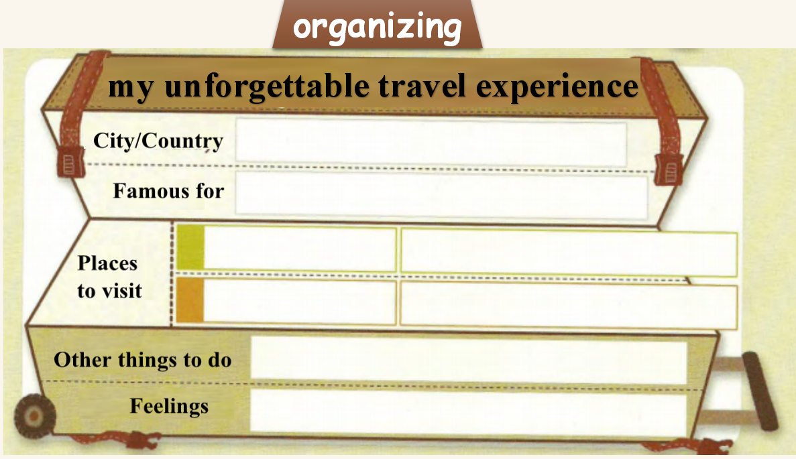
任务二:请随李华开启美文写作之旅吧！请完成“李华难忘旅行经历”的组织结构图.

任务三：随李华步步为营，亮点的句型为你所用。
Q1. Where and when did you go?
________________I could share my ___________________________ with you. It was the trip to __________________
Body

Q2. What did you do?
(paragraph 1)——旅游地点基本信息
Xi'an is a/an _________________city in China. It _______________ its old buildings, its artworks and its cuisine.
(paragraph 2)——描述经历
经历一：参观兵马俑
I __________ the Terracotta Warriors ______________ I arrived in Xi'an. I ______________ thousands of warriors.(适当拓展)___________________________.
经历二：参观陕西博物馆
______________________visit Shaanxi History Museum and see lots of artworks of ancient China. ________________________ finish the tour.
经历三：品尝当地美食
I tried some local food, ______ Chinese hamburgers and Biangbiang noodles. They are__________________I want to taste them again.
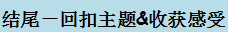
Conclusion

Q3. How did you feel?
The trip to Xi'an ________ relaxed my mind _______ broadened my horizons. ___________________it is！
任务四：Homework.
“读万卷书，行万里路”，走出去总能让你开阔眼界，学到很多。假如你是李华，请你为校刊英语园地“游学/旅游使我成长”专题写一篇短文，分享你的游学或者旅行经历，并说说你的感受。
提示词语：travel to, visit, local food, so..that...,happy
提示问题：
1. Where did you go and who did you go with?
2. What did you do there?
3. How did you feel?
______________________________________________________________________________________________________________________________________________________________________________________________________________________________________________________________________________________________________________________________________________________________________________________________________________________________
_____________________________________________________________________

