**7年级英语第15课时**

**《如何与他人谈论计划》拓展资源**

（一）

文本阅读

我们经常信心满满地制定各种计划，但是许多却难以坚持到最后。那么就请阅读下面的文章：*How to stick to (坚持)your plans*? 希望能给你一些启示。

We often make great plans and then it’s not unusual for us to give them up halfway. We will lose confidence in ourselves. What’s the problem?

The key to sticking to your plans is not to make so many of them to begin with. Just imagine that plans were books: It’s not a good idea to read several books at the same time, as it would be hard to focus on(关注于）so many different stories at once. It’s the same with plans: If you just focus on one thing at a time, you’re likely to see it through to the end.

The next time you make a plan, try to focus on it fully. It would be a good idea to break your target(目标) into several smaller steps. For example, if you join your school’s running club, you could set a target of your best running time at the beginning of each month. That way, you’d always have something to get you to go on. Most things in life need hard work and strong will. By sticking to your plans, you will teach yourself a valuable life lesson about the importance of being both dependable and dedicated (专注的).

（二）

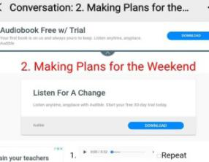 对话音频和文本

如果你希望进一步提高自己的听、说能力，在和别人谈论计划时能轻松应对, 那么扫码加入学习吧。

（三）

音乐欣赏

如果你喜欢音乐，希望通过歌曲来学习英语，那么你还可以听下面的英文歌来进一步理解 “be going to do”这一结构的语境。

1. *Do You Know Where You're Going to* (Diana Ross 演唱) 在酷狗音乐中输入歌名就可以搜到并下载。

2. *We Are Going to Be Friends* 扫描右侧的二维码就可以在爱奇艺上欣赏这首歌曲了。