**7年级英语第13课时**

**《英文绘本阅读》学习指南**

**【学习目标】**

1. 通过问题引导和绘本图片提示，能够理解故事内容，梳理故事发展脉络。
2. 能够客观评价故事人物的性格，分析Nick的情感变化。
3. 能就同学间如何融洽相处发表自己的看法。

**【学习任务单】**

1. 读前词汇学习。根据句意选择与其对应的图片，并理解画线单词的含义。

|  |  |  |  |
| --- | --- | --- | --- |
| 1580963617(1)  A | cdc431ab353abd2e182e839842b955dB | 1580964632(1)C | 1580963146(1)D |

( ) 1. Jack’s mother is **furious** with him because he tells a lie (说谎) again.

( ) 2. It’s dark (黑) in the evening, so I am **scared** of going out alone.

( ) 3. He always pushes (推) his classmates, everyone thinks he is **mean** and impolite (不礼貌的).

( ) 4. The poor man is very **skinny** because he doesn’t often have enough (足够的) food to eat.

1. 请你观看微课，跟随老师阅读绘本，完成以下任务。（扫描右侧二维码，阅读绘本文本。）
2. 完成读书报告。

**Book report**

Title:_____________________ Main characters:___________________

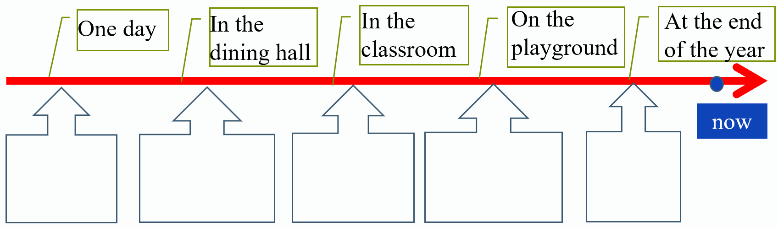Plots (情节) of the story:

2. 读后思考。

(1) What do you think of Nick and Jake?

________________________________________________________________

(2) What do you do if you meet a classmate like Nick?

________________________________________________________________

(3) What changes (改变) Nick? Can you give Nick some advice (建议) on getting on (相处) with classmates?

________________________________________________________________

三、读后提升。

1. 朗读绘本。（扫描二维码，听绘本mp3。）

1. 故事续写：假如你是Nick，请你向好朋友Jake介绍你现在的学校生活，并谈谈现在你和同学之间的关系怎样。提示词语：soccer team, get on well with…(和某人相处融洽), make friends