**Unit 5 Humans and Nature 词汇学习1——学习任务单**

**【学习目标】**

**1.归纳识别与自然景物相关的词汇,如：**

**wildlife; landscape; natural disaster; flood; drought; hurricane; landslide; volcanic eruption等。**

**2.理解并正确运用以下词汇。**

**shock; curious; escape; survive; observe; equal; extent; turn one's back on sb./sth.**

**3.运用所学词汇谈论自然以及人与自然的关系。**

**【学法指导】**

**1.通过联想法和词图匹配的方式记忆名词。**

**2.通过上下文语境，体会其它词在句子或文段中传递的意思。**

1. **Read a letter from Nature.**

My dear baby,

It’s my first time to write a letter to you. Are you **curious**? I just want you to listen to my heart.

You know, I’m beautiful and each part of myself is a wonderful **landscape**. Such as the earth and the sky, the forest and fields, lakes and rivers, the mountain and the sea. I’m loved by the w**ildlife** and other l**iving things**. I’m always happy. But sometimes, I become **horrible** and in cold blood. I am not willing to **turn my back on** you, making you **shocked** and frightened. But I can’t control myself.

Can you help me? Help me not be angry. Help me always be a gentle and kind of loving mother.

Love your Mum

1. **Fill blanks.**

scape

J gle Forest Sea

s l things things of stery

w d tree sh k fl t

sect dol tidal whirlpool

life f x wh l w v

kang

d r

gle

1. **Words and expressions- part 1.**

**a.shock 1. 2. 3.**

1.The news that the forest fire in Australia lasts for 5 months **shocked** me a lot.

2.It was a real **shock** to find out that chickens could tell what color they were eating.

3.The lecture was so **shocking** that the two students were **shocked** by the fact that our humans

harmed nature so much. (P29)

4. Make your own sentence with ***shock***.

**b.turn one's back on sb./sth.**

1.I won't forgive my sister——she **turned her back on** me and refused to give me a hand when

I lost my job.

2.My father deserted (抛弃) my mother and me when I was 5 years old. But I can't **turn my back on** him now that he's old and sick.

3.As a result, nature got hurt, felt pain, and finally **turned its back on** us.(P29)

4.无论发生什么，他都不会对她置之不理。（汉译英）

1. **Label the pictures with the words in the box.**

drought flood hurricane landslide volcanic eruption forest fire earthquake

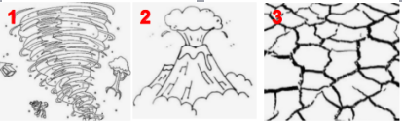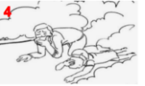

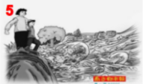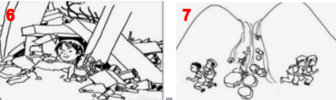

1. 2. 3.  *4.*
2. 6. 7.

**V. Words and expressions-part 2.**

**c. curious 1. 2.**

1.Children always like to ask their parents questions because they **are curious about** everything

around them.

2.Tom found a good way to solve this math problem and he **was curious to** share with others.

**d. escape**

1.Fortunately, Sarah managed to **escape** serious injury out of the volcanic eruption.

2.The soldier **escaped** from the enemy's prison and returned to his motherland.

3.He made his **escape** in disguise(伪装).

**e. survive**

1.She died in a car accident. If she had been wearing her seat-belt, she might have **survived**.

2.These drugs can help people **survive** heart attacks.

**f. observe**

1.Children learn by **observing** their parents.

2.Objects may also fall after an earthquake. **Observe** carefully before you move away.(P41)

3.By 14 days of **observation** of the monkeys, this team gained a lot of studying material.

**Describe each picture with the words as follows.**

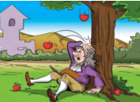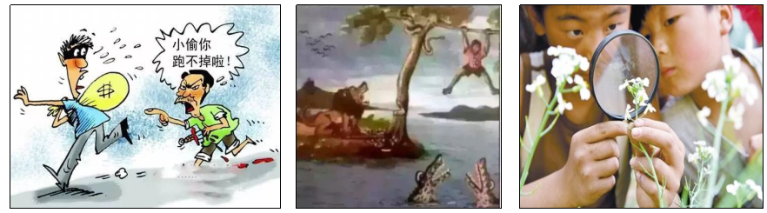

curious

survive

observe

escape

1.

2.

3.

4.

**g.equal 1. 2.**

1. There are 14 girls and 14 boys in Class2. That is to say the number of boys and girls is **equal**.

2.In old times, women and men are not **equal.** but now they have **equal** rights to get education

and do many things.

3. Make your own sentence with ***equal***.

**h. Extent 1. 2.**

1. The garden is about two acres(英亩)in extent.

2. He didn't pass the exam. But, to some extent, it's good for him to think about his ways to

study.

3.在很大程度上，我同意你的观点。（汉译英）

**VI.Complete the story with the proper form of the following words.**

curious extent equal escape survive observe

One day, a fisherman met a huge whirlpool in the sea. He was going round in circles at great speed. He saw clearly that there were other objects in the whirlpool—trees and barrels. After a while, he became about the whirlpool itself. He then made three important . The first, the larger the bodies were, the more rapidly they fell; the second, between two objects of , round objects fell down less rapidly; and the third, between two objects of the same size, objects shaped like a tube fell down more slowly. So he tied himself to a barrel to help him float. Without waiting, he jumped into the sea to try and .Finally, he managed to and went back home.

**VII.Reply to Nature.**

Your letter should Include the following aspects:

1. The detailed information about Nature. (something that makes you comfortable while

something that makes you frightened.)

2. The reason why she was angry and became horrible.

3.The ways to help her.

My dear Mum,