**M2U5 语法学习（2） Relative clause revision & suffix**

|  |
| --- |
| 学习目标 |

**1. 能够掌握引导定语从句的关系代词和关系副词**

**2. 能够使用正确的后缀改变单词的词性**

**3. 能够在句子中正确运用单词词性**

**4. 能够用定语从句及含有后缀的单词介绍著名的探险家**

|  |
| --- |
| 学法指导 |

**Learning strategy (学法指导)**

* **meaning >form 【意义>形式】**

**在关注定语从句使用形式的基础上，务必关注上下文的语境，体会句子或文段所传达的意思才是更重要的。**

* **关注单词的词性,增强词性意识，从而使语言的表达更加准确。**

【task 1】**Review the relative pronouns and adverbs in relative clauses. Take notes.**

|  |  |  |
| --- | --- | --- |
| **先行词** | **关系代词/关系副词** | **在定语从句中充当的成分** |
| people |  |  |
|  |  |
| thing |  |  |
|  |  |
| time |  |  |
| place |  |  |
| reason |  |  |

【task 2】**Match the sentence from column A to an appropriate word and an relative clause in columns B and C.**

|  |  |  |
| --- | --- | --- |
| **Column A** | **Column B** | **Column C** |
| **That is the reason**  **Xia Boyu is a great climber**  **Rescue teams try to save people**  **Amundsen will never forget the time**  **The scientists hope to discover the drug**  **My brothers and I went back from the islands**  **People all over the world were moved by the courage** | **who**  **which**  **that**  **whose**  **when**  **where**  **why** | **are trapped under buildings.**  **they set foot on the South Pole.**  **was shown by Scott and his men.**  **we often got more fish than others.**  **is used to treat the pneumonia (肺炎)**  **Scott won the respect of the whole world.**  **experience has been an inspiration to us.** |

【task 3】**writing**

**You are supposed to make a brief introduction of Xia Boyu’s life experience to your class. Use at least 5 relative clauses appropriately.**

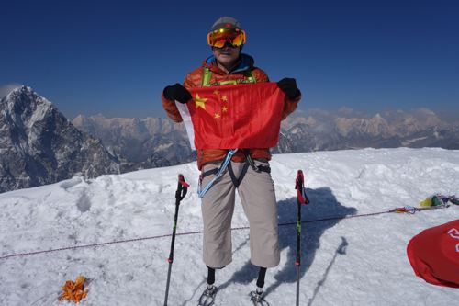

|  |  |  |
| --- | --- | --- |
| **when** | **where** | **what** |
| **1949** | **Chongqing** | **was born** |
| **1975** | **at an altitude of 8,600 meters** | **gave his sleeping bag to a teammate**  **lost both of his lower legs** |
| **1975-2018** |  | **kept training** |
| **May 14th, 2018** | **the summit(=top) of Qomolangma** | **succeeded** |

【task 4】Complete the Word Builder. Then use the correct form of the words to complete the sentences in exercise 7 on page 39.

|  |  |  |  |
| --- | --- | --- | --- |
| Word builder | suffixes | | |
| prepare |  |  |
| situate |  |
| protect |  |
| explore |  |
| die |  |
| disappear |  |
| hope |  |
| harm |  |
| cheer |  |
| sad |  |
| ambition |  |
| anxious |  |

**Note taking:**

* 句子的主语或宾语 (动宾/介宾) 一般是__________________
* 句子的表语或定语 (修饰________________) 一般是形容词;
* 句子的状语(修饰_________________)一般是副词